- Resistive circuits (20 points)

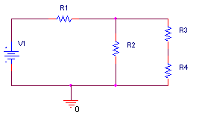

Given: V1=5 volts. R1= 2000Ω, R2= 1000Ω, R3= 500Ω, R4= 400Ω

- (8 points) Find the total resistance of the circuit.

RT=R1+R2//(R3+R4)
(R3+R4) = .5K + .4K = .9K
R234 = R2//(R3+R4) = (1K*.9K)/(1K+.9K) =0.474K
RT=2K+0.474K = 2.474 Kohms

b) (6 points) Find the voltage across R1.

IT = VT/RT = 5V/2.474K = 2.02 mamps
V1 = IT*R1 = 2.02m * 2K = 4.04 volts

c) (6 points) Find the current through R4.

V2 = VT-V1 = 5 – 4.04 = 0.96 volts
I2 = V2/R2 = 0.96/1K = 0.96 mamps
I3=I4=IT-I2=2.02m-0.96m = 1.06 mamps
2. Thevenin circuits (20 points)

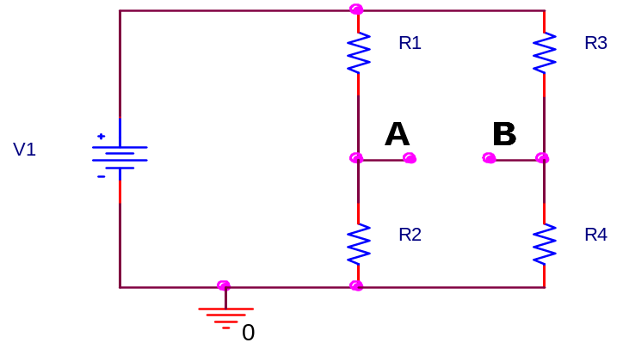

Given: V1=12 V; R1=2 kΩ; R2=4 kΩ; R3= 8 kΩ; R4= 4 kΩ

a) Find the Thevenin Voltage (Voc) of the circuit assuming the load will be connected between A and B. (6 points)

Vth = VA – VB = V1*R2/(R1+R2) – V1*R4/(R3+R4)
Vth = 12*4K/6K – 12*4K/(8K+4K) = 8-4 = 4 volts

b) Find the Thevenin Resistance (6 points)

Redraw circuit:
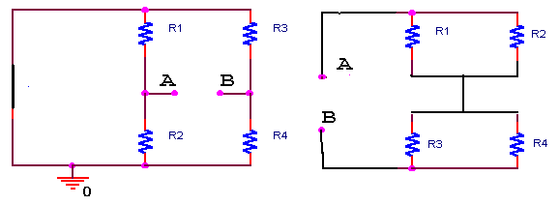 Rth = R1//R2 + R3//R4 = R1*R2/(R1=R2) + R3*R4/(R3+R4)
Rth = 2K*4K(2K+4K) + (8K*4K)/(8K+4K) = 4/3 + 8/3 = 12/3 = 4 Kohms

c) Find the current going from A to B if a 4 kΩ resistor is connected between A and B. (8 points)

V=IR Vth = I* (Rth+4K) 4 = I * (4K+4K)

I = 0.5 mamps

3. Sine Waves (20 points)

a) sinusoid

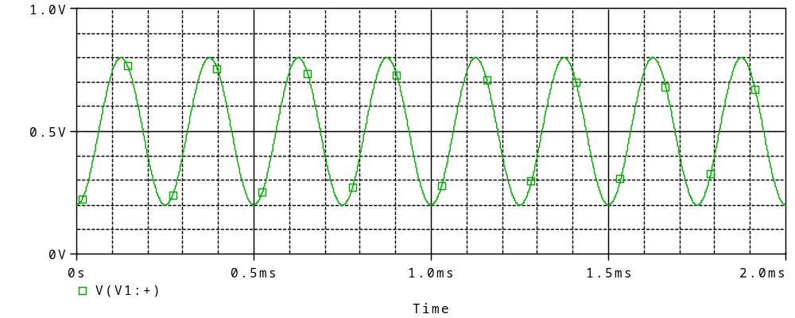

i) Consider trace in the plot above and give the following values (6 points):

(Do not forget the units.)

frequency: period = 0.25ms frequency = 1/.25m = 4 KHz

amplitude: A=Vp-p/2 = (.8-.2)/2 = 0.3 volts

rms value: 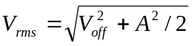 = 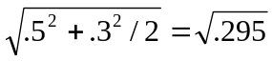 = 0.543 volts

peak-to-peak voltage: Vp-p = 0.6 volts

phase shift: φ = -2π*1/4 = -π/2 rad/sec or

φ = -ωt₀ = -2πf(.06ms) = -0.48π rad/sec = -1.51 rad/sec

offset voltage: offset = 0.5 volts

ii) Write down the mathematical expression for trace a) in the form

v(t) = V_{dc} + A sin (ωt + ϕ). (4 points)

v(t) = 0.5 + 0.3 sin(8Kπt – π/2)

b) decaying sinusoid

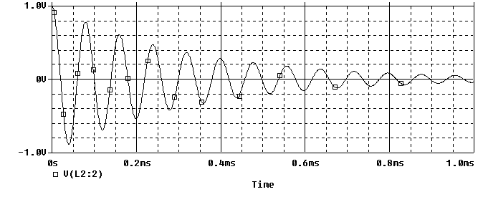

i) Consider the plot above and give the following values (6 points):

(Do not forget the units.)

frequency: 5/0.4ms = 12.5 KHz

amplitude (at t=0 s): 1.0 volt

decay constant α: P0=(0ms,1volt) P1=(0.79ms, 0.08volts)

0.08 = 1 e^{-α(t1-t0)}

ln(0.08) = -α(0.79)

α = 3.2 per millisecond

α = 3197 per second

ii) Write down the mathematical expression for the trace b) in the form

v(t) = A e^{-αt} sin (ωt). [Ignore the phase shift] (4 points)

v(t) = 1.0 e^{-3197t} sin(25Kt) for seconds or
v(t) = 1.0 e^{-3.2t} sin(25t) for milliseconds

Extra credit: What is the phase shift for the decaying sinusoid in b)?

+π/2 rad/sec (+2π*1/4cycle) or –ωt₀=-2π(12.5K)(-.02m) = 0.5π rad/sec

4. Inductance and capacitance at very high and very low frequencies (20 points).
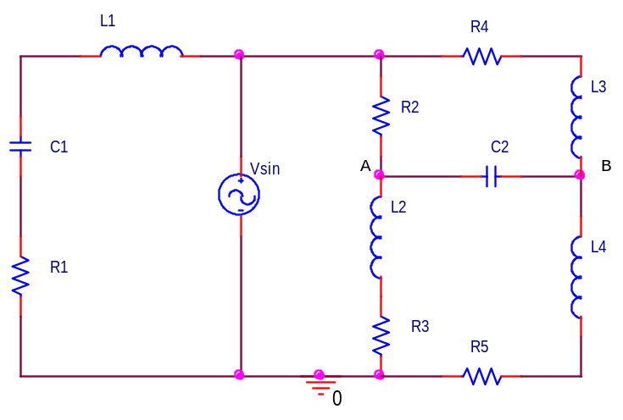
Consider the above circuit and apply your knowledge about the behavior of capacitors and inductors (i.e., open or short circuits at very high or very low frequencies).

- Redraw this circuit when Vsin is low frequency (8 points).
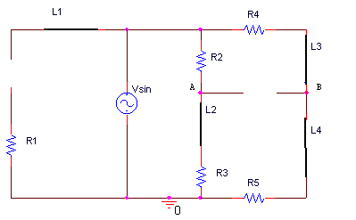
- At low frequencies, this circuit most behaves like a (circle one) (2 points)
open circuit short circuit bridge

- Redraw this circuit when Vsin is high frequency (8 points)
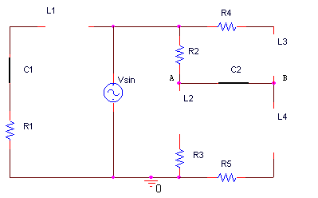
- At high frequencies, this circuit most behaves like a (circle one) (2 points)
open circuit short circuit bridge

5. Instrumentation (20 points) [ 1:200mV 0.00s 100μs/  1 RUN ]
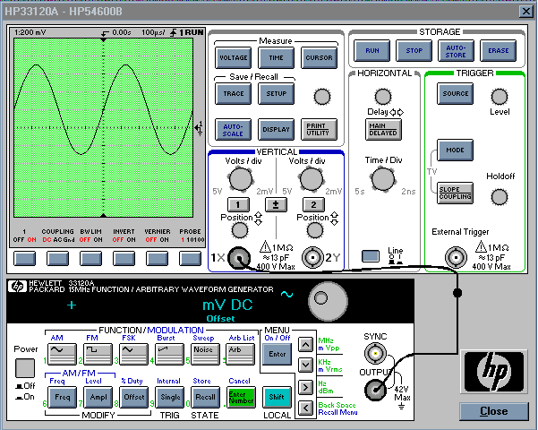
a) Explain as simply as possible how to set up the function generator and scope to display the signal shown. (Use of Autoscale is NOT allowed). Give specific values.
(8 points)
1) Push the Freq button on the function generator.
2) Turn the dial until the frequency reads 2 K hertz.
3) Push the Ampl button on the function generator.
4) Turn the dial until the peak-to-peak voltage reaches 500 millivolts [the peak-to-peak voltage on the ‘scope will show 1volt]
5) Push the Offset button on the function generator.
6) Turn the dial until the DC offset on the function generator reaches 100mV [the offset on the ‘scope will show 200mV]
7) Adjust the volts/div for channel 1 to 1:200mV.
8) Adjust the time/div for the horizontal trigger to 100microseconds/
9) Turn the position knob on channel 1 until the arrow lines up with the zero mark.

b) List two ways to obtain the peak-to-peak voltage of the above signal using the oscilloscope (4 points)

1) Measure the distance from the minima to the maximum of the sine wave by counting the number of major divisions and multiply by the scale in the upper left corner to get the peak to peak voltage.
2) Push the voltage button. When the soft keys appear at the bottom of the screen, hit the one corresponding to Vp-p.

c) When the function generator is connected to the scope you should notice a discrepancy between the reading on the display panel of the function generator, and the signal displayed on the scope. What discrepancy do you see and which device is correct?
(2 points) Why? (6 points)

The scope will read twice the value of the function generator. The ‘scope is correct.
The function generator expects a 50 ohm load to match its 50 ohm impedance. With this expectation, it displays a value equal to half of what it puts out. The load of the ‘scope, when it is connected directly to the function generator, is 1Meg ohm. The 1Meg ohm resistance is so much higher than 50 ohms, that the vast majority of the voltage goes to the scope, making the voltage at the function generator output essentially equal to what it is putting out (instead of the ½ it expects).

