1. RLC, RL and RC Circuits (25 points)

Shown below are 5 circuits. Assume the input voltage (V_{in}) is applied across the left-most terminals and the output voltage (V_{out}) is measures across the rightmost terminals
(1 point each).
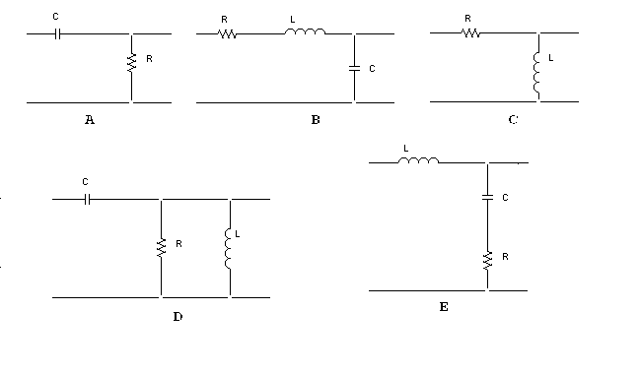
Given below are several possible expressions for generic transfer functions for such circuits. Indicate which circuit goes with which function.

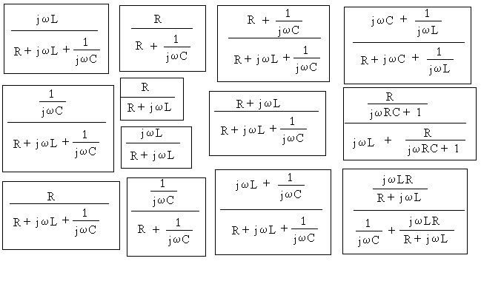

Find the approximate resonant frequency ω_{r} for the RLC circuits and the corner frequency ω_{c} for the other circuits. That is, write the general expression for each frequency (1 point each).

A.

B.

C.

D.

E.

Determine the complex transfer function for two of the five circuits (A and B) at the resonant frequency or corner frequency. Be sure your answer is given in terms of R, L, and/or C and does not contain ω. This may seem like an obvious comment, but we want to make sure you have the simplest possible expression. Identify the magnitude and the phase of the transfer function at this frequency (6 points).

A. V_{out}/V_{in} = H(jω_{c}) =

|H(jω_{c})| = ∠H(jω_{c}) =

B. V_{out}/V_{in} = H(jω_{r}) =

|H(jω_{r})| = ∠H(jω_{r}) =

Determine the transfer function, magnitude of the transfer function, and phase of the transfer function at low frequencies for C and D. These should be simplified and expressed these in terms of ω where appropriate (6 points).

C. V_{out}/V_{in} = H(jω_{lo}) =

|H(jω_{lo})| = ∠H(jω_{lo}) =

D. V_{out}/V_{in} = H(jω_{lo}) =

|H(jω_{lo})| = ∠H(jω_{lo}) =

Finally, find the transfer function, magnitude of the transfer function, and phase of the transfer function as ω approaches infinity for E. These should be simplified and expressed in terms of ω where appropriate (3 points).

E. V_{out}/V_{in} = H(jω_{hi}) =

|H(jω_{hi})| = ∠H(jω_{hi}) =

2. Diodes (25 points)

In the full wave rectifier below, each of the diodes turns on at 0.6 volts and the resistances are as shown.
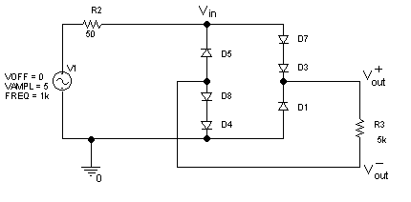
a. (10 points) Draw a circuit which shows:

i) the positive half cycle of the circuit. (when current flows in the positive direction).

ii) the negative half cycle of the circuit. (when current flows in the negative direction.)

b. (9 points) What will the voltage between V⁺_{out} and V⁻_{out} be when

i.) Vin = 5 V

ii) Vin = -5 V

iii) Vin = 0V

c. Which of the plots below represents Vin and Vout for this circuit (6 points)?

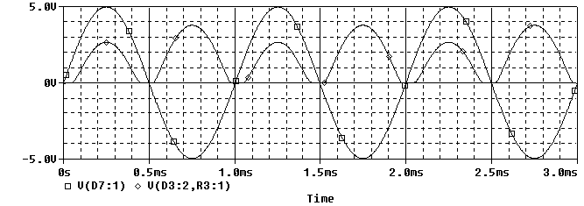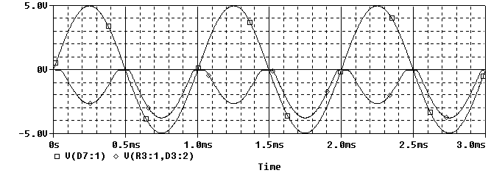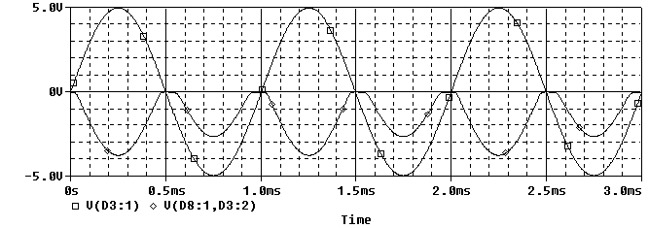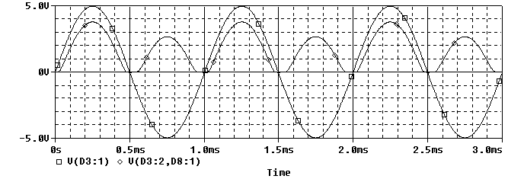

3.Filters (25 points)
The following circuit analysis consists of a sinusoidal source and a circuit containing resistors, capacitors, and inductors.

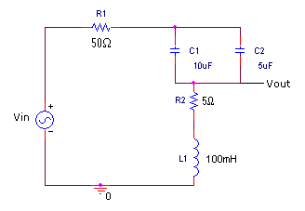

Vin is the sinusoidal source and R1 denotes its internal impedance. Redraw this circuit at high frequencies. (3pt)

Redraw this circuit at low frequencies. (3pt)

Is this a high pass filter, a low pass filter, band pass, or band reject filter? Explain your answer (2pt)

The source voltage Vin as a function of time is shown below.

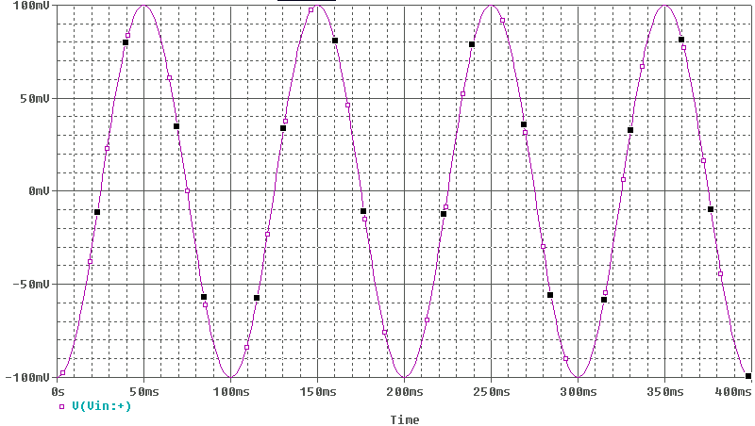
Write the mathematical expression for v_{in} in the form 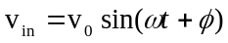. Provide values for v_{0, ω,} and φ. (6pt)

Create a rough sketch of the magnitude of the transfer function for this circuit as a function of frequency. You need only show the general shape, not the phase. Indicate on the graph where the resonance frequency is located. Please give a numerical value. (6pt)

Given your knowledge of corner and resonant frequencies, will v_{out} have greater, equal, or less amplitude then v_{in}? Explain your answer. (5pt)

Question 4 Op-Amps (25 points)
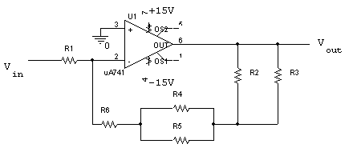
Above is a figure of an op amp circuit where R1=1K, R2=3K, R3=4K, R4=2K, R5=2K and R6=4K.

a) (4 points) Is this an Inverting, Non-inverting, or Differential Amplifier?

b) (7 points) Calculate the value of the feedback resistance, R_{f}, in this circuit.

c) (7 points) What is the gain of this circuit?

d) (7 points) Sketch the output voltage (Vout) for the input voltage (Vin) shown below.


