1. Resistive Circuits (20 points)

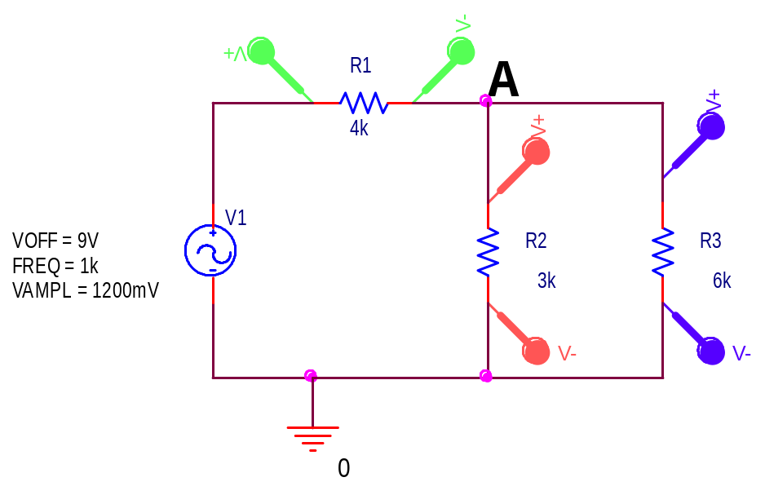

a) Given the circuit above, calculate the DC offset voltage at point A. (5 points)

VOFF = 9V R23 = R2//R3 = (3K*6K)/(3K+2K) = 2K ohms
VA = 9V * (2K)/(2K+4K) = 9/3 = 3V
DC Offset at A is 3V

b) For the same circuit, calculate the amplitude of the voltage at point A. (5 points)

VAMPL = 1200mV = 1.2V
AAMPL = 1.2(2K)/(2K+4K)=1.2/3 = 0.4V

Amplitude at A is 0.4 V or 400mV

c) What is the current through R1? (5 points)

The current through R1 is a sinusoid. We know V=IR. We also know V(t)=I(t)R. If we write this in terms of the sine function,
VDC_{R1}+VAC_{R1}sin(ωt) = [IDC_{R1}+IAC_{R1}sin(ωt)]*R1 where ω=2πf=2Kπ
VDC_{R1}=VOFF(4K/(2K+4K))=9*2/3 = 6V (or read off plot on next page)
VAC_{R1}=VAMPL(4K/(4K+2K))=1.2*2/3=0.8V (or read off plot on next page)
IDC_{R1}=6V/4K=1.5mA IAC_{R1}=0.8V/4K =0.2mA

I_{R1}(t) = 0.2mA sin(2Kπt) + 1.5mA
(You should get some partial credit for successfully finding IDC_{R1} and IAC_{R1})
c) Which of the following plots corresponds to the correct output for the circuit pictured above? (5 points)
The plot below has no DC offset, so it cannot be correct.
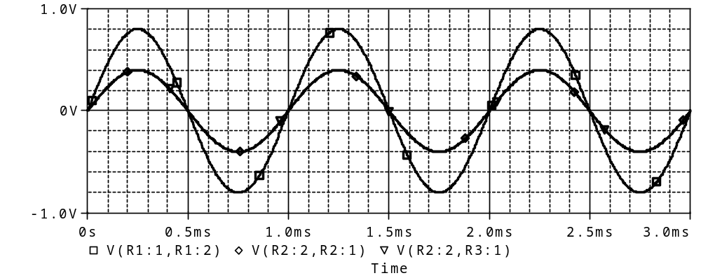
The plot below divides the DC offset correctly (6V and 3V), but the amplitudes are too big (2V and 1V)
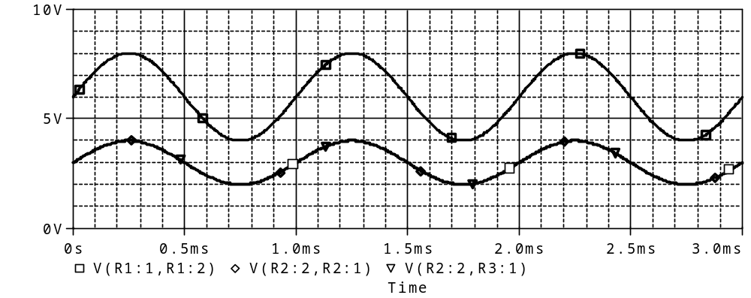

The plot below is correct. The DC voltage is 6V for R1 (square), and 3V for R2 and R3 (triangle and diamond). The amplitude across R1 is about 0.8V and over R2 and R3 is half that. The voltage across R2 and R3 must be the same because they are in parallel.
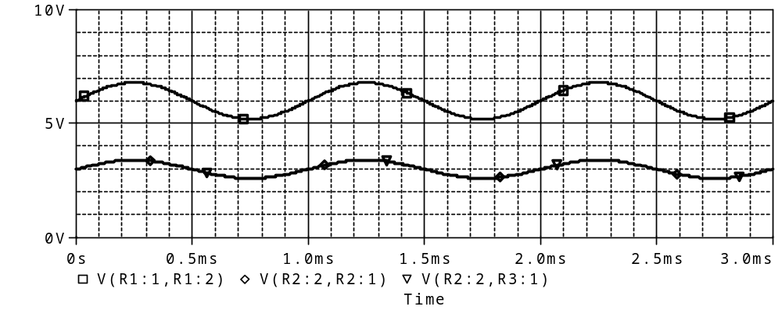
Note: On test 1B, these graphs are in a different order. The top one (which is identical to the one above) is correct on these tests.

2. Thevenin Circuits (20 points)

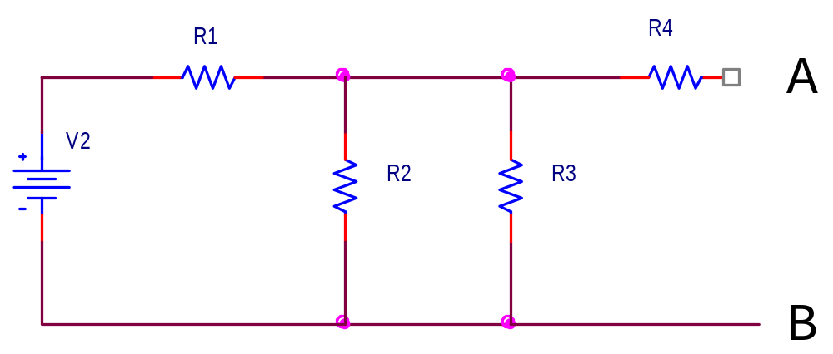

Let V2=12V, R1=50 ohms, R2=1K ohms, R3=2K ohms, and R4=500 ohms.

- Find the Thevenin voltage between A and B (8 points)

Test A: Vth = V_{R23} R23=R2//R3=1K*2K/(1K+2K)=0.66667K
V_{AB} = 0.66667K/(0.66667K+50)(12V)=11.16V
V_{AB} = 11.16V

Test B: Vth = V_{R23} R23=R2//R3=2K*0.5K/(2K+0.5K)=0.4K
V_{AB} = 0.4K/(0.4K+50)(12V)=10.67V

V_{AB} = 10.67V

- Find the Thevenin resistance (8 points)

Test A: Rth = R4 + R123
R123 = R1//R2//R3 → 1/R123 = 1/50 + 1/1K + 1/2K → R123 = 46.5 ohms
Rth = 500+46.5 = 546.5 ohms
Rth = 546.5 ohms

Test B: Rth = R4 + R123
R123 = R1//R2//R3 → 1/R123 = 1/50 + 1/2K + 1/0.5K → R123 = 44.4 ohms
Rth = 3000+44.4 = 3044.4 ohms
Rth = 3044.4 ohms

- Draw the Thevenin equivalent circuit with a load of 4K ohms. (4 points)

TEST A TEST B
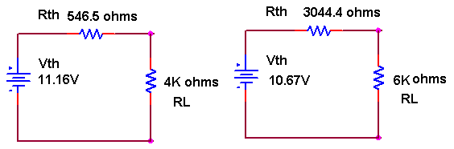
3. Sinusoids (20 points)

The following data was obtained for some kind of a measurement. 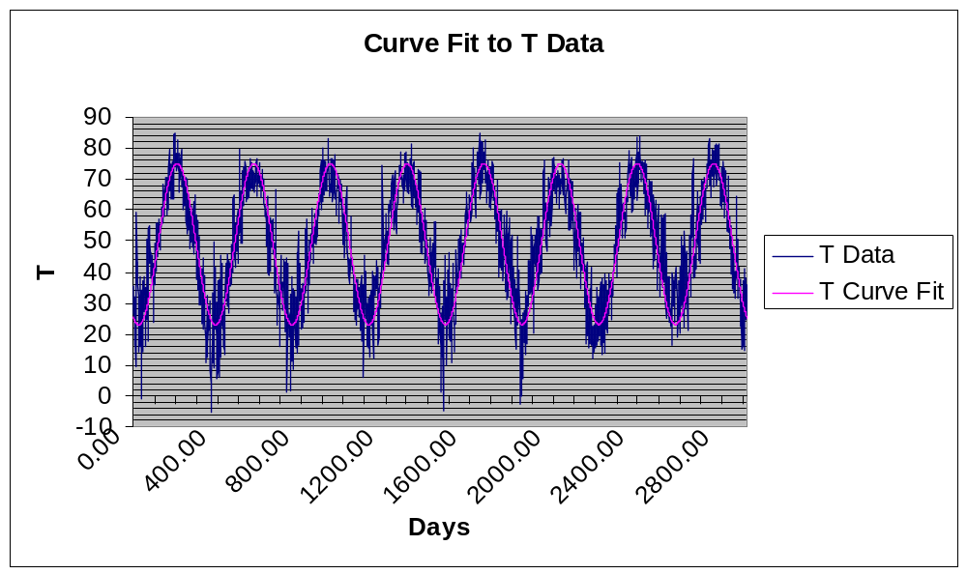
The horizontal scale is in days. The vertical scale is unknown at the moment.
With the horizontal scale expanded,
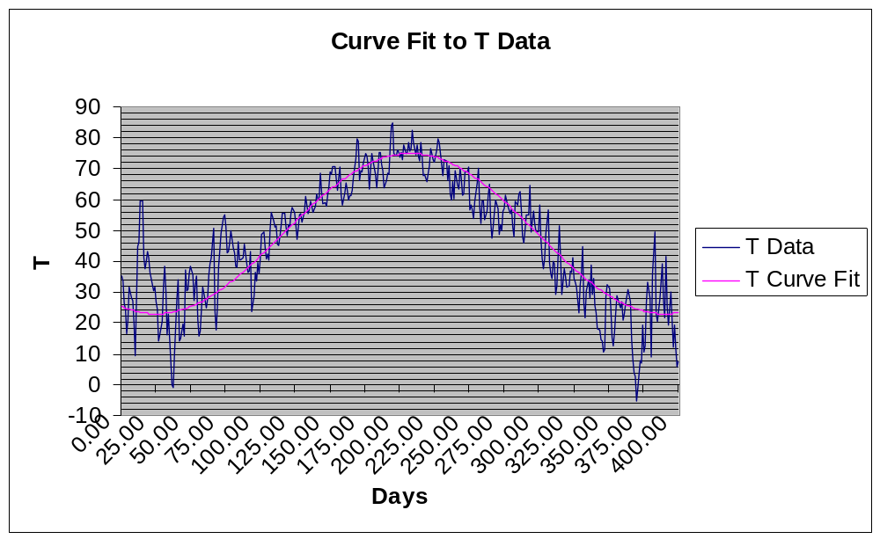

a) Since this data looks approximately sinusoidal, determine its period and frequency. You may make any reasonable assumption. (6 points)

T = (400-35) = 365 days
F = 1/T = 0.00274 cycles/day
Anything in a reasonable range is acceptable.

b) The data is not exactly sinusoidal since it is very noisy and also the maximums and minimums are not the same. In addition, there is a finite offset (DC) value. What is the approximate value of the offset? (3 points)

peak-to-peak voltage = 76-24=52 amplitude = 52/2 = 26
Offset is the center of the wave, which is 24 to bottom+26 or about 50.
50 (units unknown)
Anything in a reasonable range is acceptable.

c) Write a mathematical expression for the signal and its offset. (Note that there is also a phase shift in this signal.) T=T₀ + T₁sin(ωt+φ₀) where φ₀ is the phase term, T₀ is the offset and T1 is the amplitude of the sine function. (9 points)

We still need to find the radial frequency and the phase shift.
ω=2πf = 2π(0.00274)=0.0172 radians/day
φ₀=-ωt₀=-(0.0172)(130)=-2.24 radians

T = 50 + 26 sin(0.0172t – 2.24)

- Based on your answer to part (a-c) and the values given for the data, what do you suppose is being measured? (2 points)

It looks to me like temperature in degrees Fahrenheit over several years. Other ideas that seemed reasonable were also accepted.

4. Inductors and Capacitors at High and Low Frequency (20 points)

a) The circuit shown below is a delay line. That is, for some signals input at terminals A and B, the same signals will appear at terminals C and D, but delayed in time.

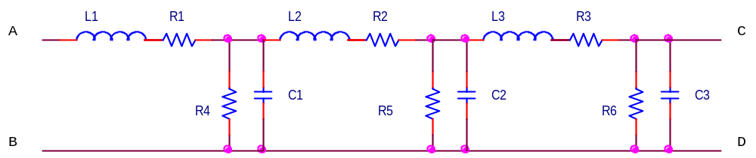

i) Simplify this circuit for zero frequency (DC) conditions (4 points)

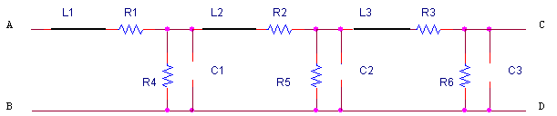

ii) Simplify this circuit for very, very high frequencies (4 points)

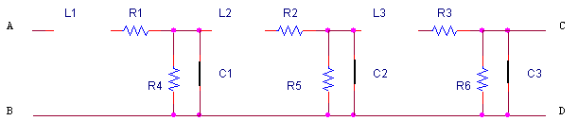

iii) Given that no other components are connected to A&B or C&D, what is the resistance that would be measured at very low and infinite frequency at the terminals indicated below? (8 points)

Assume R1=R2=R3=R4=R5=R6=2K ohms, C1=C2=C3=1μF, and L1=L2=L3=3mH

At low frequencies:
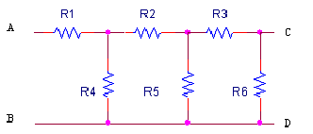
The total resistance between A and B is R1 + R4 // [R2 + R5 // (R6+R3) ]
Test A: R63 = 2K+2K=4K R563=2K*4K/(2K+4K)=1.33K R2563=2K+1.33K=3.33K
R42563 = 2K*3.33K/(2K+3.33K)=1.25K R142563=2K+1.25K = 3.25K ohms

Test B: R63 = 3K+3K=6K R563=3K*6K/(3K+6K)=2K R2563=3K+2K=5K

R42563 = 3K*5K/(3K+5K)=1.875K R142563=3K+1.875K = 4.875K ohms

At high frequencies:

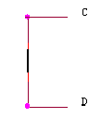
Since C and D are connected together by a wire, there is no resistance between them. (If it was an open circuit, the resistance would be infinite.)

Very Low Frequencies Very High Frequencies

R_{AB} = Test A: 3.25K ohms R_{CD}= 0 ohms
Test B: 4.875K ohms

b) Many of you own devices that connect to your computers that have a thick cylindrical section that surrounds one of the power or signal cords. This is a magnetic material that adds inductance to both signal leads. The resulting circuit looks like the following.

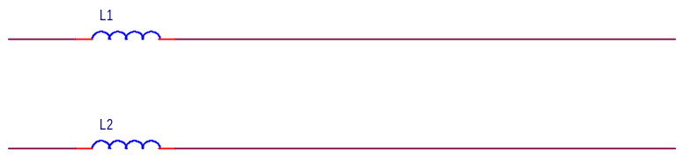

Simplify this circuit at high and low frequencies. (4 points)

High frequencies:

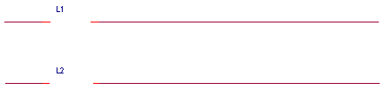

Low frequencies:

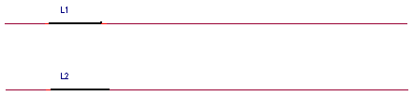

5. Instrumentation and Sine Waves (20 points)

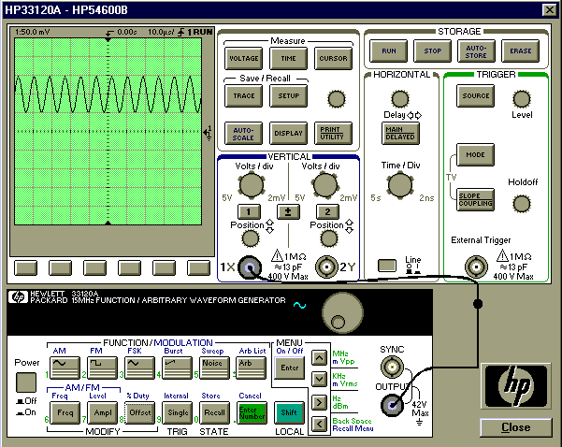

a) Explain as simply as possible how to set up the function generator and ‘scope to display the signal shown. (Use of Autoscale is NOT allowed). Give specific values.
(8 points)

1) Turn on the ‘scope and the function generator.

2) Connect a BNC cable from the function generator output to channel 1 of the ‘scope.
3) Push the Freq button on the function generator.
4) Turn the dial until the frequency reads 120K Hz. (6 cycles/5x10μs)
5) Push the Ampl button on the function generator.
6) Turn the dial until the peak-to-peak voltage on the function generator display reads 50 mV (or Amplitude reads 25mV). (This is ½ observed on ‘scope.)
7) Push the Offset button on the function generator.
8) Turn the dial until the DC offset on the function generator display reads 50 mV.
9) Adjust the volts/div for channel 1 to 1:50 mV.
10) Adjust the time/div for the horizontal trigger to 10.0 μs/
11) Turn the position knob for channel 1 until the arrow lines up with the zero mark.

b) If you were to attach another function generator to channel 2 of the ‘scope, what would you set the frequency of the signal output by the second function generator to in order to generate a Lissajous pattern that looks like an upright figure eight? (Assume channel 1 is on the x axis) (2 points)
How would you set up the ‘scope to display this signal? (2 points)

X:Y = 1:2 = sideways figure 8 (on crib sheet)
You want an upright figure 8. Therefore, X:Y = 2:1
X:Y = 120K:Y = 2:1 2Y=120K Y=60KHz
Set other function generator to 60K Hz.

To get a Lissajous figure. Press the Main/Delayed button and then press the XY soft key.

c) When the function generator is connected to the scope you should notice a discrepancy between the reading on the display panel of the function generator, and the signal displayed on the scope. What discrepancy do you see and which device is correct?

(2 points)

Why? (6 points)

The function generator reads half of the scope. The scope is correct.

The function generator expects a 50 ohm load. It has an internal impedance of 50 ohms. When it outputs a voltage, it assumes that that 50 ohm load is there and it has a voltage divider which divides the voltage in half. To account for this, the function generator displays half of what it is actually putting out. When you put a large load like the ‘scope on the function generator, you no longer have a voltage divider that divides the voltage in half. The load is so big relative to the 50 ohm impedance of the function generator, that the output is more or less equal to the amount that the function generator is actually putting out. The function generator has no way of knowing this, therefore, it still displays half of what it puts out and the display reads incorrectly.

