Experiment 8
Op Amp Configurations – Integrator, Differentiator, Voltage Follower

Purpose: In this experiment, we will look at two of the standard op amp configurations that give us the mathematical operations of differentiation and integration. Also we will see how we can add just about any kind of load to an amplifier and not change its performance by using a voltage follower.

Background: Before proceeding, please review section 6.2.3 of Gingrich in which he describes various mathematical operations that can be performed with op amps. You will see that it is quite easy to perform additions, subtractions, derivatives and integrals. That is why collections of op amp circuits have been used in the past to represent dynamic systems in what is called an analog computer. There are some very good pictures of analog computers and other computers through the ages at H. A. Layer’s Mind Machine Web Museum at http://userwww.sfsu.edu/~hl/mmm.html

Also review sections 6.2.1 and 6.2.2 on non-inverting and inverting amplifiers, respectively. The first section introduces the voltage follower. Finally, check out the websites listed in the helpful info section of the course webpage. Some of the highlights of these pages have been extracted below. Please note that both V and E are used to represent voltage.

We will be considering several basic op-amp configurations. The first is the voltage follower
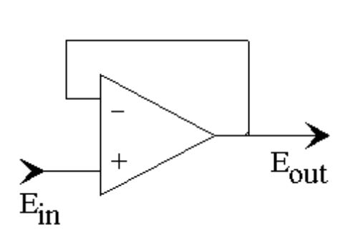
where E_{in} is the input voltage and E_{out} is the output voltage. The non-inverting voltage follower is a configuration that can serve as an impedance matching device. For an ideal op-amp, the voltages at the two input terminal must be the same and no current can enter or leave either terminal. Thus, the input and output voltages are the same and Z_{in} = E_{in}/I_{in} → ∞. In practice Z_{in} is very large which means that the voltage follower does not load down the source. The second is an inverting amplifier
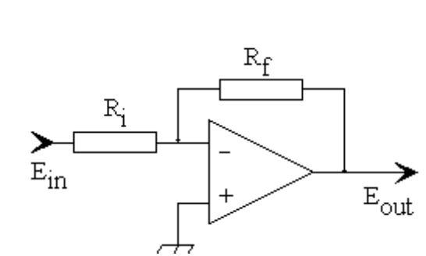

(Another note on notation: The symbol with the three legs connected to the non-inverting input is another symbol for ground.) The inverter with voltage gain amplifies the signal and changes its sign, E_{out} = E_{in}(R_{f} /R_{i}). It is possible to select R_{i} = R_{f} which just changes the sign of the input. More than one input can be used if we wish to add signals. To construct this circuit, use two or more input resistors in parallel. The resistors are all connected to the common or summing point of the circuit. By using the basic design rules for operational amplifiers, it is easily shown that the output voltage will be
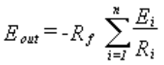
where n is the number of input resistors. The input resistors can have any values but this circuit generally uses the same values for the R_{in}.
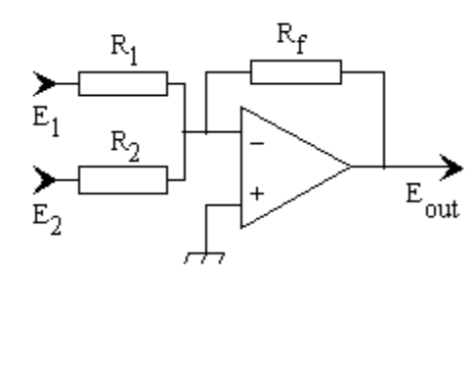
The next configuration is known as the Miller integrator. They are mostly employed today as low pass filters. The circuit is similar to the voltage inverting amplifier, only the feedback resistor is replaced with a capacitor. As a practical device, this configuration does not work unless there is also a resistor included in parallel with the feedback capacitor, as is discussed below.
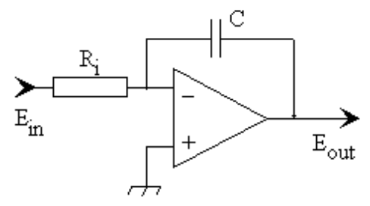

An analog differentiator circuit can be constructed by using a capacitor as the input element and a resistor in the feedback position of the inverter circuit.
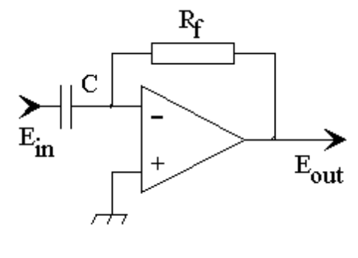
Equipment Required:

- HP 33120A 15 MHz Function / Arbitrary Waveform Generator
- HP E3631A Power Supply
- HP 54603B 2 Channel 60 MHz Oscilloscope
- Protoboard
- Some Resistors and Capacitors
- 741 Op-Amp or 1458 Dual Op-Amp
- OrCAD Capture and PSpice

There are several basic circuit blocks that we will use in this experiment. Rather than drawing the entire circuit at once, it is more instructive to show them separately, so that each function can be identified. First there is the function generator, that we will represent as a Thevenin equivalent, followed by the load resistor. If we connected the load resistor R_{L} directly to the function generator, what voltage would we observe across the load?

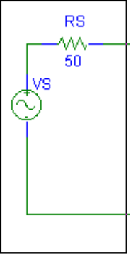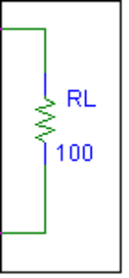
Function Generator Load

In this experiment, we will be connecting the load to the function generator, but not directly. We will first integrate or differentiate the source signal and then connect to the load. We will see that we can make the operation of the circuit more independent of the load by adding a voltage follower.

Next is the basic op amp configuration with enough components to be either an integrator or differentiator. These components can represent impedances we have placed in our circuit on purpose or parasitic impedances that come from interactions between wires, etc. (Note that a voltage divider has been included at the output of this amplifier. Recall that we used a potentiometer like this in the Project 2 circuit as a volume control.):

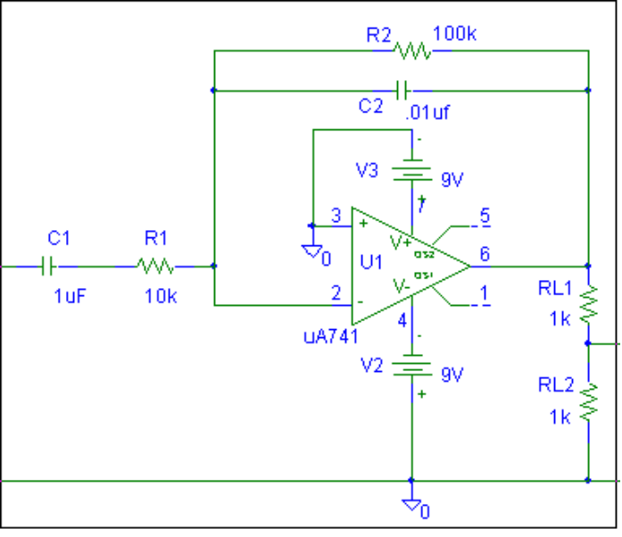
General Op-Amp Configuration

Finally, the voltage follower:
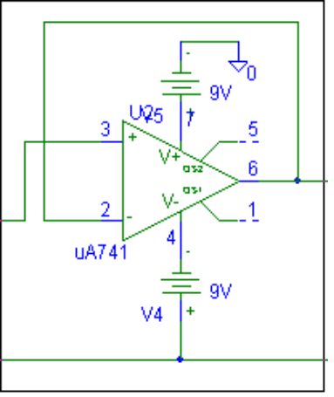
Voltage Follower

Part A The Voltage Follower

Begin by simulating the circuit consisting of the source, the basic op amp and the load. We will add the voltage follower next. Use a source voltage of 1 volt and a frequency of 1kHz. Do an AC Sweep from 1 Hz to 100 kHz. Obtain a plot of the output showing the voltages at the output of the function generator (before the first capacitor), at pin 6 of the op amp, and across the load. Note that you are plotting the input signal, the output of the basic op amp (pin 6), the output from the voltage divider and the voltage across the load resistor. In this case the latter two voltages are connected directly.
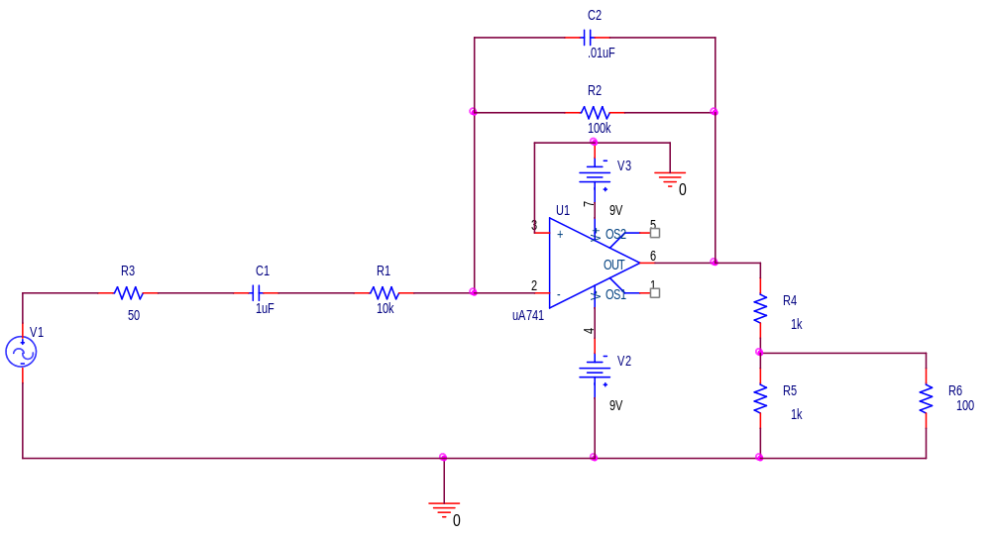
Now add the voltage follower circuit between the voltage divider output of the basic op amp and the load (see below). Do the same AC Sweep and obtain a plot of the output. What similarities and differences do you observe between the two sweep outputs? It is said in Gingrich that the voltage follower (also called a buffer amplifier) is used to isolate a signal source from a load. From your results can you explain what he meant?

Voltage followers are not perfect. They are not able to work properly under all conditions. To see this, do a transient analysis of the circuit in steps of 10 us for a total time of 10 ms. You should see the circuit working more or less as you would expect. Now change the load resistor to 10 ohms and do the transient analysis again. What do you observe now? Can you explain it?
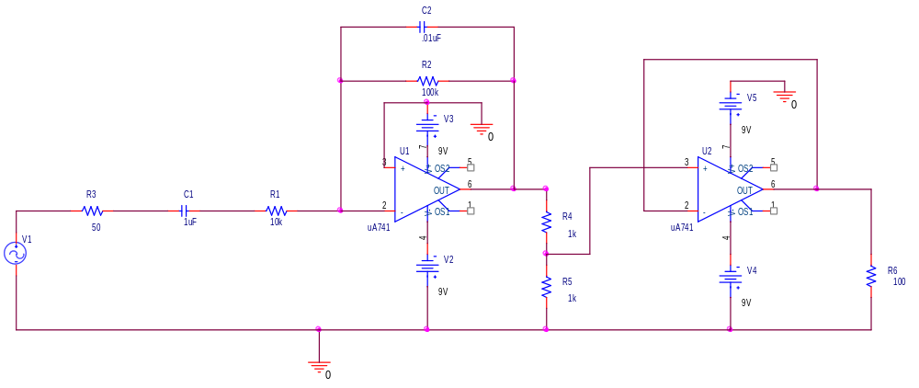
Finally, it was noted above that the input impedance of the voltage follower should be very large. Determine the input impedance by finding the ratio of the input voltage to the input current for the follower. That is, find the ratio of the voltage to the current for the non-inverting input of this device. Since PSpice tries to be a realistic as possible, you should get a large but not infinite number. You can obtain the voltage we need by placing a voltage marker near the non-inverting input. However, it is not as easy to identify current. Fortunately, we can use what we know about basic circuits to figure it out. The current we need is the difference between the current through R4 and R5. From your AC sweep results, plot V(U2:+)/(I(R4)-I(R5)). Note that your voltage divider resistors might have different names if you placed them on the schematic in a different order. You will note that we are getting into the noise levels for the simulation, so that the plot will be a bit ragged.

Results and Discussion

- Compare the AC sweep outputs with and without the buffer circuit in place. What is the function of the buffer circuit?
- Why is the follower unable to work properly with a small load resistor?
- What is the typical value of the input impedance of the voltage follower when it is working properly?

Part B Integrator

Now remove C1 from your circuit and replace it with a wire. Also, go back to the original 100 ohm load. Repeat the transient analysis of this circuit and obtain a plot of your results. You should observe that this circuit does work approximately as an integrator. What is there about the transient response that tells you this? If you have trouble answering this question, you might want to do all the tasks in part B and then come back to it.

Now repeat the AC Sweep. In addition to the voltages that you have been plotting, also plot the phase of the voltage across the load. What should the value of the phase be (approximately) if the circuit is to be working more or less like an integrator. (Hint – look at Gingrich) You should observe that this circuit will work better if you lower the characteristic RC frequency by increasing C2. Try C2=1uF. Repeat the simulation. Does it now work better? Why? Print a copy of the transient output and AC Sweep. Indicate on these plots why you think the integrator is now integrating correctly.

In addition to looking at the phase of the output, we can also check its magnitude to see when this circuit acts best as an integrator. Assume that the input voltage is sinusoidal, V_{in} = V_{o} sinωt. Using the equations on page 112 of Gingrich, show that the magnitude of V_{out} = V_{in}/(ωRC), where R = R1 and C = C2. In our PSpice simulation, V_{in} is the output voltage of the function generator (voltage between R3 and R1), while V_{out} is the voltage at pin 6 of the op-amp. Change the plot for the AC sweep to show just V_{out} and V_{in} /(ωRC), which should show when they are approximately equal and, thus, when the circuit is acting like an integrator. Note that you need to input the frequency ω as 2*pi*Frequency in your PSpice plot.
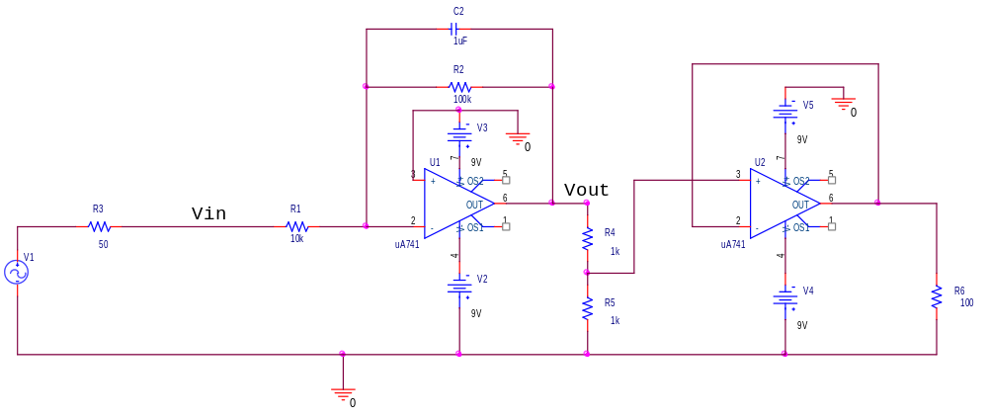
A more direct way of demonstrating that integration can be accomplished with this circuit is to replace the source with a DC source and a switch. Note that the switch is set to close at time t=0.01 sec. Use a voltage of 0.1 volts to avoid saturation problems. Do the transient analysis for times from 0 to 50ms with a step of 10us. Rather than plotting the output voltage (voltage across the load resistor), plot the negative of the output voltage. You should see that this circuit does seem to integrate reasonably well. Indicate on your plot how close it has come to doing what it is designed to do. Does it do its job for the entire simulation time? Evaluate the slope of the output signal and use this information in your discussion.
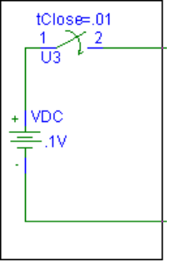
Adding this source should make your circuit look as follows:
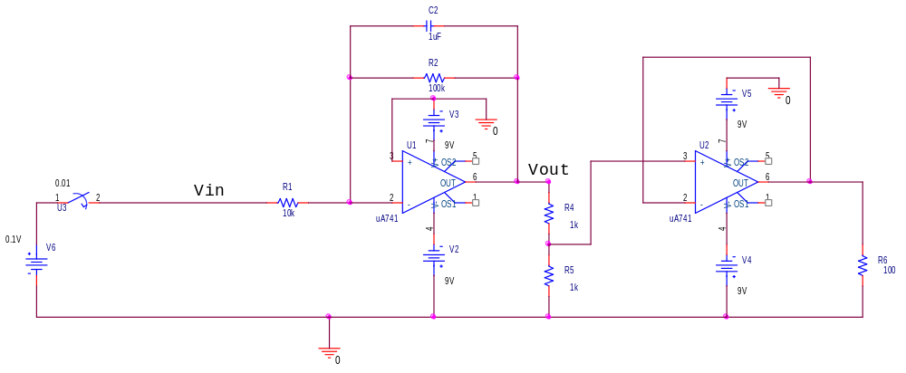

To show what our problem was before when it did not produce an output proportional to the integral, decrease C2 to its original value of 0.01uF and repeat the simulation. Decreasing the capacitance decreases the RC corner frequency. See section 3.3.2 of Gingrich for the general discussion of approximate integrators. Print your output and describe the performance of the circuit. That is, does it integrate, even approximately, for any period of time? Increase the capacitance to 10uF and plot your results. Use the information in your plot to show that it does indeed work better. Can you think of any reason why we might prefer to use the 1uF capacitor in the feedback loop, even though the circuit does not integrate quite as well?

Please note that the ideal integrator does not have a feedback resistor. We have been looking at the configuration with such a resistor because it is more practical. Set the feedback capacitor back to its value of 1uF. Remove the resistor from the feedback loop and run your transient analysis again. You should see that the circuit no longer works. Plot your results and indicate what is wrong with the output. The problem with this circuit is that there is no DC feedback. The circuit will operate on both the AC and DC inputs. There will always be a small DC offset voltage at the inputs. This voltage will be amplified by the full intrinsic gain of the op-amp and thus the output will be saturated.

Hardware Implementation Using either a 1458 or 741 op amp, set up the integrator/low pass filter circuit in the most effective configuration analyzed above. Use the sine wave from the function generator for the voltage source, set the amplitude to 0.1 V (remember to use the ‘scope to set the amplitude correctly). Obtain measurements of the input and output voltages at frequencies of 100Hz, 1kHz, and 2kHz. Add your experimental points to your PSpice plot.

Try playing around with a square wave input (vary the frequency and amplitude) to see if you can make the output look like an integrated version of the input. Describe what you did to make this happen and produce a plot showing your input and output.

Results and Discussion

- Derive the relationship between V_{out} and V_{in} for the integrator circuit, as described above.
- What are the features of the AC sweep and transient analysis of an integrator that shows it is working more-or-less correctly?
- Why is the integrator also called a low-pass filter?
- In the hardware implementation, you should have used a square-wave input to demonstrate that the integrator was working approximately correctly. If it was a perfect integrator, what would the output waveform look like? (Make a sketch of the input and output voltages.) If we had built a differentiator instead, what would the output waveform look like for the square-wave input? What would the differentiator circuit output look like for a triangular wave input. (Again, make a sketch of the input and output voltages.)
- (Extra Credit): Who was the Miller of the Miller Integrator? What else is he known for? The answer to the first question might be quite hard to find, but you might find some information on the second question.

Experiment 8
Please list the names of all group members. A TA or instructor will initial a participation box each class day you attend and participate in this experiment. When you have completed all of the experimental and simulation activities, have a TA or instructor initial under completed. They should also look over what you have done to be sure that your results are useful. If you are unable to attend class for any reason, you can make up the work during an open shop time. The maximum participation grade is 5 points.

Student Name | Participation | Participation | Participation | Completed | Date | Pts

Please answer any questions asked above under the Report and Conclusions sections. Also, attach any plots requested. On each plot, describe what is being displayed and why the results make sense. Include a hand-drawn or computer drawn circuit diagram for any PSpice output or plots of measurements indicating where and how the measurements were made. Summarize the key points of this experiment. Discuss any problems you encountered or mistakes you made and how you addressed them.

Names:

1. ____________________________

2. ____________________________

3. ____________________________

4. ____________________________

Grade: ___________ (Out of 25)

