Experiment 4
Bridges, Potentiometers, and Harmonic Oscillation

Purpose: In the following exercises, you will learn what a bridge is and how it can be used to measure small changes in resistance. You will also learn how to balance a bridge using a potentiometer. Then you will use the bridge to measure small resistances from a strain gauge mounted to an oscillating cantilever beam. You will use the oscillation frequency and your knowledge of cantilever beams to determine the material the beam is made of. Finally, we will extend the theory of oscillation to an electrical system, an oscillating circuit.

Equipment Required:

- Oscilloscope (HP 54603B 2 Channel 60 MHz Oscilloscope)
- Function Generator (HP 33120A 15 MHz Function/Arbitrary Waveform Generator)
- Instrumented Beam
- Parts Kits

Helpful links for this experiment can be found on the links page for this course: http://hibp.ecse.rpi.edu/~connor/education/EILinks.html#Exp4

Part A – Bridge Circuits

Background

Bridges and Voltage Dividers: In Experiment 1, we looked at one of the simplest useful circuits – the voltage divider. In many simple applications of electronics, we have only a small number of standard voltages in whatever circuits we are building. When we use a 9 volt battery as our source we have only one voltage level available, unless we use a voltage divider to get smaller voltages. We can also use a divider to measure resistance, if we have some device with an unknown resistance. For example, if we connect an unknown resistor in series with a known resistor, then the voltage across the unknown resistor can tell us the value of the resistance. An even better measurement can be done by combining two voltage dividers in a configuration like the one shown in the following figure. Note that if R1 = R2 = R3 = R4, the voltages at the two points marked Vleft and Vright will be equal to half of the source voltage. Thus, their difference should be zero. Whenever the voltage difference across a bridge is zero, we say that the bridge is balanced.

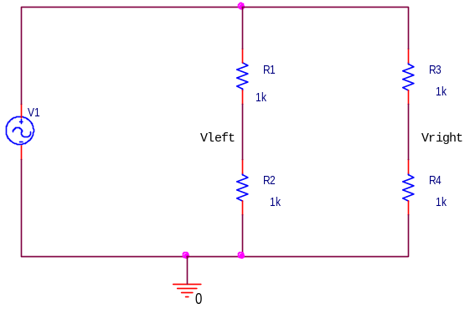

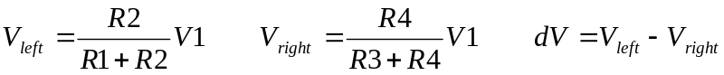

Experiment

Modeling a bridge in PSpice
In this part, we will set up a bridge in PSpice and look at the effect of a small change in one of the resistors on the difference across the bridge.

- Look at the behavior of a balanced bridge circuit.
  - Set up the circuit on the previous page as shown.
  - Use a 100mV amplitude, 1KHz frequency and no DC offset.
  - Place voltage markers at Vleft and Vright and run a transient analysis. (You have done enough transients now to be able to find a reasonable “run to time” and “step size”.)
  - Add a Trace of the difference between the two voltages. (Vleft-Vright)
  - Is the difference zero?

- Look at the behavior of an unbalanced bridge circuit.
  - Now, change R4 to be equal to 1.1k ohms.
  - Do the analysis again and add the trace of the difference between the two voltages.
  - What is the amplitude of the difference voltage as a percentage of the source voltage?
  - Print out this plot and include it with your report.

- Analyze this circuit by hand
  - Use voltage dividers to find the voltages at the two points and their difference. Make sure that your answer agrees with the PSpice simulation.
  - Assume that R1 = R2 = R3 are known resistors equal to R, and that R4 is unknown. Derive a formula for R4 in terms of R , the source voltage V1, and the voltage difference between the two divider voltages (dV=Vleft-Vright). [Hint: Substitute voltage divider expressions in for Vleft and Vright and solve for R4.]

Summary

A bridge allows you to compare two voltages. We will use it in part B to observe small voltage differences caused by very small changes in the resistance of a strain gauge.

Part B – Potentiometers and Strain Gauges

Background

Potentiometers: A very useful type of voltage divider is the potentiometer (or pot). The symbol for the pot is very descriptive of its operation.
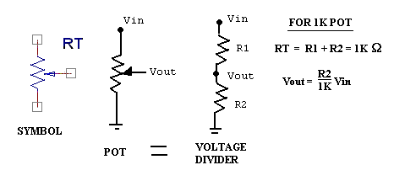
A potentiometer is a resistor that has a tap that can slide up and down to produce two variable resistors. Pots are rated just like resistors. There are 1K pots, 10K pots, etc. The naming system for pots is based on a number XYZ, where the value is XY×10^{Z} ohms. For example, a 10K pot will be marked with 103. The resistance at the top of the pot and the resistance at the bottom always add up to the rated value of the pot. The wiper (which is usually a screw of some kind) changes how much of the total is on the top and how much is on the bottom. The output voltage, Vout, can be determined using a simple voltage divider.

Strain Gauges: A strain gauge measures the displacement of a surface when it is subjected to stress. The gauge is mounted securely to a surface (usually with super glue). When the surface stretches because of an external force, a tiny difference in the distance between the wires of the strain gauge is created. This results in a small change in wire resistance. The change in resistance of the strain gauge will give a signal proportional to the displacement at the end of the beam.
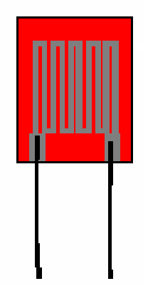

The Cantilever Beam: The beam comes with two sets of output wires. One, usually covered with black insulation, is connected to a coil located on the support plate near the moveable end of the beam. The other, usually with twisted wires, is connected to a small strain gauge cemented near the fixed end of the beam. We will only be using the strain gauge in this part. The strain gauge is relatively fragile, so its wires are usually fixed to the support plate before going to the outside world. It is still a good idea, however, to be very careful with such devices. The ones we are using are quite good (aka not cheap).

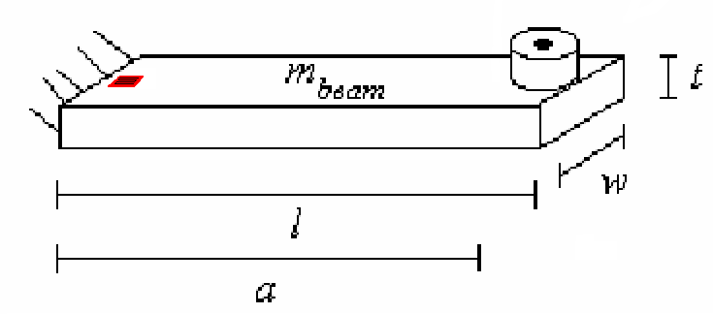

Damped Sinusoids: A damped sinusoid (shown below) is governed by the equation: v(t)=Ce-αtsin(ωt), where α is called the damping constant that determines the rate of decay. To find the damping constant, choose two points at extreme ends of the sinusoid and use the following equation and solve for α:

v1 = v0e ^{-α (t1– t 0)}

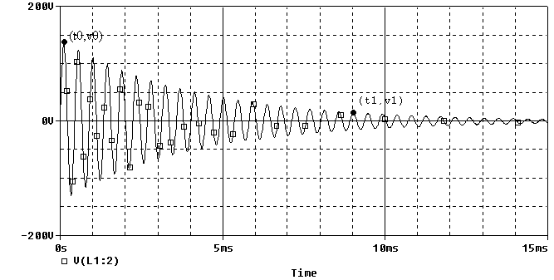

Experiment

Potentiometers
In this part, we will look at the behavior of two pots with different loads on the output voltage. Remember that the size of the load resistor can be significant in the performance of a circuit.
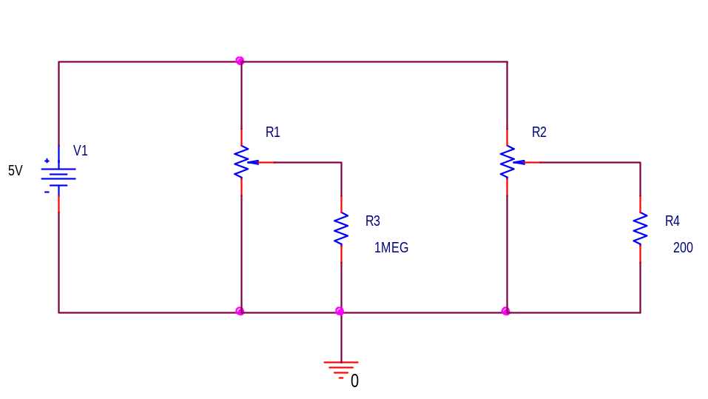

- Using PSpice, create the circuit shown.
  - The voltage source is now VDC rather than VSIN, since we only want a DC source this time.
  - The pots are called POT in the parts list and are located in the Breakout Library.
  - Since pots are variable, their values have to be set up before the analysis can be done. Unlike other parts, pots come with a complete set of default attributes. The total resistance of the pot will be 1k ohm and the tap (also called the wiper) will be set at the half way point. Connecting across the entire pot from top to bottom will give a resistance of 1k ohm. Connecting from the top to the tap will give a resistance of 500 ohms, as will a connection from the tap to the bottom. Thus, for the default conditions, we have, in effect, a 500 ohm resistor above the tap and a 500 ohm resistor below the tap.
  - Place voltage markers at Vout for both of the pots shown and at the source voltage.
  - Run a transient analysis and you will see that the voltage at the tap on the left pot is close to half of the source voltage, as it should be. (Since the source is DC, all of your traces should be straight lines.)
  - The large 1 M ohm resistor does not load down the pot voltage divider very much. However, the 200 ohm load on the right pot is much smaller than the 500 ohm resistance of the bottom half of the pot and thus this voltage divider is loaded down significantly. The voltage across the 200 ohm resistor is determined more by the 200 ohms than the 500 ohms of the bottom half of the pot.

- View the PSpice output file
  - To get additional information about the exact value of your voltages, you can look in the output file. In the OrCAD/Pspice demo window (which displays the simulated ‘scope traces), choose Output File from the View menu. The display will switch to the text file containing the output. (See the figure on the following page.)
  - Scroll down until you see a heading Initial Transient Solution. Just below that, you should see a series of node names and voltages. Each of the uniquely defined non-zero nodes should have a voltage value. In this case, there are three such nodes, one for the voltage at the top of the voltage source and one for each of the wiper voltages.
  - Once you have found these voltages, write them down.
  - Look through the rest of the file and see how PSpice describes this circuit.
  - To return to the ‘scope display, use the tab in the lower left corner of the screen.

Draw the equivalent circuit (as just regular resistors, not with pots) and then calculate the voltages you expect to see at the three points with voltage markers. Check to be sure that your answer agrees with the PSpice Output File.

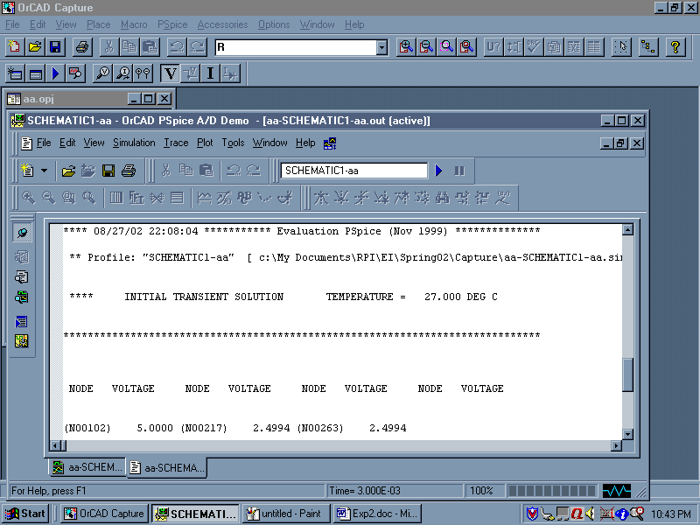

DC Sweeps and Parameters in PSpice
In this part, we will use PSpice to simulate the turning of the screw on the pot from one extreme to the other.

- Now we want to use another function of PSpice to see what happens as we vary the position of the tap. To do this, we have to set the tap position as a variable, rather than having it fixed. Use the following procedure:
- Double click on the left pot and change the value of the SET attribute to setvar. You can make the name anything you want, but this reminds us what we are doing. This makes the value of the left set point a variable we set when we set up the analysis.
- Next we have to tell PSpice that we are using some parameters. To do this, we go to the parts list and select PARAM, which we will find in a library called Special. Place this item in an uncluttered spot on your schematic.
- The PARAMETERS: “part” is a list of variables. You can now create and assign value to your variable setvar using the following procedure:
- Double click on the word PARAMETERS: to display the spreadsheet and click on New Column.
- In the Property name textbox, enter your chosen name (here use setvar).
- Enter 0.5 for the default value, since that will leave the wiper half way up in its default position and click ok.
- While this cell is still selected, click Display.
- In the Display Format window select Name and Value, then click OK.
- Click Apply to update all the changes to the PARAM part.
- Close the Parts spreadsheet.
- When you have finished, you will see the parameter and its default value listed under PARAMETERS:.
- Now your circuit should look like the figure below. When you have finished, you will see the parameter and its default value listed under Parameters.
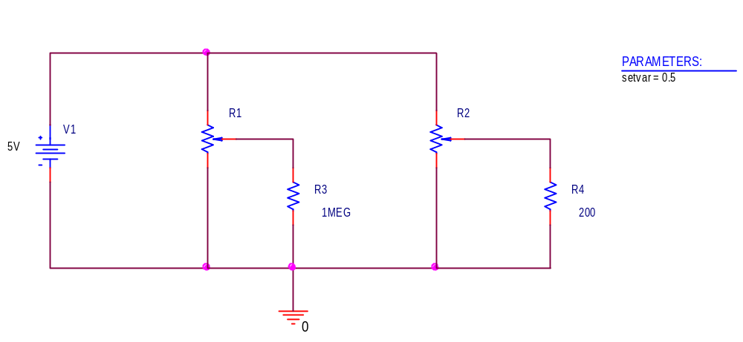

- Next we will set up the analysis (see following page).
- Create a simulation.
- Select DC sweep.
- Set up the global parameter which we have called setvar to vary linearly from 0 to 1 in steps of 0.01.

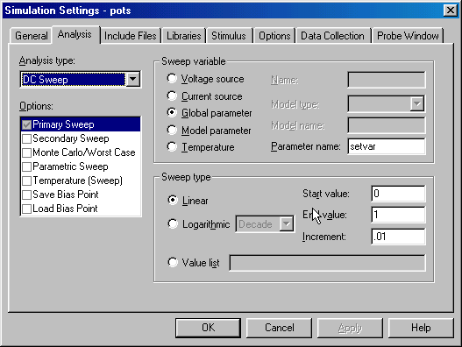

- Perform the simulation and you will see the voltages at the taps of the two pots. You should print this particular plot and then discuss why it looks the way it does. Include this in your report.

Strain Gauges
We will now combine our study of potentiometers and bridge circuits in a practical hardware application. We will create a bridge circuit and use a strain gauge mounted to a beam for one of the bridge resistors. Then we will put a strain on the beam and observe the results.

- Before you build the circuit, use the multimeter to determine the resistance of your strain gauge in its rest position.
  - Do not make this measurement when the beam is connected to the circuit. Do not over extend the beam upwards or downwards.
  - Measure the resistance of the strain gauge with the DMM when the beam is at rest.
  - Deflect the beam down until it touches the support plate and measure the resistance with the DMM.
  - Deflect the beam up an equal amount and measure the resistance with the DMM.
  - Note that the resistances you measure are proportional to how much you move the beam.
  - Write down the maximum and minimum resistance of your strain gauge. You should now see why we indicate this resistance with a variable resistor in the figure below.

- Build the circuit using the circuit diagram below.
  - Use a 1K pot (102), one 1K resistor, and the strain gauge on the beam.
  - Note that we have used a 5V DC source to supply the voltage. The oscillation this time will be created by the beam.

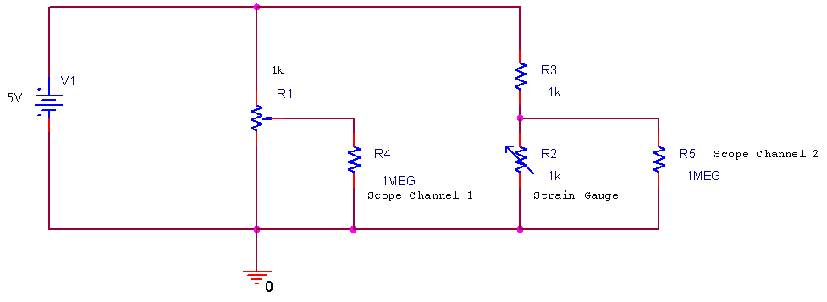

- Balance the bridge
  - Adjust the pot so that there is no voltage difference between the two channels of the scope when the beam is not deflected. The best way to monitor the difference between the two output points is to connect each point to one of the scope channels and then use the channel math button to display the difference between the two voltages.
  - It is important to balance the bridge because we want to observe only the changes in voltage created by the resistance changes of the strain gauge.

- When you have everything hooked up, set the beam into free oscillation.
  - You should observe a decaying sinusoidal voltage.
  - You will note that the AUTO SCALE feature will probably not work at this low frequency. This is one of the problems with mechanical systems. The natural frequencies of mechanical devices are usually low. You will have to learn to set your scales manually if you hope to see anything useful.
  - Once you have obtained a clear signal of a decaying sinusoid, stop the scope scan so that you can look at the signal for some time.
  - Use the Agilent software to obtain a picture of the signal.
  - Determine the frequency of oscillation, the decay constant, and the range of amplitudes of your signal.
  - Include this plot with your report. Indicate on it how you found the beam frequency and the decay constant. Note that a more accurate estimation of the frequency can be found by averaging over many cycles.

Note that there is a very good reference on strain gauges from the Vishay Measurements Group, Inc available in the links page. To apply any of the materials available there to the experiment we are doing, you need to know that the gauge factor of the strain gauge we are using is 125. (Typical for semiconductor gauges.)

Summary

A pot is a single component voltage divider. Pots are often used in bridges to make them easier to balance. A bridge which is balanced to zero at some reference location can be used to measure very small changes in resistance. In this experiment, we used one to observe the oscillation of a cantilever beam.

Part C – Instrumented Beam as a Harmonic Oscillator

Background

Coil Sensor: The sensor underneath the doughnut at the end of the beam, we call a coil. We call it this because inside is an inductor coil. The metal doughnut holds a magnet which moves relative to the coil as the beam oscillates. The magnet generates a current in the coil, and thus, a voltage (V_{L}=L×dI/dt). We can measure this voltage directly with the scope by connecting the leads of the coil to one of the channels. The signal from the coil is quite a bit larger than that from the bridge. However it is not proportional to the position of the beam, rather, it is sensitive to the beam velocity. [If the magnet does not move, no voltage is generated, and the coil signal will be zero.]

Simple Pendulums: Before we address harmonic circuits, we will review some of the properties of the simple pendulum. The instrumented beam is a very good example of a simple pendulum, even though it looks more like a small diving board. Let us assume that the end of the beam moves in the x-direction. Obviously, this is a simplification, since it really travels along the arc of a circle. When the beam is stationary, we will assume that it is horizontal and at x=0. Again, this is an approximation because the beam must bend downward slightly due to its own weight. When the beam is bent, it experiences a restoring force like a spring F = -kx, where k is the spring constant. From Newton’s Law F = ma = m dv/dt = m d²x/dt² which, when combined with the previous expression , gives us m d²x/dt² + kx = 0 the harmonic oscillator equation. In standard form, the harmonic oscillator equation is d²x/dt² + ω² x = 0 where ω is the frequency of oscillation. Thus, the beam will oscillate at ω = (k/m)^{1/2} = 2πf. The solution to this equation is x = x_{o} cos(ωt + φ_{o}), where x_{o} is the initial deflection of the beam and φ_{o} is the initial phase. For simplicity, there is no need to include φ_{o}. We have also not included any damping in this model. Thus, we get an oscillation that will go on forever, rather than decaying slowly away. (If you do not recall that this is the solution, plug the expression for x into the differential equation and you will see that it works.)

The kinetic energy of the beam is KE = (1/2) m v² while the potential energy is PE = (1/2) k x².
Upon initial deflection, the energy of the beam is W = PE = (1/2) k x_{o}². Since we have assumed no dissipation (no friction or other damping force), this total energy will be conserved and
W = (1/2) m v² + (1/2) k x² = constant. To summarize, the pendulum or any harmonic oscillator works by exchanging energy between two different forms. Not all forms of energy can be easily converted to another state and then back again, but we know this is trivial with the kinetic and potential energy of a mass.

We can start at this expression of energy conservation to determine the equations of motion of the beam or any other simple pendulum. Since the total energy is a constant, we can take the time derivative of the entire expression and set it equal to zero: dW/dt = (1/2) m 2 v dv/dt + (1/2) k 2 x dx/dt = 0. Since v = dx/dt, we can write (m dv/dt) v + (k x) v = 0 or m dv/dt = -k x which is the original equation of motion. Thus, once we have a conservation law, we can use it even to find out how things change with time.

Young’s Modulus: We can use frequency to determine the properties of an oscillating mechanical system. In this part, we will use it to determine Young’s Modulus for an oscillating beam and use this information to guess what type of material the beam is made of. We can do this using the relationship between ω and the properties of the oscillating system. We already know the relationship between force and the properties of a spring. We can solve for –k. 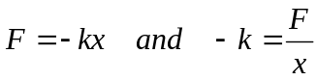 . For the oscillating beam, x corresponds to the displacement at the end of the beam. This relationship is defined by the physical properties of the beam, 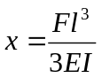, where l is the length of the beam, E is Young’s Modulus, and I is the moment of inertia of the beam. If we solve this relationship for F/x, we will have a second expression for our constant, 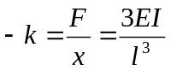. Now, we can look up the moment of inertia for an object with a rectangular cross-section and substitute it in for I.: 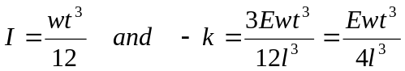.

Recalling our relationship for frequency from before and solving for k, we find: 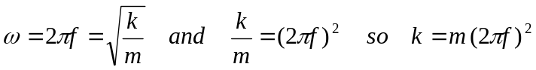. Since this is an oscillating system, we will ignore the negative sign. This gives us our final result:
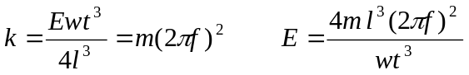

Therefore, if we can come up with a reasonable estimate for the mass of the beam and its resonant frequency, we should be able to find Young’s Modulus and use that to look up the material from which the beam is made.

The mass of the cantilever beam: Recall that the pendulum or harmonic oscillator equation holds for point masses located at the end of a massless beam. Since the beam has mass, but its center of mass is not located at the end of the beam, this term is multiplied by 0.23 to give the equivalent mass placed at the end of the beam that produces the same response. The beam also has a sensor attached to the end which adds extra mass. When we talk about “m” in this experiment we are referring to the actual mass of the beam migrated to the end. Thus m is the effective mass of the beam with no load and 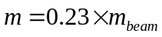.

Experiment

Frequency of a loaded beam
In the last experiment, you should have measured the oscillation frequency of the unloaded beam using the strain gauge and the bridge circuit. Since the coil and the strain gauge are subject to identical oscillations, we can use either to measure the frequency of the beam. For this experiment, we will use the coil..

- Use the coil to find the frequency of the beam
  - Hook the coil leads directly into one of the scope channels.
  - Set the beam into oscillation.
  - Produce a plot of the decaying sinusoid you observe using the Agilent-Intuilink software.
  - Record the frequency in the first row of table below
  - The mass at the end of the unloaded beam is the mass of the doughnut plus the magnet. The doughnut’s mass is 13 grams. It is glued to the beam, so you will have to take our word on that mass. The mass of the magnet is about 24 grams. These masses vary a bit. You can measure the mass of the magnet directly by removing it from the doughnut, however you MUST replace it at the same height as it was before you took it out. If you want you can use our estimation of 24 grams and then,
m₀ = 24g + 13g = 37g = 0.037 kg.

Mass of object | Mass of clamp | Mass of sensor | m_{n} = Total mass at end of beam | Frequency (Hz)
0 kg | 0 kg |  | m₀ = | f_{o} =
 |  |  | m₁ = | f₁ =
 |  |  | m₂ = | f₂ =
 |  |  | m₃ = | f₃=

- Measure the frequency three more times using additional masses of your choice.
  - Choose three objects from about 100 to about 500 grams. You should try to get a good distribution to get discernable data. The actual mass of the beam becomes less important with the heavier masses. So one mass should be heavy (around 500 grams). Don’t load the beam with a mass so heavy that it permanently bends the beam.
  - Measure the masses of the objects you have chosen with the scale in the studio. Enter them into the table.
  - Measure the mass of a c-clamp and enter that in the table.
  - The total mass at the end of the beam, m_{n}, is the sum of the object plus the clamp plus the sensor.
  - Place each mass as close to the end of the beam as possible using a c-clamp – ideally they should be located at the very end of the beam. Orient the c-clamp and mass so that their center of mass is near the end of the beam. For example, attach the c-clamp from the side rather than from the end of the beam..
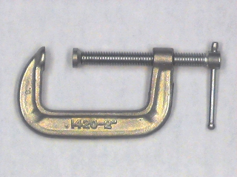
Magnet
C-Clamp
  - Find the beam frequency for each mass and record it in the table. Try to be as accurate as possible. You should check the frequency a couple of times, since you should notice that there will be a range of values for the frequency, primarily because of noise and the somewhat non-ideal nature of the sinusoidal voltage.

Analysis of beam data
In this part of the experiment, we will analyze the frequency data to determine the mass of the beam, Young’s Modulus for the beam, and, finally, the material out of which the beam is made.

- Find 4 equations in 2 unknowns
  - We know that our system is governed by the relationship between the oscillation frequency and the properties of a spring.
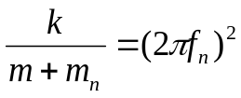 n=0,1,2,3

- We can write out a k expression for each of the four frequencies you have measured:
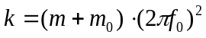
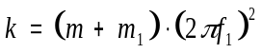
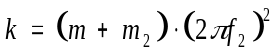
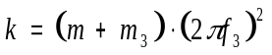

- Use these numbers to determine the values of k, and m.
  - Note that you are making four measurements to determine two constants. This means that you have some redundancy built in and also that you will not obtain perfect agreement for all four equations. None of your measurements will be perfect, so it is best to have some more measurements than constants to determine to average out measurement error. You need to find the values of k and m that come the closest to satisfying all four equations.
  - We are going to use Excel to plot the frequency of our system in relation to the mass added to the end. First we must solve for f_{n} . Note that in the equation below, m_{n} is the x variable and f_{n} is the y variable.
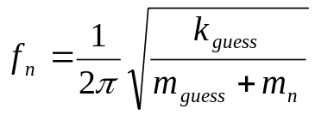

  - We need to determine a good guess for k (the spring constant) and m (the effective mass of the beam) in order to plot this equation. Use the data from only two of your masses and solve two equations in two unknowns to determine a guess for k and m. (If you get a negative mass, try using your smallest and largest mass to do the calculation.) Keep in mind that these are just guesses, so you don’t need to get carried away solving all combinations of all the equations. You could use some type of statistical analysis instead to get your guesses for k and m. For example, you could determine the standard deviation of the four expressions for k for a range of realistic values for the effective beam mass.
  - Now you can plot the equation in Excel. Use k_{guess} and m_{guess} you just calculated. Choose values for m_{n} between 0 and 600 grams. You are plotting a general function and matching your data to it. m_{n} is the domain of your function, you just need a set of x (m_{n}) values so you can calculate y (f_{n}). Have Excel calculate values for f_{n} for each m_{n} and plot the results.
  - Place your four data points on the plot. How well do these points fit the curve you generated? If your guesses are exactly perfect, they will lie right on the curve. Since they are only guesses, there is probably room for improvement.
  - Now it is time to adjust k_{guess} and m_{guess} to get the curve to match your data as closely as possible. Adjusting one will move the plot up and down. Adjusting the other will cause the curvature to change. Play with the numbers until the curve matches your 4 data points as closely as possible. When you are doing this, keep in mind that the location where the graph crosses the y axis represents the unloaded frequency of the beam. The function goes up very quickly near zero mass. What is a reasonable estimate for the unloaded beam frequency? Include the final plot with the general curve and the four data points marked in your report.
  - Use the values of k_{guess} and m_{guess} that give you the closest match in your final calculations for the beam mass and Young’s Modulus.

- Final results
  - Calculate the mass of the beam using your best guess for m .
  - CAREFULLY measure the dimensions of your beam. A small inaccuracy in your measurements can lead to a large discrepancy in your results.
  - Extrapolate the frequency for the beam (with no load at all on the end) from your plot. This is the point at which mass at the end of the beam is 0 kg.
  - Calculate Young’s Modulus using your best estimate for k.
  - Look up Young’s Modulus in the table of your choice and find some possible materials for your beam. (There may be more than one possibility.)

Summary
In this part of the experiment, you used the oscillation frequency and other physical properties of a cantilever beam to find information about the beam that you could not measure. You also learned how to use curve fitting to find a solution when there are more equations than unknowns.

Part D – Oscillating Circuits

Background

Energy storage in inductors and capacitors: In passive electrical systems, there are three kinds of circuit elements: resistors, capacitors and inductors. Resistors turn electrical energy into heat. When a current I flows through a resistor, there will be a voltage drop V across the resistor. The power dissipated by the resistor is equal to the product of I times V. Since resistors produce heat, it should be no surprise that they play the same role as friction in a mechanical system. The ideal pendulum will oscillate forever … a real pendulum will oscillate until all its stored energy is converted to heat through friction. Thus, if we wish to create a circuit analogous to the ideal harmonic oscillator, it can have no resistors in it. Rather, we will combine only inductors and capacitors.

A typical inductor consists of a coil of wire. If we pass a current through the coil, a magnetic field will be created. Many of us have made simple electromagnets at some time in our lives by wrapping wire around some magnetic material like a nail. When a battery is connected to the wire, it is possible to attract small pieces of iron to the nail. The field created by the coil, the magnetic field, can do work and thus contains energy. The energy stored in an inductor is given by the expression
W_{M} = (1/2) L I²

where we have used the subscript M to indicate that the energy is stored in the magnetic field and L is the inductance in units of Henries. Joseph Henry was honored by using his name for this unit because of his early work in developing practical electromagnets. He began his work here in New York’s capital district when he was teaching at the Albany Academy. There is a statue of this great scientist outside the original location of the Academy across the street from the Albany City Hall. Henry was a contemporary of Amos Eaton, the intellectual force behind the founding of RPI. He eventually left Albany for Princeton and the Smithsonian.

A typical capacitor consists of two metal plates of large area separated by some insulating material such as teflon or some other plastic. When a voltage source is connected to the plates, charge flows from the source to the plates with positive charge deposited on the plate with the highest voltage and negative charge deposited on the plate with the lowest voltage. Since these charges are opposite in sign and since unlike charges attract one another, there is a force between the two plates. Again, the existence of this force tells us that we have to do work to charge up the plates and that there is energy stored. In this case, the energy is stored in the electric field created by the charges. The energy stored by a capacitor is given by the expression

W_{E} = (1/2) C V²

where we have used the subscript E to indicate that the energy is stored in the electric field and C is the capacitance in units of Farads. Michael Faraday also worked on electromagnets and, being British, gained much more fame for his work, since America was a scientific backwater at the time. Henry showed him how to make better magnets, but Faraday’s work was much more far reaching. Henry also showed Morse how to build a telegraph!

Aside: It is somewhat interesting to note that neither Henries nor Farads turns out to be much of a common practical unit. One Henry is a huge inductor, rarely seen in practice. One Farad is also rare, now occasionally seen in highly filtered power supplies for computers. We will need to use the prefixes milli-, micro-, nano-, pico-, etc. a lot when dealing with these components. We also do not see one Ohm all that much, but require the other kind of prefixes (kilo-, mega-, etc.).

Conservation of Energy in a Harmonic Circuit: There are many important lessons we can learn from the harmonic oscillator, but perhaps one of the most useful is the value of conservation laws. It is fair to say that the most powerful problem solving technique is to first decide which conservation laws hold. Once the conservation laws are identified, they can be used to determine a great deal of information about any system.

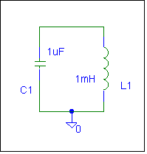

Consider the simplest possible configuration of a single capacitor and a single inductor connected as shown below. Note that, since there are only two components, one can describe this connection as either in parallel or in series. Also assume that the capacitor has been charged up to some voltage V at time t = 0, at which time it is connected to the inductor. The charge will begin to flow creating a current through the inductor. After a short time, all the charge that was originally on the capacitor plates will be gone and the current through the inductor will reach its maximum value. Thus, we began with all the energy stored in the capacitor and none in the inductor and end with the opposite condition. The current flowing through the inductor will then charge the capacitor back up and the process will begin again. The energy is traded back and forth between the two storage elements. There is an excellent applet on the links page which illustrates this principle.

The total energy of the system must remain constant because there is no dissipative element (no resistor). The total energy is given by W = (1/2) C V² + (1/2) L I² = constant. Since this is a constant, we can take the time derivative of this expression and set it equal to zero.
dW/dt = (1/2) C 2 V dV/dt + (1/2) L 2 I dI/dt = 0 or (L dI/dt) I + (C dV/dt) V = 0 which we can separate into L dI_{L}/dt = V_{L} and C dV_{C}/dt = I_{C.} Recall that these are the basic equations that govern the behavior of these two devices. If we note that V = -V_{C} = V_{L} and I = I_{C} = I_{L}. V is the voltage at the top of the circuit and I is the current flowing around the circuit. The convention for circuit elements is that the current flows into the end with the highest voltage and thus we have to reverse the capacitor voltage to get the correct expression for V and I.

We can combine the two current-voltage relationships for the capacitor and inductor of our simple circuit to obtain
d/dt (C dV_{C}/dt) = d/dt I_{C} = dI_{L}/dt = V_{L}/L = -V_{C}/L . Thus the final equation for an ideal harmonic oscillating circuit is given by:
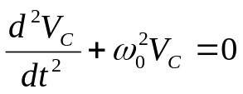
This is the general form of the harmonic oscillator equation. The frequency can be trivially determined since the form is the same as we saw with the pendulum. Thus,
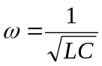

This is the resonant frequency of our oscillating circuit. Also recall that this is the equation for the resonant frequency of any simple RLC circuit.

Damped Oscillation: The circuit we modeled above is unrealistic because it has no resistance at all. This is analogous to a mechanical system with no friction. To make a more realistic system, we must add some resistance. The circuit will still oscillate, however, the oscillation energy will gradually dissipate because of the resistance. The output signal will be similar to the oscillation behavior of the beam -- a damped sinusoid.. Note that this circuit has no voltage source. It needs to have an initial amount of energy placed into it. This is similar to the initial displacement you place on the beam to make it oscillate.

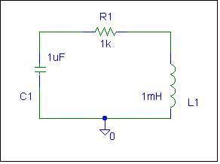

The damped circuit has the following oscillation equation
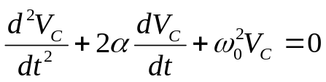
where α is the damping constant. It can be shown that in an ideal damped oscillation circuit, α is given by the following equation below:
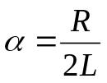

Experiment

Modeling a damped oscillator
We will now consider an RLC circuit, with all three kinds of passive components and observe the damped oscillations.
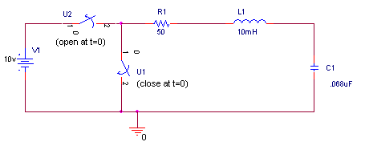
- Create the oscillating circuit above in PSpice
  - In order to place some initial energy into the circuit, we use two switches. Before time t=0, switch U2 is closed and switch U1 is open. This places an initial charge on the capacitor. Now the capacitor has enough energy stored in it to start the oscillation. At time t=0, we disconnect the voltage source from the circuit and let it oscillate on its own. (Just like you release the beam and watch it vibrate until it stops.)
  - The switches are in the EVAL library (Sw_tClose will close at a specified time period after t=0 and Sw_tOpen will open at a specified time period after t=0).
  - Place voltage markers on the circuit between R1 and L1 and between L1 and C1.
  - Use PSpice to simulate the transient response of this circuit for a total time of 1ms.
  - Print out your results and include them in your report.
  - What features of the voltages reminds you of the instrumented beam?
  - Use the transient plot to find the oscillation frequency of your circuit. How does it compare it to the calculated value of f = 1/[2π√(LC)] ?
  - Use the plot to determine the damping constant of the circuit. In a simple RLC circuit, such as this one, the damping constant can also be found mathematically using the expression α=R/(2L). Calculate the damping constant and compare it to the one you found using the plot.

Summary

In this part of the experiment, you have related your knowledge of oscillating mechanical systems to an oscillating electrical system and created an oscillating circuit.

Report and Conclusions

The following should be included in your report. Everything should be labeled and easy to find. Partial credit will be deducted for poor labeling or unclear presentation.

Part A

Include the following plots:
- PSpice voltage divider plot with R4 = 1.1K ohms (1 pt)

Answer the following questions:
- What is the value of the difference voltage as a fraction of the input voltage for the case where one of the 1k resistors is replaced with a 1.1k resistor? Show that you get the same answer when you analyze the circuit by hand, applying the appropriate formulas to do the analysis. (3 pt)
- Assuming that R1 = R2 = R3 are known resistors equal to R, and that R4 is unknown, DERIVE a formula for R4 in terms of R , the source voltage V1, and the voltage difference between the two divider voltages
(dV = Vleft-Vright). (3 pt)

Part B

Include the following plots:
- PSpice setvar sweep plot (1 pt)
- Agilent plot of beam oscillation with calculations of beam frequency and damping constant on it. (3 pt)

Answer the following questions:
- What is the resonant frequency of the beam? What value did you find for the damping constant? Write an equation for the decaying sinusoid output of the beam in the form v(t)=Ce-αtsin(ωt). (2 pt)
- What is the resistance of your strain gauge when the beam is in its undeflected position? … when it is deflected fully downward? … when it is deflected upward? (2 pt)
- Why must resistance measurements be made while components are not connected to the circuit? (2 pt)
- Draw the equivalent circuit of the unbalanced bridge circuit. (Use two resistors for each pot.). Calculate the voltages you expect to see at the two wipers. (Assume the pots have a set value of 0.5) Check to be sure that your answer agrees with the PSpice Output File.(2 pt)

Part C
Include following plots:
- Agilent plot of the decaying sinusoid obtained with the coil for the beam with only the sensor
on the end. (1 pt)
- Excel plot of frequency vs. load mass with four points marked (3 pt)

Answer following questions:
- Include a copy of the table of your mass and frequency data. (2 pt)
- Explain how you did your analysis to determine a reasonable first guess for k and m. (2 pt)
- What are the values for k and m that you obtained by making the plot in Excel? Do your results seem plausible? Why? (2 pt)
- Calculate the mass of the beam. (1 pt)
- Estimate the frequency of the beam with a 0 kg load (not even the sensor). Explain how you did this. (2 pt)
- Calculate Young’s Modulus for the beam. Clearly indicate the values you measured for the beam’s dimensions. (2 pt)
- What do you conclude the beam could be made of? Why? (2 pt)

Part D
Include following plots:
- PSpice plot of output from oscillating circuit. (1 pt)

Answer following questions:
- Determine the resonant frequency and damping constant of the circuit you analyzed using the PSpice output plot 1. Write an equation for the output in the form v(t)=Ce-αtsin(ωt). (3 pt)
- What value did you calculate for f using the equation for the resonant frequency? How close of an estimate is this to the resonance you found in the plot? (1 pt)
- What value did you calculate for α using the equation? How close of an estimate is this to the damping constant you found in the plot? (1 pt)

Summarize key points (1 pt)

Discuss mistakes and problems (1 pt)

List member responsibilities (1 pt)

Total: 45 points for report

Attendance: 3 classes (5 points) 2 classes (3 points) 1 class (0 points) out of 5 possible points
No attendance at all = No grade for experiment.

