Experiment 7
Digital Logic Devices and the 555 Timer

Purpose: In this experiment we address the concepts of digital electronics and look at the 555 timer, a device that uses digital devices and other electronic switching elements to generate pulses.
Equipment Required:

- HP 34401A Digital Multimeter
- HP 33120A 15 MHz Function / Arbitrary Waveform Generator
- HP E3631A Power Supply
- HP 54603B 2 Channel 60 MHz Oscilloscope

Helpful links for this experiment can be found on the links page for this course: http://hibp.ecse.rpi.edu/~connor/education/EILinks.html#Exp7

Part A – Basic Logic Gates

Background

Digital logic gates: All digital logic gates are based on binary logic. Binary logic has two values, called TRUE and FALSE or LOGIC 1 and LOGIC 0 or ON and OFF or HIGH and LOW. The corresponding binary number can have two possible values, 1 and 0. Digital logic gates perform many common logic operations on binary signals, such as AND, OR, NOT, NAND, and NOR. The table below contains the common symbol for each type of gate, an expression for the function of the gate in Boolean algebra, and a truth table for the device. The truth table shows how the gate will behave for all possible combinations of digital inputs.
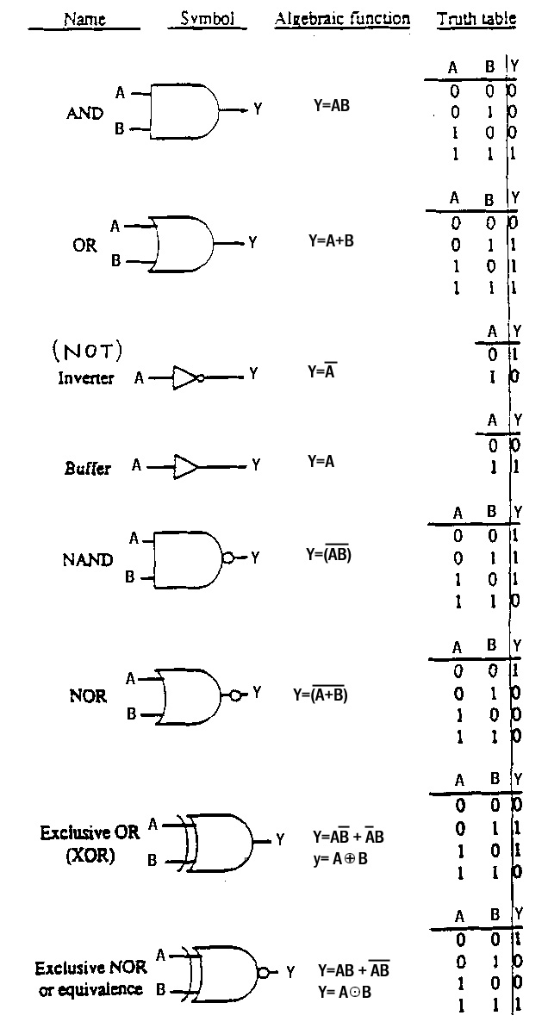

Digital logic chips: In TTL digital electronic circuits, the representation of binary numbers in terms of voltages is about 5 volts for LOGIC 1 and about 0 volts for LOGIC 0. About 5 volts usually means a voltage between 2 and 5 volts while about 0 volts means any voltage in the range 0 to 0.8 volts. The voltage levels when using TTL devices must always be in the ranges indicated, or the circuits will not functions correctly. LOGIC 1 and LOGIC 0 are the only output levels one should see with logical devices. This is one characteristic that makes them differ from analog devices. They also switch very fast from one state to the other. Switching speeds are usually much faster than for analog devices, especially cheap devices like the 741 op amp.

A digital chip generally has 14 or 16 pins. It usually contains more than one of the same logic gate. (For example, a 14 pin chip will have six single-input gates or four 2-input gates.) By convention, the upper right pin on a digital chip is always connected to HIGH (+5 volts) and the bottom left pin to LOW (0 volts). On a 14 pin chip this corresponds to pin 7 (0V) and pin 14 (5V) and on a 16 pin chip, pin 8 (0V) and pin 16 (5V). These two connections provide reference values for the operations the chips perform. Generally circuit diagrams do not show these two reference connections. If you forget to connect these two pins, your circuit will not function correctly.

Timing diagrams: Timing diagrams are a special kind of transient output which is useful for viewing many binary signals. Since the voltage levels of binary signals can only be either high or low, knowing the exact voltage level is not as significant as knowing when the different signals transition from high to low (or low to high). A timing diagram is much easier to read when you need to compare many binary signals. Unlike a regular PSpice plot (where all signals are displayed with the same voltage and time axis) a timing diagram displays the signals on separate lines with the same time scale. A sample is shown below:

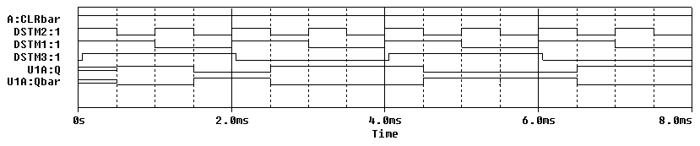
Note that there are six signals shown on this plot. We can see where they are high and low and we can also see the relative time that each signal changes state.

Experiment

Truth Tables of Basic Logic Gates
We will now consider three basic logical elements: a two input NOR gate, a three input NAND gate and an INVERTER.

- Wire the circuits below on your protoboard. Do not forget to tie pin 14 to 5V and pin 7 to 0V on each chip. (Also note that the 74107 chip and the 7410 chip in your kit are not the same chip. Here we want the 7410.)
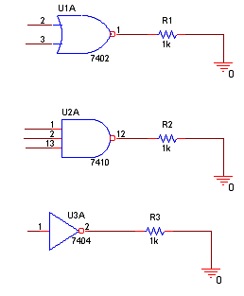

- Consider all possible combinations of inputs to generate a truth table for each device.
  - The NOT gate has only one input. Therefore, we need only need to observe the output when the input is HIGH (5 volts) and LOW (0 volts).
    - First connect pin 1 to +5 volts and record the output voltage at pin 2.
    - Then, connect pin 1 to 0 volts and record the output at pin 2.
    - Does the gate invert the input?
    - Take a picture of one of the input/output trace combinations.
    - Draw a truth table for this gate on the output plot. Include this plot in your report.
  - Now you will repeat this process for the other two gates.
    - The NOR gate has two inputs, so we must observe the output at pin 1 for all possible combinations of binary inputs at pins 2 and 3: (LOW, LOW), (LOW, HIGH), (HIGH, LOW) and (HIGH, HIGH).
    - Print a sample input and output trace. (Note: You will only be able to show one input on the ‘scope.) Record the truth table on the plot. Include this plot in your report.
    - The NAND gate has three inputs. How many combinations of HIGH and LOW are required to fully test this gate?
    - Record the input and output for this gate in a truth table on a sample output plot, as well. Include this plot in your report.

Simulation of Basic Logic Gates
We will now wire the same three basic logical elements using PSpice.

- Create the following circuit in PSpice.
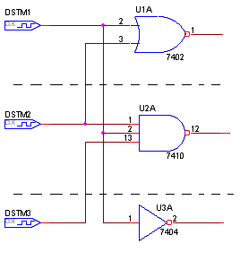
  - Wiring the circuit in PSpice is somewhat different than on the protoboard.
    - PSpice assumes that the +5 volt and 0 volt references have already been wired, so you do not need to make these connections.
    - We cannot simply move the wires to record all possibilities. Therefore, we use digital clocks with different pulse lengths to create the signals we need to test the gates.
    - We have removed the resistors connecting the gate outputs to ground. This tells PSpice to output timing diagrams by default.
  - Now we need to set the clocks up to work with different pulse lengths.
    - Use DigClock in the SOURCE library
    - Use the default settings for DSTM1 (no delay, on time = 0.5us, off time = 0.5us).
    - For DSTM2, double the on and off times to 1us.
    - For DSTM3, double them again to 2us.
- Run a simulation
  - Simulate for 8us with a step size of 0.01us.
  - Display all the inputs from the clocks and the output of each of the three gates.
  - Produce a hardcopy of the timing diagram with the inputs and the outputs for all three gates.
    - Mark the output trace for each gate on the diagram. For each gate, generate the truth table for the device based on the outputs and inputs you observe on the timing diagram. Write them on the output plot.
    - Include this plot in your report.
    - Do your results agree with the truth tables you found using from the circuits you built?

Summary

Basic logic gates allow you to use electronic signals to perform operations on digital signals. They can also be combined to perform more complex operations, such as addition and subtraction. This makes them a basic building block of digital computers.

Part B – Flip Flops

Background

Flip Flops: It is possible using basic logic gates to build a circuit that remembers its present condition. These circuits are called flip flops. There are several different kinds of flip flops with slightly different characteristics. In this course we use the JK flip flop. JK flip flops, like other flip flops have four inputs, two outputs and the usual two power connections (V_{CC} and ground). The outputs are labeled  and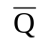(also called Qbar and NQ). They are complements of one another. Thus, when Q is LOW, Qbar is HIGH, etc. CLK is the digital clock. A flip flop only changes its output when the clock pulse at CLK goes from HIGH (5V) to LOW (0V). This is called the “falling edge” of the clock. The input 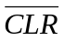, when LOW, will reset the outputs to a known state. It has the following truth table:
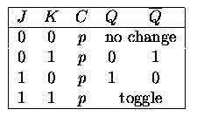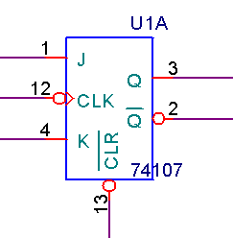

Note that the flip flop is an edge-triggered device. This means that instead of changing state as soon as its inputs change, it “waits” until it receives a falling edge at the clock input (CLK). To decide how to set the output, the flip flop “looks” at the values at the inputs at J and K AND at the current value of the output. Based on these three values, it decides how to reset the output.

You may be familiar with clocks. They are used to coordinate the instructions performed by the CPU and other devices in a computer. When a computer has a clock speed of 1 Giga Hertz. It can handle 1×10⁹ instructions per second. One for every clock cycle. The flip flop works on the same principal. With every clock cycle, it looks at its inputs and changes state accordingly.

The flip flop is a memory device. If both inputs are zero, its output will remain the same indefinitely. A
bank of 4 flip flops can store a digital byte of memory in a computer. If you want to change the value of a single bit of that byte to zero, you can set the inputs to the corresponding flip flop to J=0 and K=1. On the next clock cycle, the output will change to zero. If you want to change a single bit of the byte to one, you can set the inputs of the corresponding flip flop to J=1 and K=0. On the next clock cycle, the output will change to 1. You can also toggle the value of the flip flop output by setting both inputs to 1.

Timing diagram for a flip flop: To illustrate the behavior of a JK flip flop, we wired the following circuit in PSpice and created a timing diagram.

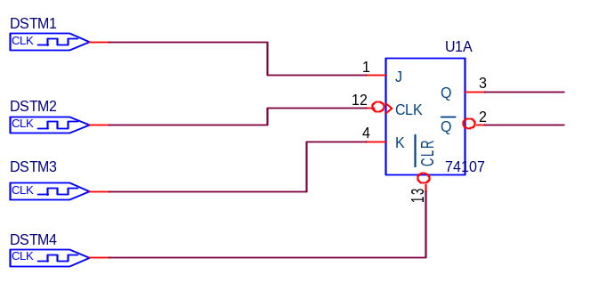

DSTM2 is the clock. Each time the clock falls, look at the values of the inputs at J (DSTM1), K (DSTM3), and the output signal (U1A:Q). If the truth table is correct, what should the output value at U1A:Q be for each combination? Is the timing diagram correct? Please check the datasheet for the SN74107 flip flop located on the course web page for details about this device.

Noise and Digital Circuits: Any time you build a circuit, there will be noise. In an edge-triggered device, where timing is a factor, noise can cause many problems. A noise spike might be interpreted as the falling edge of the clock. If this happens, the flip flop will change state at the wrong time and possibly with the wrong inputs. To avoid this problem, it is essential to use a bypass capacitor in every timed digital circuit you build. A bypass capacitor is simply a capacitor placed between the source voltage and ground. What it does is filter out high frequency noise, so that any spikes that might be misinterpreted are filtered out. Below is a picture of a bypass capacitor:
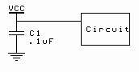
To understand how the bypass capacitor works, we only need to recall that a capacitor looks like an open circuit at low frequencies and a short at high frequencies. Digital signals consist of two DC values, 0V and 5V. A DC voltage has zero frequency. Therefore the bypass capacitor will look like an open circuit and all of the DC signal will pass into the circuit. A noise spike is a very sudden high frequency event. At high frequencies, the capacitor looks like a short. Therefore, the high frequency event will pass through the capacitor to ground and not continue on to the circuit.

When a signal changes from low to high (or high to low), the temporary noise of the transition may cause the device to make the wrong output decision. Since the values of the inputs as they are changing is indeterminate, the output that a flip flop will generate if the inputs are changing is unknown. In PSpice, this unknown state is depicted by a double red line. If you look at the timing diagram above you will see that both Q and Qbar start out in an unknown state until the first falling edge of the clock. Also notice that the transitions for J and K take place well before the falling edge of the clock. We deliberately set up the timing of DSTM1 and DSTM3 so that they do not change the state of the input at the same time the clock transitions from high to low. If we had, PSpice would continue to display the double red line, signifying that it cannot properly set the output because it isn’t sure what the inputs are supposed to be.
Experiment

The JK Flip Flop
In this part of the experiment, we will look at the behavior of a flip flop on your protoboard.

- Set up the 74107 JK flip flop on the protoboard.
  - Provide 0V at pin 7 of the chip and +5V to pin 14.
  - Place a 0.1uF by-pass capacitor between 0 and 5V.
  - Use the function generator for the clock (DSTM2). Set it for a square wave frequency of 1kHz. Use the offset feature to shift the square wave up such that it cycles between 0V and 5V. Be sure that you use the ‘scope to check the operation of the function generator.
  - Set the CLR to zero to be sure that the FLIP FLOP begins in a known state. THEN attach it to +5V to enable the function of the chip.
  - Use the ground (0V) and +5V connections on your protoboard to supply all possible combinations of logic levels for J and K. Connect J and K manually in the same manner as you did for the logic gates. Since the flip flop also looks at the output, you will have to take that into consideration, as well.
  - Observe the output Q on channel 2 of your scope and the clock on channel 1.
  - Construct an experimental truth table for this device.
  - Print a single trace, as in the previous part, draw the truth table for the flip flop on it, indicate which combination of inputs and initial state the plot represents, and demonstrate that the output is correct. Include this plot in your report.

Summary

The JK flip flop is an edge-triggered device that uses an external clock to coordinate state changes with other clocked devices in a circuit. It is capable of holding its output stable, changing its output directly to high or low, or toggling the output to the opposite of its current value. It can be used as a memory device or as a building block to create more complex devices, such as counters.

Part C – Counters

Background

Binary Counters: JK flip flops can be connected in a counter configuration as shown below:

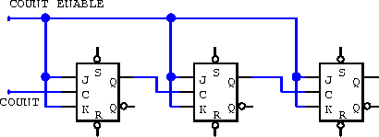
The output of each flip flop is used as the input clock to the next flip flop. On all flip flops, J and K are tied high. This means that they will toggle on each pulse of their clocks. The first flip flop toggles every clock cycle. The second flip flop toggles every time the output from the first flip flop changes. This causes it to toggle at a rate equal to half of the clock rate. By the same reasoning, the third flip flop toggles at a rate ¼ of the clock rate. If we attach a bit of a binary number, (b0,b1,b2), to the output of each flip flop (b0 to the first, b1 to the second, and b2 to the last). We get a pattern out which corresponds to the binary counting shown in the figure below:

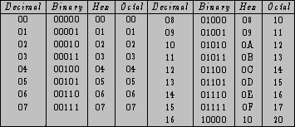

The lowest order bit of the binary numbers toggles from 0 to 1: (0-1-0-1-0-1….). The second order bit also toggles between 1 and 0, but at half the rate: (0-0-1-1-0-0-1-1-….). The third order bit toggles also, but at half the rate of the previous bit: (0-0-0-0-1-1-1-1-0-0-….). The pattern in the table is the same as the pattern created by the cascaded set of flip flops. Thus, the counter is counting.

It is not necessary for us to configure several flip flops to create a counting circuit, because this is already done in many kinds of chips. The SN74393, for example, has two sets of four JK flip flops connected as binary counters.

Light Emitting Diodes: LEDs (light emitting diodes) are very useful when dealing with digital circuits. Because they have two states, ON and OFF, you can hook them to a binary signal, and use them directly to observe whether or not the signal is HIGH or LOW. Although there are conventions for the polarity of diodes, many manufacturers do not seem to follow them. The best way to determine the polarity of a diode is to place it directly between +5V and ground. If it lights, use it in that direction. If it doesn’t light, try switching the polarity. If it lights that way, then use that polarity. If it lights in neither polarity, throw it away. It is burnt out.

LED’s are like light bulbs. They burn out after a while. In order to prolong the life (and brightness) of an LED, it is a good idea to wire it in series with a small resistor (330 ohms is about right). If the LED is not bright enough, you can replace the resistor with a smaller one.

Experiment

Simulation of a cascaded binary counter
In this part of the experiment, we will use PSpice to create a simulation of a two counters cascaded together. This will allow us to count to numbers greater than 15.

- Simulate the following circuit in PSpice
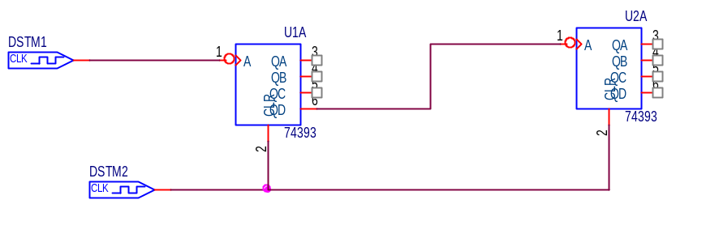

  - DSTM1 is a normal clock with OFFTIME = ONTIME= 0.5us.
  - DSTM2 is set up so that it first clears the counters, lets them count, and then clears them again. (OFFTIME=25us, ONTIME=2us)
  - If the PSpice models for counters or flip flops are not cleared initially, they will not give any data.
  - By connecting the two counters together as shown, the sequence of numbers 2QD, 2QC, 2QB, 2QA, 1QD, 1QC, 1QB, 1QA (IN THAT ORDER) form the binary number. Since the counter is set up to count clock pulses, it will count up from 0 (at reset) to the number of pulses sequentially.

- Run the simulation
  - Generate the output for this circuit for time 0 to 30us using 1us increments.
  - You should display the reset pulse, the input clock at pin 1 of U1A, and all eight of the counter outputs (QA,QB,QC,QD for both counters).
  - Using the timing diagram, verify that the counters are actually counting. You can use the cursor to easily get your binary number.
  - What is the highest number it counts to before it resets? At what time does it reset? Express this number both as a binary number and a decimal number.
  - Write it on the timing diagram for the circuit. How many pulses will the clock have to cycle through between the time it is reset and when it hits its maximum value of 11111111?
  - Include the timing diagram output in your report.

Build a counter circuit
In this part of the experiment, we will build a counter circuit on the protoboard.

- Build the following circuit on your protoboard.

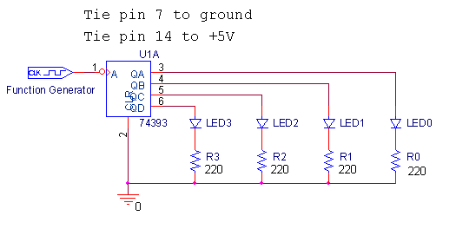
  - Use the function generator for the clock. Set it for a square wave with a frequency of 10Hz. We are using a fairly low frequency so that we will be able to see the switching with the LEDs. Use the offset feature to shift the square wave up such that it cycles between 0V and 5V. Be sure that you use the ‘scope to check the operation of the function generator.
  - Tie pin 7 to ground and pin 14 to 5V.
  - Place a 0.1uF by-pass capacitor between +5 and ground.
  - Check your LED’s by placing them between +5V and ground to see which polarity causes them to light. Place them in the correct polarity in the circuit.
  - If you cannot find 220 ohm resistors, use ones close to 220 ohms. If your LEDs are not bright enough, you can replace the resistor by a wire.
  - Set the CLR to +5V to be sure that the counter begins counting at zero. THEN attach it to 0V to enable the chip to function. Note that this is the opposite of the flip flop. The circle at the input to the clear tells you whether the CLR signal must be high or low. (Circle→Hold high for function. No Circle—> Hold low for function. If you tie this pin incorrectly, the chip will continuously reset itself and it will not work.

- Once you have the circuit working, observe the output.
  - Your counter will count very fast, but this will allow you to work with it more effectively on the scope. You may not be able to see the lower order bits flashing clearly, but you will be able to see the higher order bits change. If you want it to count slower, reduce the input frequency.
  - Are they changing at the expected rates?
  - Place channel 1 of the scope on the clock signal and set the time controls so that it displays 50 clock cycles. Do not change the time scale as you take your pictures. All four should show 50 clock cycles for comparison purposes.
  - You will need to take four pictures using the Agilent software. Include them in your report.
    - Channel 1 = clock and Channel 2 = QA
    - Channel 1 = clock and Channel 2 = QB
    - Channel 1 = clock and Channel 2 = QC
    - Channel 1 = clock and Channel 2 = QD
  - What do you observe about the rates of the different signals with respect to the clock? Can you tell which output corresponds to which bit in the binary number?
  - Keep this circuit for part D.

Part D – The 555 Timer

Background

The 555-Timer: The 555-timer is a chip that allows us to create a variety of useful digital and analog signals. Much like the op-amp, it can be used to perform different functions depending upon what circuit you place it into. The 555-timer can be used to generate digital pulses. When it is wired as a “one-shot” (also called mono-stable mode), it generates a single, clean, digital pulse at the output, when it experiences a (possibly noisy) pulse at the input. This is useful when de-bouncing a mechanical switch. In this experiment, we are concerned with the 555-timer when it is wired in astable mode. This is also called an astable multivibrator. In this mode, the 555-timer circuit creates a stream of regular pulses. The wiring diagram for the 555-timer in astable mode is shown below:

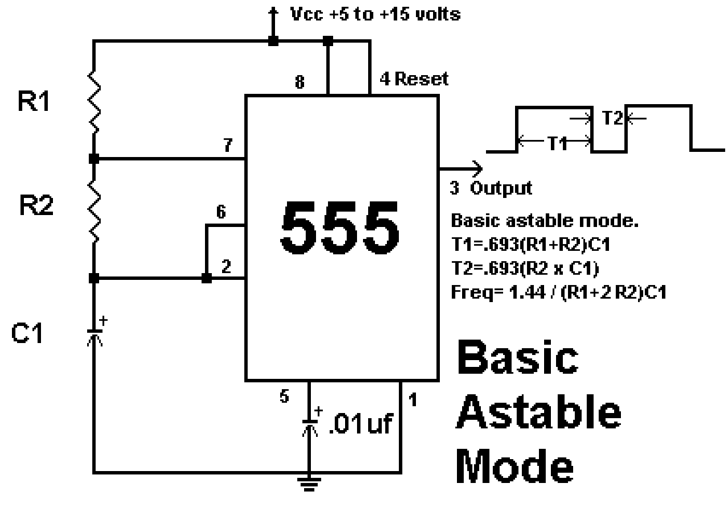

Inside the 555-Timer: In order to understand how the 555-timer can create this regular stream of pulses, we need to look inside and see how it functions. The inside of the device contains many of the components we have studied in experiments 6 and 7.
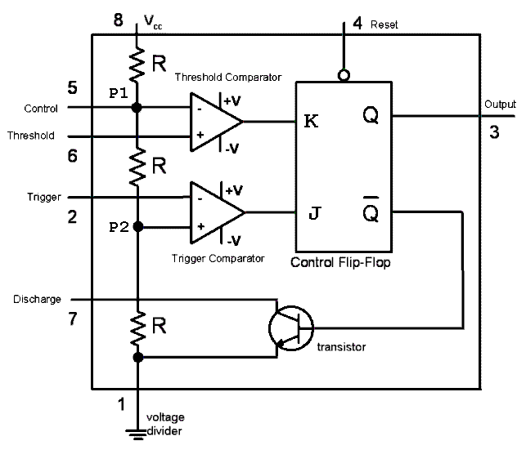
First note that there is a voltage divider along the left side of the diagram. This divides a DC source voltage at Vcc into three equal voltages. Therefore, P1 is equal to (2/3)Vcc and P2 is equal to (1/3)Vcc. Next to the voltage divider, there are two comparators. The Threshold Comparator compares the voltage at pin 6 (the Threshold) to the voltage at P1. Since the Threshold is at the non-inverting input, the comparator will saturate high when the Threshold exceeds P1. The Trigger Comparator compares the voltage at pin 2 (the Trigger) to the voltage at P2. Since the Trigger is at the inverting input, the comparator will saturate high when the Trigger dips below P2. The output of these two comparators are used to control a flip flop. (You may also see an “RS” flip flop here, but we have used a JK flip flop because that is the one you are familiar with.) When the Threshold comparator outputs a high signal, the K input is high and the output of the flip flop goes low. When the Trigger comparator outputs a high signal, the J input is high and the output of the flip flop goes high. The output of the flip flop is attached to the 555-timer chip’s pin 3 (Output). The 555-timer chip has one more feature, a transistor switch. This switch will be off when the Output pin is high and the signal at pin 7 (Discharge) will not be influenced by the switch. When the Output pin 3 is low, however, the transistor switch is closed. This forces the Discharge pin to ground.

The 555-Timer in Astable mode: When we wire the 555 timer in astable mode, we create a circuit that generates a string of pulses with the same period and duty cycle. The nature of these pulses is determined by the values of the R1-R2-C1 combination on the outside of the timer in the diagram for Basic Astable Mode on the previous page. We have seen that when current flows through a series combination of a resistor R and a capacitor C, that the circuit responds with a characteristic time constant τ = RC. The on-time for each pulse is determined by how fast the capacitor C1 charges when the transistor switch is open and the output of the timer chip at pin 3 is high. In this case, the capacitor is attached to the source voltage through the resistors R1 and R2. The charging time constant is τ_{charge}= C1(R1+R2). When the capacitor has charged up to (2/3)Vcc, the Threshold Comparator saturates high, the flip flop switches, the output goes low and the transistor switch closes. The off-time for each pulse is determined by how fast the capacitor discharges to ground through the transistor. The discharge path is through R2 to pin 7 to ground, so the discharging rate is τ_{discharge}= C1(R2). When the capacitor has discharged down to (1/3)Vcc, the Trigger Comparator saturates high, the flip flop switches, the output goes high, the transistor opens, and the capacitor is no longer attached to ground at pin 7. The capacitor begins to charge again and the cycle repeats.

By selecting just the right values for the resistors and capacitors in this circuit, we can make the voltage at pin 3 (the OUTPUT) go from zero to V_{CC} at whatever rate we desire. We can also control the percentage of time that the output will be on relative to the length of an entire cycle. The equations that govern this behavior are:

Modulation: One important aspect of the 555-timer is that it can be used to do different types of modulation. Modulation is a method of encoding a signal that you want to transmit within another signal (called a carrier). You are probably already familiar with amplitude modulation (AM) and frequency modulation (FM). Examples of these are pictured below:

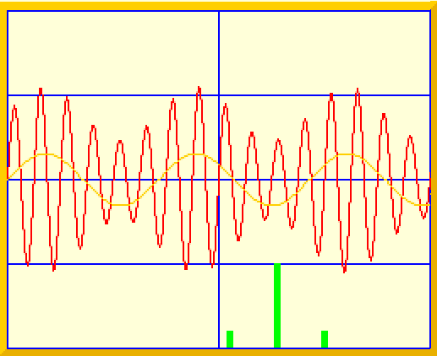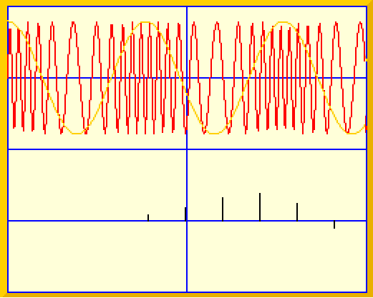
Amplitude Modulation Frequency Modulation

In amplitude modulation, the frequency of the carrier remains the same and the transmission signal is used to alter the amplitude of the carrier. In frequency modulation, the amplitude of the carrier remains the same and the transmission signal is used to alter the frequency of the carrier. 555-timer circuits do modulation based on square pulses rather than sign waves. This type of modulation includes: pulse width modulation, pulse position modulation and pulse frequency modulation.

In pulse width modulation, the period of each pulse remains the same, but the relative amount of time each pulse stays high (on-time) varies. In pulse position modulation, the width of the on-time of each pulse remains the same, but the period and duty cycle of the pulse change. In pulse frequency modulation, the duty cycle remains constant, but the period of the pulses changes.

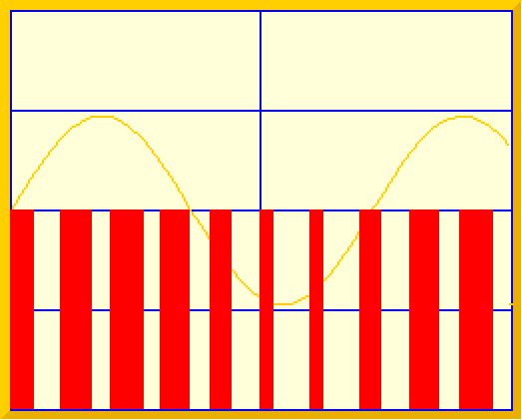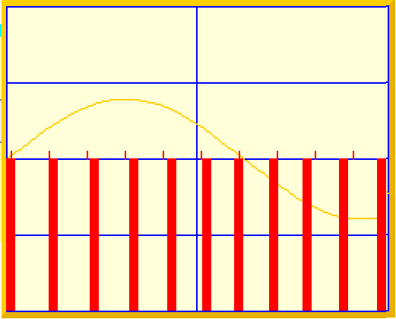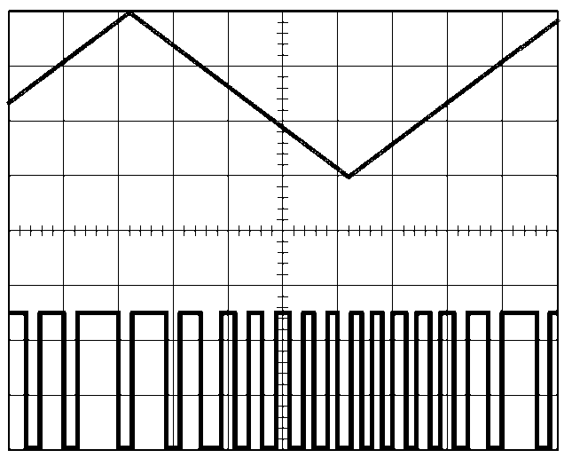
pulse width modulation pulse position modulation pulse frequency modulation

Pulse width modulation: One of the most important methods we have for controlling and driving a large variety of systems is pulse width modulation. Please read over the links on motor control and flow valve control on the course links page. The power of pulse width modulation comes from its simplicity. Rather than controlling the flow of some liquid by carefully opening a valve part way, you can alternately open and close the valve fully in such a manner that the average open time produces the same effect as a partially open valve. In effect, the rate of flow is controlled by the duty cycle of the controlling voltage. It is much easier to fully open or close a valve than to precisely open it part way. One can also apply power to a motor in this manner to control the speed of rotation. The key goal of this modulation process is to achieve a desired average value for some process. The range of possibilities is shown in the figure below where A has a high duty cycle (fast) and C a low duty cycle (slow).

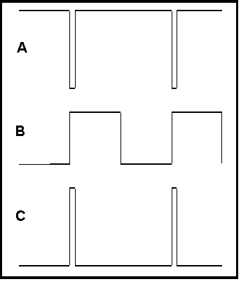

Experiment

Simulation of a 555-timer circuit.
In this part of the experiment, we will use PSpice to demonstrate the operation of the 555-timer chip in astable mode.

- Wire the following circuit in PSpice

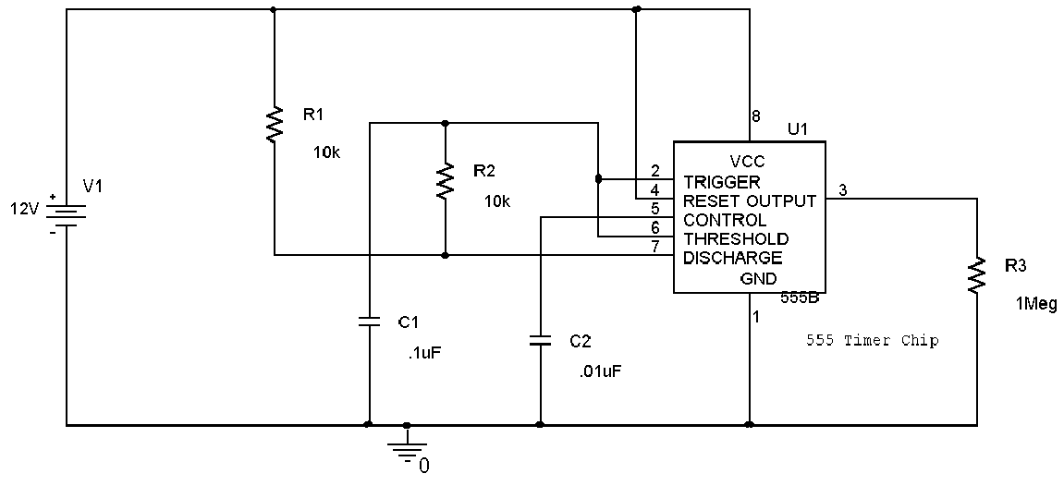
- Run the simulation
  - Perform a transient analysis in increments of 2us up to 5ms.
  - Plot the threshold/trigger, discharge and output voltages. The trigger voltage is pin 2 and the threshold voltage is pin 6. (They are tied together.) The discharge voltage is pin 7, and the output is taken at pin 3.
  - Print your plot and include it in your report.
  - Verify that the timer output changes according to the rules listed for the 555-timer in astable mode. Use the plot to find the time period that the output is ON and the time period that the output is OFF. Note: Do not use the first cycle of pulses produced by the timer circuit. It takes one cycle to settle in to its steady-state condition. One of these times should be equal to 0.693(R1+R2)C1 while the other should be equal to 0.693(R2)C1. Which is which? What is the total period of this output?
  - Which of the three signals on your plot corresponds to the charging and discharging of the capacitor, C1? To what voltage does it charge each time? To what voltage does it discharge? What it the rate of charge? Is the rate of discharge the same?

- Determine the average voltage of the signal.
  - Change the end time for the transient analysis to 60ms.
  - Display only the output voltage (pin 3) on your plot.
  - Rerun the simulation.
  - Add a trace of the average of the output using the average function, AVG(). This should add a trace of the time average of the output voltage. The average at any instant of time is the average of the voltage from time = 0 to the time of interest. Thus, you should see that the average asymptotically approaches a particular value.
  - Print this plot and write the approximate voltage the average is approaching on the plot.
  - Include this plot in your report.

- Find a larger and smaller average voltage for your circuit
  - Find an expression for the duty cycle of an astable 555-timer circuit using the equations given. Consider what relative values of R1 and R2 would produce the highest duty cycle and what relative values of R1 and R2 would produce the smallest duty cycle.
  - Now, using any combination for 3kΩ, 10kΩ or 30kΩ resistors for R1 and R2, find the combination of two resistors which results in the largest average voltage and the combination of two resistors which results in the smallest average voltage.
  - Print your plot for each of these two cases, write the values for R1 and R2 you used on each plot. Include these two plots in your report.
  - Verify in each case that the pulses produced by the multi-vibrator circuit obey the design rules. If the simulation does not work, the design rules are probably violated.

Build the 555-timer circuit on your protoboard
In this part of the experiment, we will build the astable multi-vibrator and use it as the clock for your timer circuit.

- Wire the astable multi-vibrator on your protoboard.

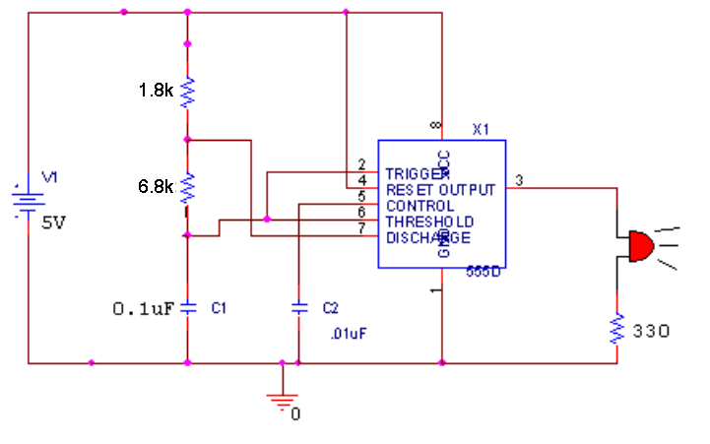
- Record your results
  - You will not be able to see the LED flash because the period of your circuit is too fast.
  - Take an agilent picture of your output.
  - Print this plot and include it in your report.
  - What is the period of your output signal? What are the off-time and on-time? Use the equations to calculate what these values should be. How do they compare?

- Slow down the pulses so that you can observe them with the LED.
  - Keeping the resistors R1 and R2 the same, determine a new value for C1 such that the period of the timer will be around 1 second.
  - Replace C1 in your circuit and observe the LED. Does it flash once a second?
  - What is your on-time and off-time now? How are these related to the on- and off- times of the original circuit? Why does this relationship hold?

- Use the 555-timer circuit as the clock for your counter.
  - Remove the function generator from pin 1 of the counter.
  - Connect the output at pin 3 of the 555-timer circuit to pin 1 of your counter circuit.
  - Does the counter count the 555-timer pulses?
  - Can you see the lower order bits change now?

Report and Conclusions

The following should be included in your written report. Everything should be clearly labeled and easy to find. Partial credit will be deducted for poor labeling or unclear presentation.

Part A

Include the following plots:

1) Agilent plot of single trace from NOR gate with truth table (1 pt)
2) Agilent plot of single trace from NAND gate with truth table (1 pt)
3) Agilent plot of single trace from NOT gate with truth table (1 pt)
4) PSpice timing diagram for the three gates in the circuit with output traces marked (2 pt)

Answer the following questions:
1) What are the actual voltage values you observed as HIGH and LOW states in the hardware realization of the circuit? (1 pt)
2) How do the truth tables generated using the actual chips correspond to the truth tables you generated using your PSpice output? (1 pt)
3) If you had a gate with four inputs, how many cases would you have to consider to create the truth table? (1 pt)

Part B

Include the following plots:
1) Agilent plot of single trace from flip flop with truth table. (2 pt)

Answer the following questions:
1) Flip flops are called memory devices. Why do you think this is true? (1 pt)
2) Show that the flip flop is giving the correct output at the clock cycles (A ,B ,C and D) indicated on the timing diagram below. DSTM2 is the clock signal, DSTM1 is J, and DSTM3 is K. Show how the truth table you found for the actual flip flop is consistent with the timing diagram at those four points. (4 pt)
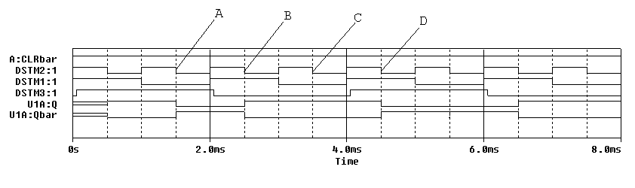

Part C

Include the following plots:
1) PSpice timing diagram of counters (2 pt)
2) Agilent plot of clock and QA (1 pt)
3) Agilent plot of clock and QB (1 pt)
4) Agilent plot of clock and QC (1 pt)
5) Agilent plot of clock and QD (1 pt)

Answer the following questions:
1) For the counter circuit configuration just studied, what is the highest number it counts to in the time shown on your output? Express as both a binary and decimal number. (1 pt)
2) How many pulses will the clock have to cycle through after it resets before the counter hits its maximum value? (1 pt)
3) Which output of the timer (QA, QB, QC, QD) correspond to the bits in the binary number (b3 b2 b1 b0):
N = b3×2³ + b2×2² + b1×2¹ + b0×2⁰. (1 pt)

Part D
Include following plots:
- PSpice plot for the astable circuit with R1=10k and R2=10k. (1 pt)
- PSpice plots for the average voltage of the astable circuit with R1=R2=10k. (1 pt)
- PSpice plot for the average voltage of the astable circuit with highest duty cycle. (1 pt)
- PSpcie plot for the average voltage of the astable circuit with lowest duty cycle. (1 pt)
- Agilent plot of output from 555-timer circuit when R1=1.8K, R2=6.8K and C1=0.1μF (2 pt)

Answer following questions:
- What are the on-time, the off-time, and the period of the signal in plot 1)? What are the calculated values for these? Are they consistent? (2 pt)
- What are the maximum and minimum values for the voltage across the capacitor C1 (at pins 2 and 6)? (Ignore the voltage at times before it reaches steady state.) Why do these values make sense? (1 pt)
- Calculate the value of τ (the decay constant) that controls the rate at which the capacitor C1 charges. Calculate the value of τ (the decay constant) that controls the rate at which the capacitor C1 discharges. (1 pt)
- What is the minimum duty cycle that can be obtained from the astable multivibrator we modeled using PSpice? Can you show this mathematically using Duty Cycle = T1/(T1+T2)? (2 pt)
- What was the average voltage for your original circuit? What were the minimum and maximum average voltages when you considered different combinations or R1 and R2? (2 pt)
- What are the on-time, the off-time, and the period of the signal in plot 5)? What are the calculated values for these? Are they consistent? (2 pt)
- How did you find the value for C1 that gave the circuit you built a one second period? What value did you find? (1 pt)
- What are the calculated on-time, off-time and period values for your circuit with the new capacitor? How do these relate to the initial values? Why? (1 pt)

Summarize Key Points (1 pt)

Mistakes and Problems (1 pt)

Member responsibilities (1 pt)

Total: 45 points for report

Attendance: 3 classes (5 points) 2 classes (3 points) 1 class (0 points) out of 5 possible points
No attendance at all = No grade for experiment

