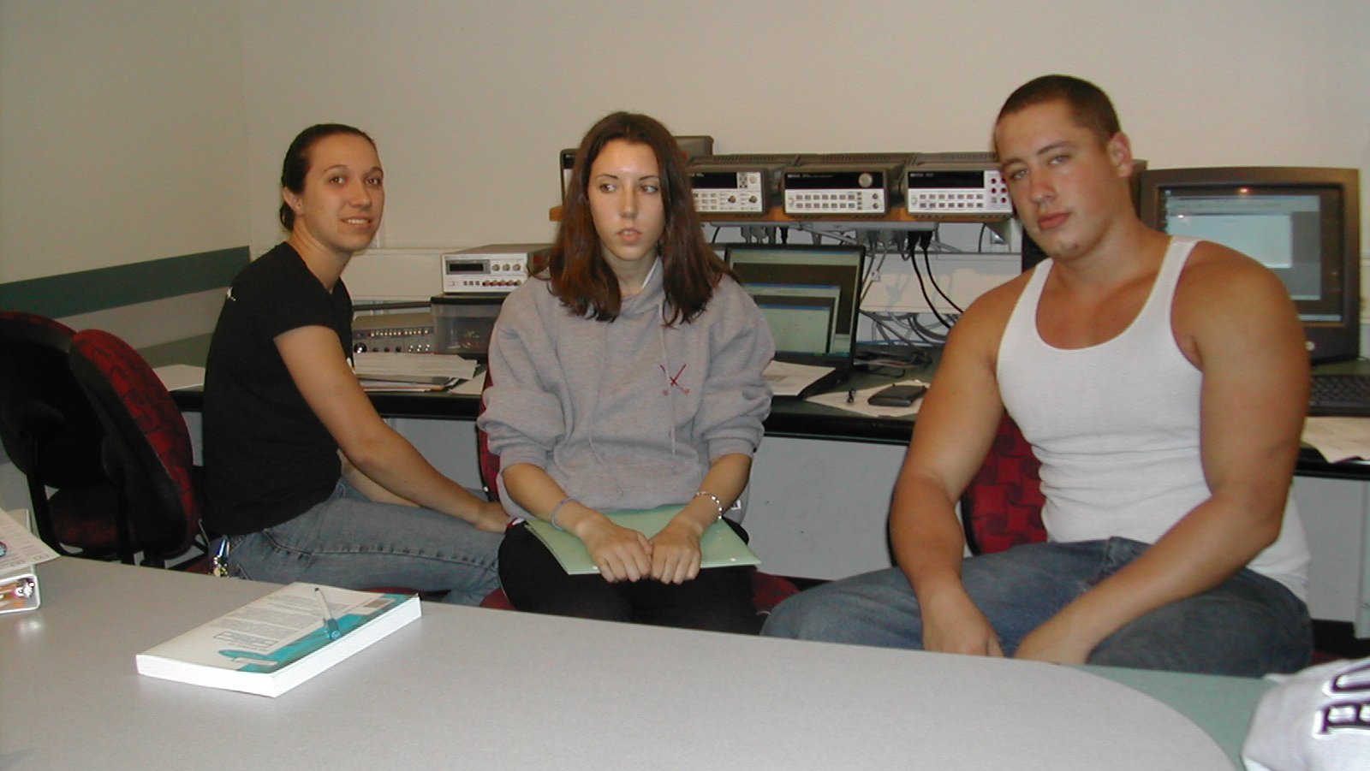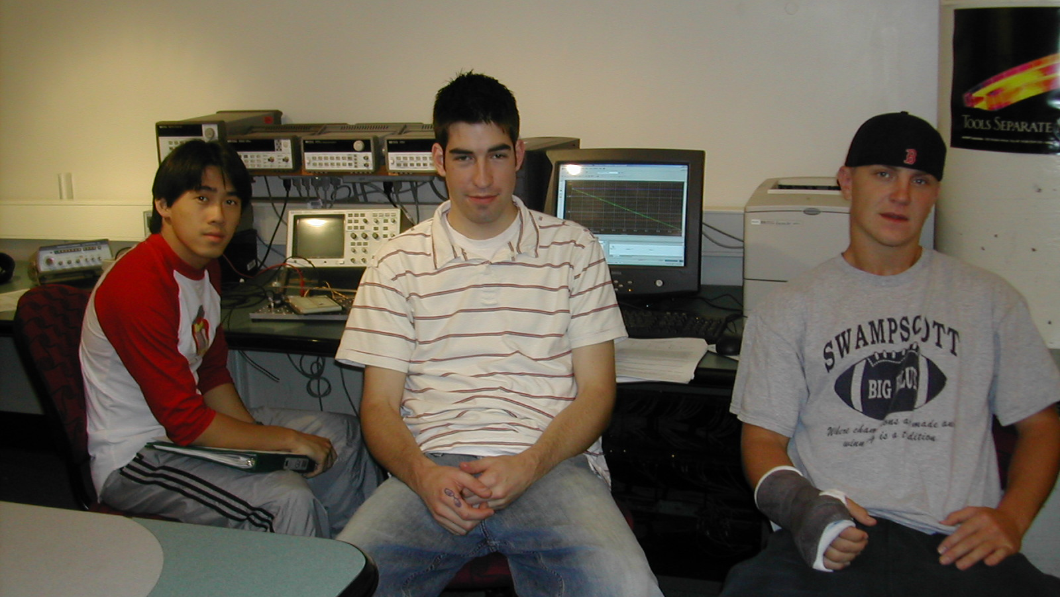
Deborah Kellogg-Van Orden Gabriel Williams ? Justin Dolley Nick Vaks
Alison Haefele

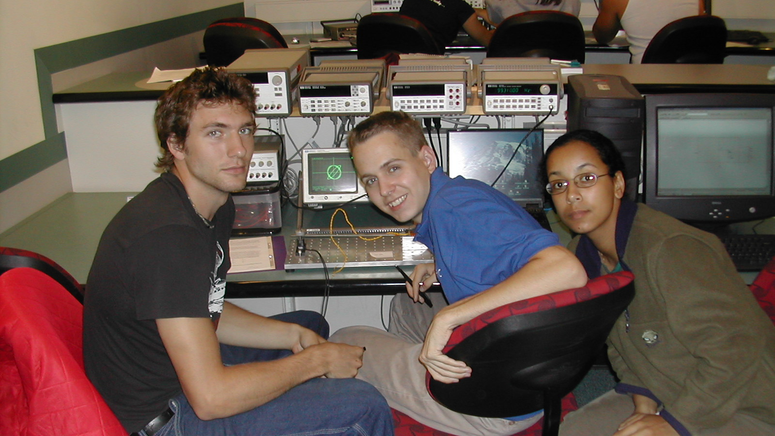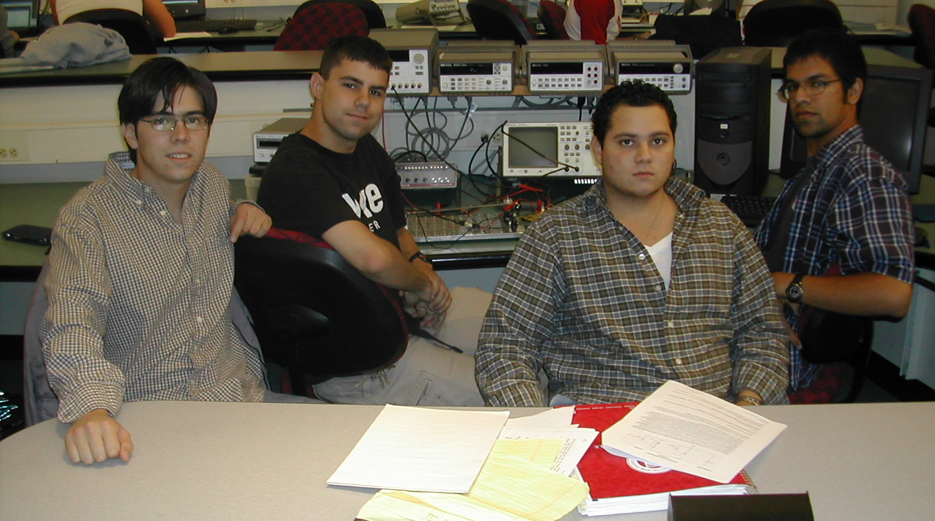
Nick Applegate Adam Plesniak Anyolina Mata Fernando Lopez, Eric Parker, Edmond Phipps, Vidhu S. Pandey
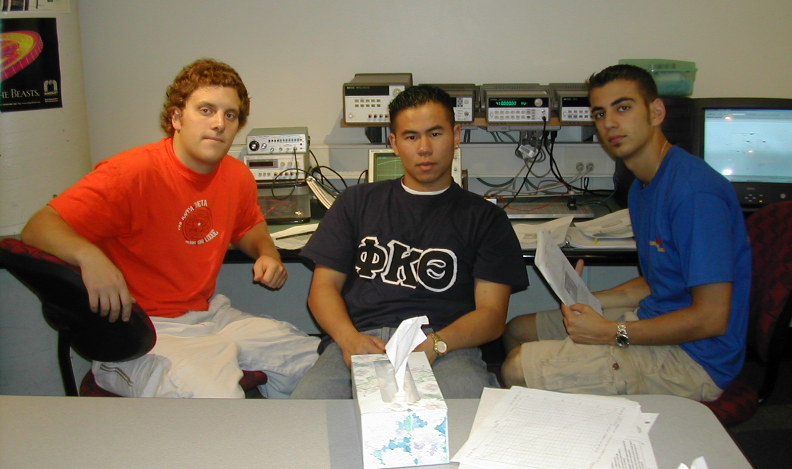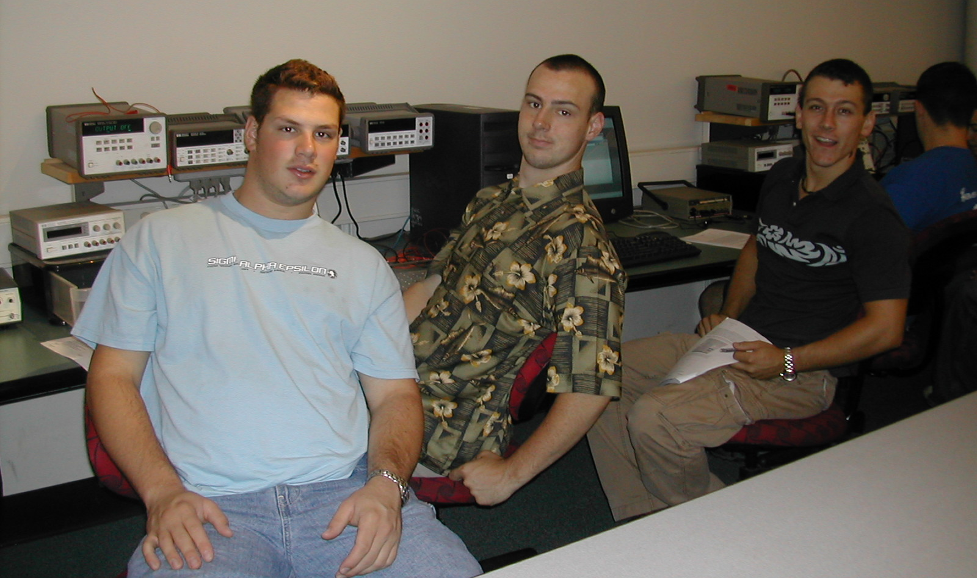
Steve Slusarski, Tames Tsou, Michael Laytin Jason Gertler ? Jared Girroir

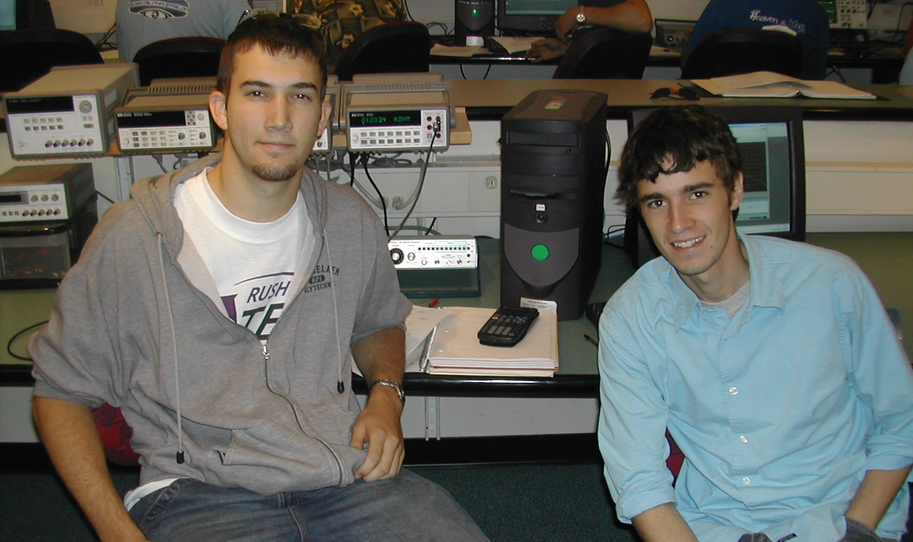
Dane Fawkes, Lail Kleinman
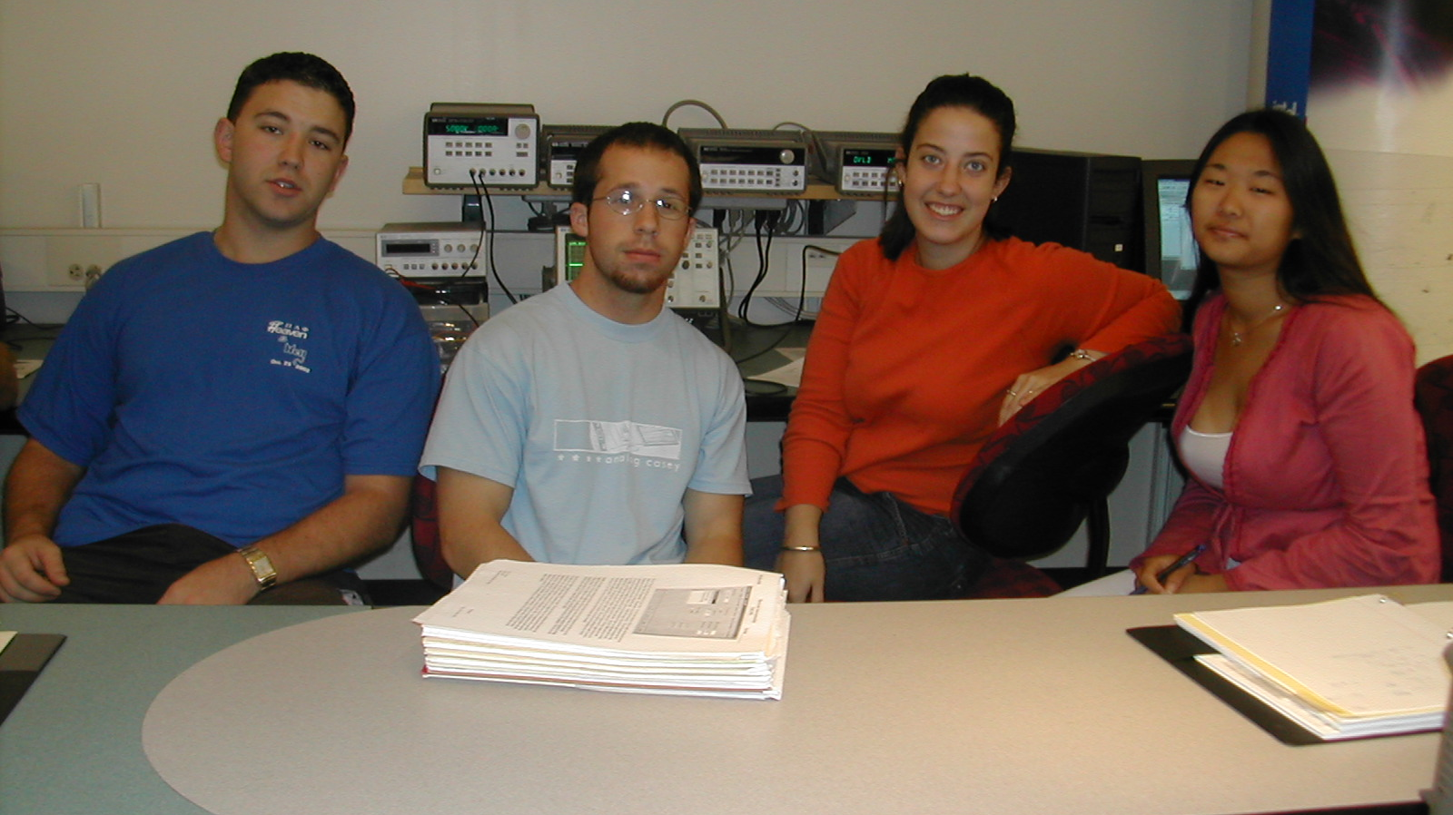
Rick Fox, Bryan Bertolami, Jill Treanor, Jessica Jablonka

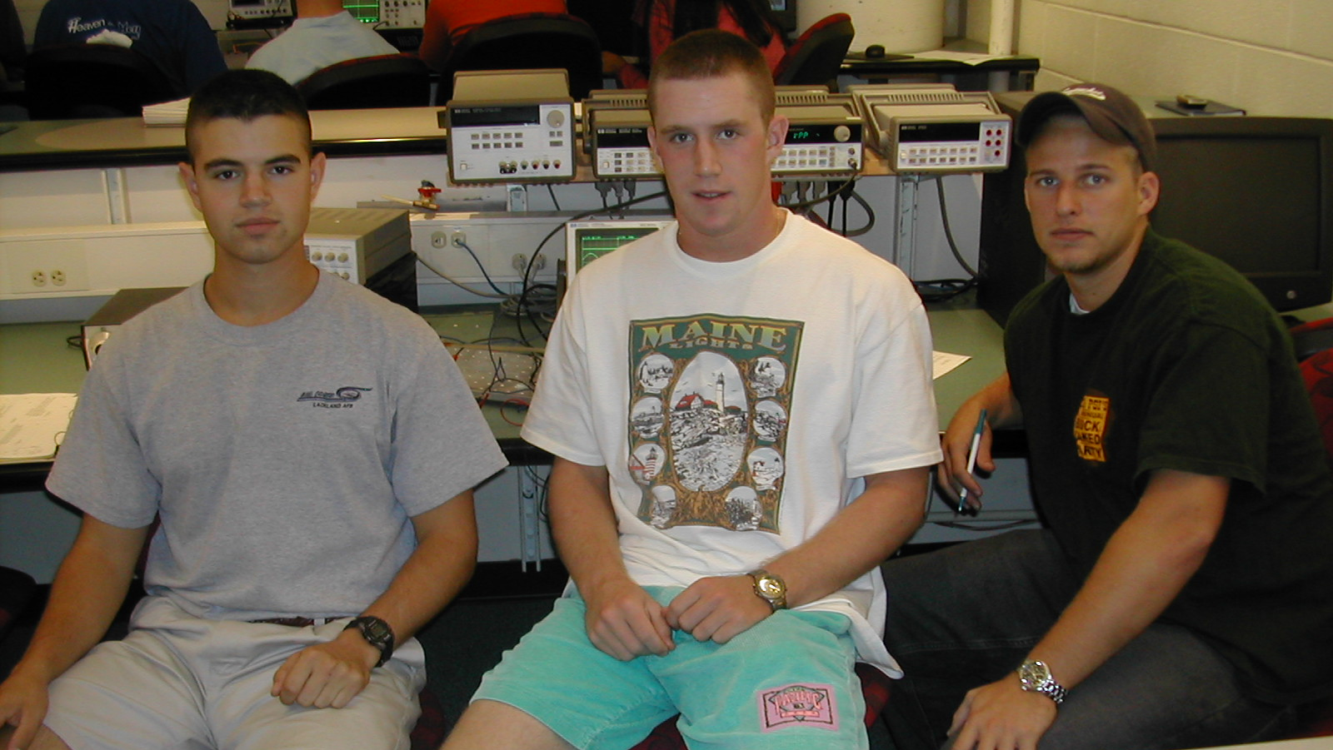
Evan Marchetti, Jesse White, Greg Loesch

