Experiment 1
Signals, Instrumentation, Basic Circuits and Capture/PSpice

Purpose: The objective of this exercise is to gain some experience with the electronic test and measuring equipment and the analysis software.

Equipment Required

- Rensselaer IOBoard Rev D (with Mobile Studio Desktop)
- Oscilloscope (Rensselaer IOBoard)
- Function Generator (Rensselaer IOBoard)
- DC Power Supply (Rensselaer IOBoard)
- DMM (HP 34401A 6-1/2 Digit Multimeter in JEC 4107 and handheld multimeters in JEC 4201)
- Two 100 ohm resistor, two 1M ohm resistors and two 1k ohm resistors.
- Protoboard
- Audio speaker

Helpful links for this experiment can be found on the links page for this course: http://hibp.ecse.rpi.edu/~connor/education/EILinks.html#Exp1

Part A – Sine Waves and Hearing

In this exercise, a function generator will be used to produce electrical signals with various shapes, including sine waves. Our objective is to learn about the basic properties of sine waves and related signals by seeing them, hearing them and analyzing them with an oscilloscope (simulated by the IOBoard). The electrical signals will then be applied to an oscilloscope and a speaker, that will allow us to see, hear and analyze the signals. We will also demonstrate some interesting facts about human hearing and speech.

Background

Equipment: What formerly would require the use of an entire workbench of equipment can now be accomplished using the Rensselaer IOBoard (see Figure A-1 below) and a laptop computer. This board, coupled with the Mobile Studio Desktop software, can simulate each of the following pieces of equipment: a two channel oscilloscope (scope), a digital voltmeter (DVM), two DC power supplies, a two channel function generator, and a 16 channel digital IO board. A full DMM is also used, as a measuring device that lets you take measurements of voltage, current, or resistance. The simulated digital voltmeter—DVM, has 2 channels (here we use the Analog IN channels 1 and 2 of the board). The scope is a measuring device that lets you view a plot of a voltage signal. The DC power supplies generate constant DC voltage signals (like a battery). The function generator creates a voltage signal that varies with time. The PC is an integral part of the equipment setup. You use it to simulate many of the circuits you will build, as well as to operate the IOBoard.
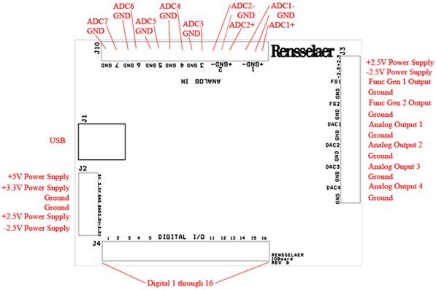
Figure A-1.

In this experiment we will use the function generator, the oscilloscope, and a speaker. The function generator is used to create electrical signals with various shapes, including sine waves. The function generator can be programmed to generate waves with specified amplitude and frequency. The function generator is connected to both the speaker and the oscilloscope. The speaker converts an electrical signal to sound that we then can hear. The oscilloscope analyzes an electrical signal and displays a picture of the signal. The combination of the oscilloscope and the speaker allows us to see with our eyes what we are hearing with our ears. We can also determine a mathematical representation of the sound that can then be used for system analysis. The function generator is located opposite the USB input. See Figure A-1.

The sine wave equation: Many of us have studied the sine and cosine trigonometric functions in math and physics classes. A sine wave is described by an equation of the form v (t) = A sin (2πft) = A sin (ωt), where the variable t represents time. We use the term "wave'" because the shape is similar to a water wave that you might see on an ocean or a lake. As shown in Figure A-2, a sine wave is characterized by two parameters, called amplitude (A) and frequency (f). The amplitude A determines the maximum value that the sine wave achieves along the vertical axis. The sine wave takes on values between +A and -A at various times.

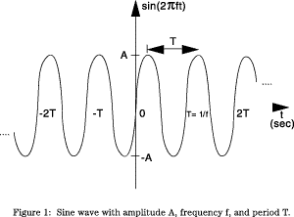
Figure A-2.

The frequency f of the sine wave can be understood as follows. Notice that the sine wave reaches its peak value of +A at regular intervals. The time between adjacent peaks is called the period of the sine wave. The period is denoted by the letter T and it is measured in units of seconds (sec). The frequency is defined as the number of times per second that the sine wave achieves the peak value of +A. Since adjacent peaks are separated by T sec, the wave achieves 1/T peaks per second. Hence the frequency f is equal to 1/T, and the units of frequency are sec⁻¹. Another name for the unit sec⁻¹ is hertz, or Hz for short. It is usual to denote the product 2πf as ω, where ω is called the angular frequency in electronics. (In physics, this is the rate of change of the angle in a rotating system, called angular velocity.) Note that one of the most common mistakes made in this class is confusing f and ω.

Adding a DC offset: If we add a DC offset voltage to the sine wave signal, as shown in Figure A-3, it moves the wave such that the center is around the DC offset. The equation becomes v (t) = A sin(2πft)+V_{DC}. In electronics, the AC and DC parts of a signal can be treated as two mutually exclusive entities.
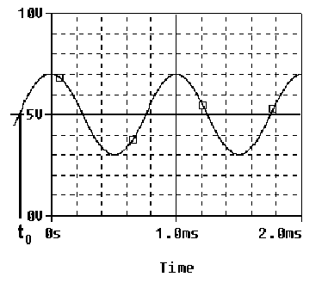
Figure A-3.

Scalar measurement of sine waves: Measurement devices do not usually give us the voltage amplitude A directly. Rather they determine V_{P-P} (the peak-to-peak voltage) or V_{RMS} (the RMS voltage). The peak-to-peak amplitude is the difference between the largest positive value of the sine wave and the largest negative value of the sine wave, so it should be nearly equal to A - (-A) = 2A. The RMS value is determined by taking the square root of the average of the square of the voltage. Since the voltages here are sinusoids, V_{RMS} = A/1.414. Note that in electronics the RMS voltage does not take into account the DC offset even when there is one on the signal, so the RMS voltage will always depend only on the amplitude.

Impedance and resistance: You are probably familiar with the term resistance. It is a measure of the degree to which a resistor resists the flow of electrons. Circuits that have a combination of components (some of which are not resistors) also resist the flow of electrons. However, the resistive behavior of these circuits is more complicated because it varies with the frequency of the signal. We call this complicated type of resistance “impedance”. Both resistance and impedance are measured in ohms, Ω, and the terms are often used interchangeably.

Human hearing: We are exposed to a wide variety of sounds every day. We hear a sound after our brain processes the sensations recorded by our ears. Two attributes that are commonly used to characterize sounds are loudness and pitch. Loudness, of course, refers to how loud or intense we perceive the sound to be. Pitch refers to whether we perceive the sound to be high or low. For example, the sound of an ambulance siren has a higher pitch than the sound of a fog horn. Keep in mind that your ear is a biological system. It is designed to hear certain pitches better than others even though, technically, they have the same loudness.

Experiment

A.1) Setting up a Sine Wave on the Function Generator
For the first experiment we wish to do here, we need to set up a sinusoidal voltage.

- After correctly installing the Mobile Studio software and connecting the IOBoard, open the software and select the Function Generator feature and the Oscilloscope feature. This will allow us to set them both as desired for the experiment.

- First we will set the frequency. The frequency of the function generator is adjusted as follows:
- Select the “Frequency” box for Ch.1 on the function generator. Set it to display 1kHz.
- Make sure the Amplitude is set. Check that the Peak-to-Peak (Pk-Pk) voltage is set to 0.4V.
- On the scope, select the Volts/div to 100mV, coupling to AC, and Input to FUNC1. Time/div should be set at 100us. When you are ready, press the “Start” button.
- If you cannot see a signal on the scope, double check to make sure all of the settings are correct. If you still cannot see it, press red button in the Channel 1 window of the scope. This will locate the signal and re-center it.
- With the knob, change the frequency up or down as desired. How does this change the signal on the scope?
- Set it again so the display reads 1K Hz.

- What is the frequency of your signal? One way to measure the frequency of the sine wave is to use the grid on the display of the oscilloscope. The scale for frequency appears to the right of the screen. Use the scale to estimate the period of your wave. The frequency is the inverse of the period. Fortunately, our scopes provide us with an easier way to measure frequency.
- Under the Windows menu on the main panel of the oscilloscope, select “Measurements.”
- You will see three measurement windows appear at the right of the screen. The top one should default to measuring frequency of Ch. 1 of the scope.
Is the frequency around 1000Hz? (Note that the oscilloscope re-computes the frequency from new measurements about twice per second, so the value that it reports is changing with time. The average of the measurements should be close to 1kHz.)

- What is the amplitude of your signal? One way to measure the amplitude of the sine wave is to use the grid on the display of the oscilloscope. The scale for voltage appears in the “Ch. 1” Volts/div scale. Use the scale to estimate the peak-to-peak voltage of your wave. You can use the scope to measure the voltage, as well.
- With the “Measurements” window open from before, you should see the peak-to-peak voltage to the right of the screen.
- Compare the settings of the function generator to both the output of the Measurements window and an estimate based on the oscilloscope.
- Write down the function generator settings for frequency and amplitude.
- Write down the same values from the Measurement window
- Click on the Save Data icon of the oscilloscope and provide a file name. Start Excel, open the just created file and plot the second column vs. the first column (an x-y scatter plot). (Using the Excel icon to save data may also work, but it is prone to problems as Microsoft changes the file format from version to version without warning.)
- Print the plot and use it to determine the frequency and peak-to-peak amplitude. Mark up the plot. Have a TA sign the marked up version.
- Create a table that compares the 3 sets of numbers: FG setting, measurement numbers, and plot calculations.

A.2) Driving a Speaker with a Function Generator
We now wish to connect the function generator, the scope and the speaker together to perform some simple experiments.

- Start by measuring the resistance of your speaker using the DMM. (A speaker is not a simple resistive device, so it has an impedance. Impedance is a more general term which includes changes with frequency. We will return to this issue later in the course.)
- Connect the red lead (HI) from the DMM to one end of the speaker and the black lead (LO) to the other. In JEC 4201, just use the meter leads. In JEC 4107 there are cables available and one can use the dual banana to BNC connector. The dual banana connector has a polarity. The tab should point toward the negative connection (LO). (ALWAYS plug into the DMM using the connections furthest to the right.) Check to make sure you plug into the connectors designed to measure Ω. Plug a BNC cable into the dual-banana connector and a mini-grabber into the BNC cable. You can then connect the leads of the mini-grabber to the speaker and record the resistance.

- Now we need to hook up the speaker, so we need to connect the IOBoard to the protoboard.
- Using the diagram in Figure A-1 as a guide, connect the Func Gen 1 and Ground leads to the protoboard in such a way that you can plug one side of each into the speaker. We recommend that you used a ~6” length of the twisted pair wire, but individual strands will work.
- Plug the speaker into the protoboard so that it makes contact with the leads from the function generator.

- Adjust the volume of the signal to a comfortable level by changing the amplitude of the signal. By comfortable level, we mean the lowest amplitude that allows you to hear a distinct sound. There will be lots of sounds being made in the room, so it is best to keep them as soft as possible. What is the value of the voltage amplitude that you have selected?

- Let us investigate how our perception of loudness changes as the frequency of the sine wave is varied. With the sine wave amplitude fixed at your comfortable level, vary the frequency over the range from 100Hz to 10,000Hz. Try cycling through the following frequencies, without changing the speaker volume control: 100, 200, 300, 400, 500, 600, 700, 800, 900, 1000, 2000, 3000, 4000, 5000, 6000, 7000, 8000, 9000, and 10,000Hz. Which frequency do you hear the loudest? Is there any variation among the members of your group? If you have problems discerning significant differences in loudness, try a different speaker.

- Generate a tone at the frequency that appears loudest. Does the pitch of this tone seem to be one that you commonly hear in speech, music, and automobile traffic? Use the website on the links page to verify this.

Experiment with the Equipment
At this point, you will have put the function generator and scope through some basic tasks. Try some of the other functions of the instruments. (Experiment with the other features of the function generator like Waveform, etc. and see what happens.) Some very interesting and annoying waves can be produced. Play around a little and then find a particular set of operating conditions that you find the most interesting. Under what circumstances might you experience the sounds you have produced or generally when might you encounter a waveform like the one you have displayed on your scope?

Summary

You should now know how to set up voltage signals with the function generator feature and display them using the oscilloscope feature. You should understand the pitch/frequency and amplitude/volume relationships, and know how these relate to human hearing.

Review the report write-up section at the end of this document. Make sure that you have all the data required to complete the write-up.

Part B – Voltage Dividers and Measuring Equipment

In this part of the experiment you will be learn that equipment isn’t ideal and that “real” behavior must be taken into account when making measurements. You will look at batteries and measure the effective internal resistance; they aren’t ideal voltage sources. You will also look at the behavior of two voltage dividers when a DC voltage and an AC voltage are applied. You will use circuit analysis to examine the behavior of these circuits.

Background

Impedance: Every piece of electrical equipment has an effect on the circuit you connect it to. Just as it is impossible to design a dynamic mechanical system without friction (that resists motion), it is impossible to design an electrical system without impedance (that resists the flow of electrons). Impedance has two effects on an electrical system. It changes its magnitude (the value of the voltage) and its phase (voltage behavior over time). If the impedance affects only magnitude, then we call it resistance. Each electrical measurement device has an internal impedance, and this is also true for the IOBoard. The impedances we will concern ourselves with in this class are listed in table B-1 below: (These values aren’t exactly correct, but they still can be used to make the point.)

Device | impedance (magnitude only)
Scope (IOBoard) | 1MegΩ
DMM (DC voltage) | 10MegΩ
DMM (AC voltage) | 10MegΩ
function generator (IOBoard) | very small
DC power supplies (any) | negligible
Batteries | 0.4 to 32Ω

Table B-1

Note that presently we are only concerned about the effect of the equipment on the magnitude (resistance component) of the impedance. Also note that the devices in the studio are designed to have minimal effect on any circuit they are connected to. In this part of the experiment, we will examine how much of an effect the equipment has.

Voltage dividers: In order to analyze the effect of the equipment, we need to understand a fundamental concept of circuit analysis called a voltage divider. Basically, when a voltage in a circuit is subjected to different resistances, it divides up in a manner proportional to the resistances. That is, a larger resistance will have a larger voltage drop and that voltage drop will be proportional to the size of the resistance divided by the total resistance of a circuit.
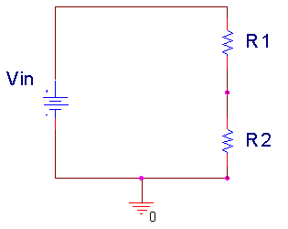
Figure B-1.

In Figure B-1 above, Vin is divided between R1 and R2. Mathematically, this can be expressed:

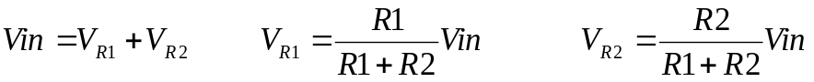

Note that R1+R2 is the total resistance of the circuit. We can use a voltage divider to determine how much effect a device has on a circuit, or in this case, the effect that a circuit has on a device. In the simple electrical model of the battery shown in Figure B-2, the internal resistance of the battery depends on the battery size and chemistry. This is a simple model that ignores much of the internal chemistry including changes as the battery is discharged. The default assumption normally is that the voltage output of a battery doesn’t change with the load. We will investigate how this works in an actual circuit.
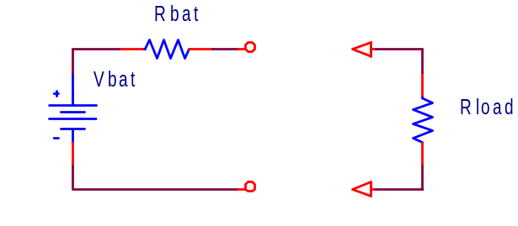
Figure B-2.

The output of the battery is measured using the IOBoard with and without a load resister. Remember that Rbat represents the internal model of the battery, you don’t add this resister to the circuit. Rload represents the load, or combined resistance of whatever circuit you place on the source. Using the voltage divider rule, we know that the voltage drop across the load is given by: 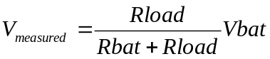.

Series and parallel circuits: Another fundamental concept we need to understand in order to analyze the circuits we will build is how to mathematically combine resistances. If any number of resistances are connected in series, you simply add them to find the total resistance. If any number of resistances are wired in parallel, the total resistance is the reciprocal of the sum of the reciprocals of all of the resistances. This is summarized in Figure B-3.
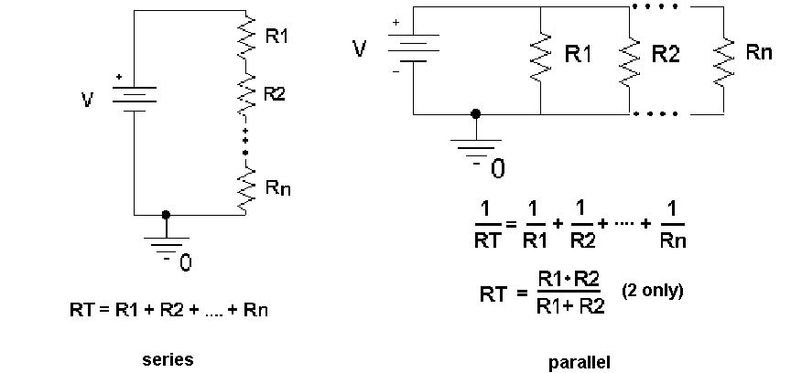
Figure B-3.

Note that the voltage divider rule applies only to series circuits. Any time we use our measuring devices to measure the voltage across a device, as illustrated in Figure B-4, we are combining that device in parallel with the resistance we are measuring. So just connecting the oscilloscope will affect the quantity to be measured. In this case the effective load resistance on the battery is Rtotal and it is the parallel combination of the scope impedance (1MegΩ) with the resistance of the load resistor (Rload). This results in total load resistance, Rtotal.

Vbat
Rbat
Rload
Rscope
1Meg
Vbat
Rbat
Rtotal
=
Figure B-4.

Once you have the total load resistance, R_{T} , you can use the voltage divider rule to find the internal resistance of the battery. Note that, since the voltage drop across any number of resistors in parallel is the same, V_{Rtotal} is equal to V_{Rload}.

Other basic circuit components: There are two other basic circuit components: capacitors and inductors. To combine capacitors in series take the reciprocal of the sum of the reciprocals. To combine capacitors in parallel, simply add the capacitances. [Note: This is the opposite of combining resistors.] Inductors combine like resistors. To combine inductors in series, you add them. To combine them in parallel, you take the reciprocal of the sum of the reciprocals.

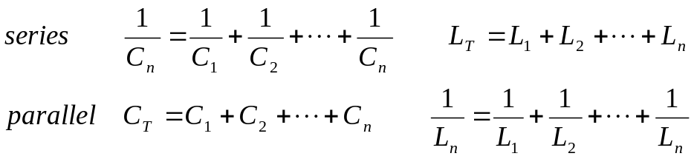

Experiment

B.1) Some DC Measurements
We will look at what happens when we apply a load to a battery.

- Measure the voltage of a 9V “Heavy Duty” battery without any load. Simply connect the battery to the protoboard and connect the leads from the protoboard to ADC1+ and GND of the IOBoard. It is recommended that ADC1- and GND be jumpered together unless we are making what are called differential measurements. We will return to that in a future experiment. In this case, the input resistance of the IOBoard is so large that it can be ignore. Rload and Rtotal are the same. Record the value.

- Now add a load to the battery, as in Figure B-5. The load is two 100Ω resistors in series. We will discuss why two resistors are used a little later. Set up the circuit so that you can add and remove the load quickly. This just means wire it so that it is easy to pull out and reinstall one end of one resistor. Record the Vmean from the measurements window of the IOBoard with the resistive load disconnected. Then connect the resistors and quickly record the new voltage. You may want to repeat this a few times to find the typical change of voltage with and without the load. Remember to record the unloaded battery voltage as well as the change in voltage.

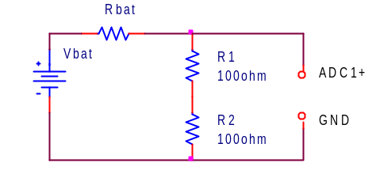
Figure B-5.
Use the results from this experiment to determine the value of Rbat.

- Repeat the experiment with a different battery. Choices are a 9V Alkaline, a pack of 2 AA alkaline batteries in series, and a watch battery. If you do a low voltage battery it may be wise to load the battery with only one
100Ω resistor.
- Collect data from other teams so that you have numbers for all 4 battery types available.

B.2) Some AC Measurements
The part above showed that the load can effect the equipment, in this case a battery. Now we will look at how the instrument can affect the circuit. The IOBoard oscilloscope, (ADC1), can load the circuit and affect the thing to be measured.

- Use the function generator, FG, of the IOBoard to put an AC signal on a resistor divider circuit shown in Figure B-6. Set the FG to 1kHz and 1Vp-p. Use R1 = 1kΩ and R2 = 1kΩ. Take data and plot the output using Excel.
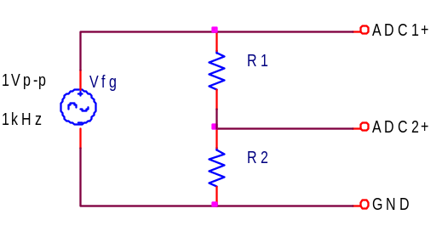
Figure B-6.
Make all the connections on the protoboard.

- Calculate the ratio of the voltage on ADC2 to the voltage on ADC1.
- Repeat the experiment using R1 = R2 = 1MegΩ resistors. Again create a plot of the voltages and calculate the ratio of the voltages.
- The more exact model of this measurement is given in Figure B-7, were Radc1 and Radc2 represent the effective internal input resistances of the channels of the IOBoard. The effective input resistance of ADC1 can be ignored, but the input resistance of ADC2 effects the measurement. Using the measurements above, estimate the value of Radc2.

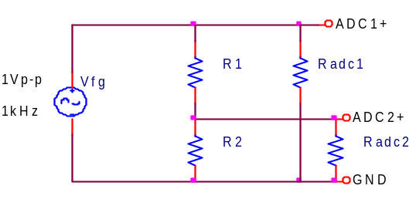
Figure B-7.

B.3) Power Calculations and Impedance Matching
Now we will look at the power associated with the battery circuit

- Power Ratings: In part B.1 you used two resistors in series. The effective resistance of resistors in series is simply the sum of the resistances. So why use two 100Ω resistors in series when we could use one 200Ω resistor? Power rating is the answer. 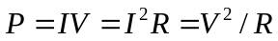 where P is the power, V, I, and R are the voltage, current, and resistance of the load. The power is in Watts if you use Volts, Amps and Ohms. Our resistors have a power rating of ¼ watt.
  - Calculate the total power out of the battery for part B.1 for just the 9V battery measurements.
  - Calculate the power per resistor. Ask for help if it isn’t now clear as to why we used 2 resistors rather than one for this measurement.
  - Calculate the total power out of the battery for part B.1 for the 2 AA battery pack.

- Impedance matching: Impedance matching is important with weak signals, not with batteries. Even so, the concept can be demonstrated using our circuits. Don’t wire this circuit; it would cause excessive heating and a rapid discharge of the battery.

For this part assume that you have a 9V battery with an internal resistance of 30Ω. Using Figure B-2, calculate the voltage that would be measured across the load if the load resistance is 100Ω, 60Ω, 30Ω, 20Ω, and 15Ω. For each load resistance, determine the power that would be dissipated in the load resistor. Plot the power dissipated vs. the load resistance.

If you did thing correctly, you will see that the maximum power in the load occurs when the load resistance is equal to the internal battery resistance. This is call impedance matching.

Summary

You should now understand how to calculate the effective resistance of resistors in series and/or in parallel. You have an appreciation of AC and DC signals, and that the load and/or the equipment affects the voltages and currents in the circuit. Lastly you should be comfortable with using the IOBoard, including the function generator, the oscilloscope and the measurement windows.

Part C – Introduction to Capture/PSpice

In this section we will learn about the circuit analysis software we have installed on our computers in the studio. You can download this software to your laptop. The download is located at: http://hibp.ecse.rpi.edu/%7Econnor/education/OrCAD105_Demo.exe

Background

The software we will be using to simulate the operation of circuits in this course is called PSpice. Actually we will be using a combination of two programs, Capture and PSpice. We will use the first to set up the circuit problem and the second for the analysis. Capture is a windows program that provides a visual interface that lets you enter circuits. It translates your pictures into information that PSpice can understand. Figure C-1 shows a simple circuit created with Capture with some useful buttons defined. PSpice is an older piece of software that takes circuit information and analyzes how it will behave. It has been modernized so that it displays an output similar to what you would see if you hooked the circuit to a real scope. Figure C-2 contains a sample output.

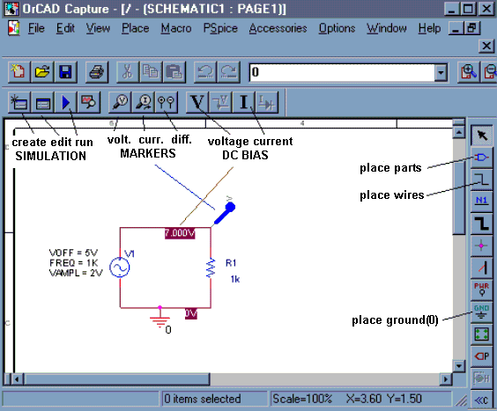
Figure C-1.

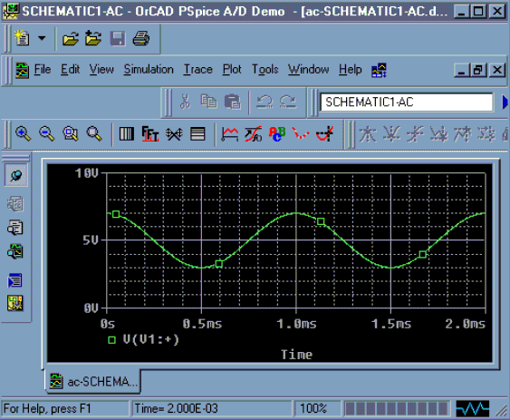
Figure C-2.

Experiment

Opening a New Project in Capture
In this part of the experiment, we will use Capture to draw the simple circuit we have been studying, a combination of resistors and a sinusoidal voltage source.

- Run the “Capture CIS Demo” program located in the applications folder or on the start menu under “OrCAD 10.5 Demo”.

- Capture will open with no current project. Click on the File pull-down menu and select New Project. You will see a new window (Figure C-3) named New Project.

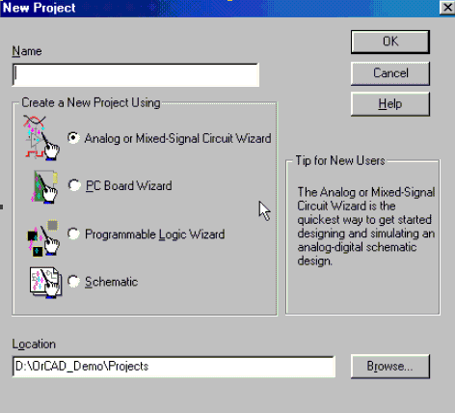
Figure C-3.

Be sure that the Analog or Mixed-Signal A/D is selected. [ALWAYS select this option.] You will use this window to give this project a name and choose a location where you wish to store it. In the box at the top of this window, give your project a recognizable name, such as EXP1-C. For a location, it is recommended that you create a temporary folder on the Desktop (or the C drive) for your projects. Capture and PSpice create around 20 files per project, so a folder for each project is a good idea. When the class is over, you should share a copy of the files with your partner. It can save a lot of time if your laptop has a problem. Once you have finished setting up the project, click on the OK button

- Next you will get a pop-up window asking if you wish to use an existing project. If the existing project is empty.opj, then that is fine. Otherwise choose create a blank project and click OK.

- Now you should see the main Capture screen. You are ready to draw a circuit. If you don’t see the Capture screen but see a file tree structure then: click on the file with the .dsn, click on SCHEMATIC1, and double click on PAGE1. This will be the Capture screen.

Drawing a Circuit
Figure C-4 is a picture of the Capture main screen with the circuit we will be drawing. Note that this is the circuit used in Figure B-7 including the input resistance of one channel of the IOBoard.

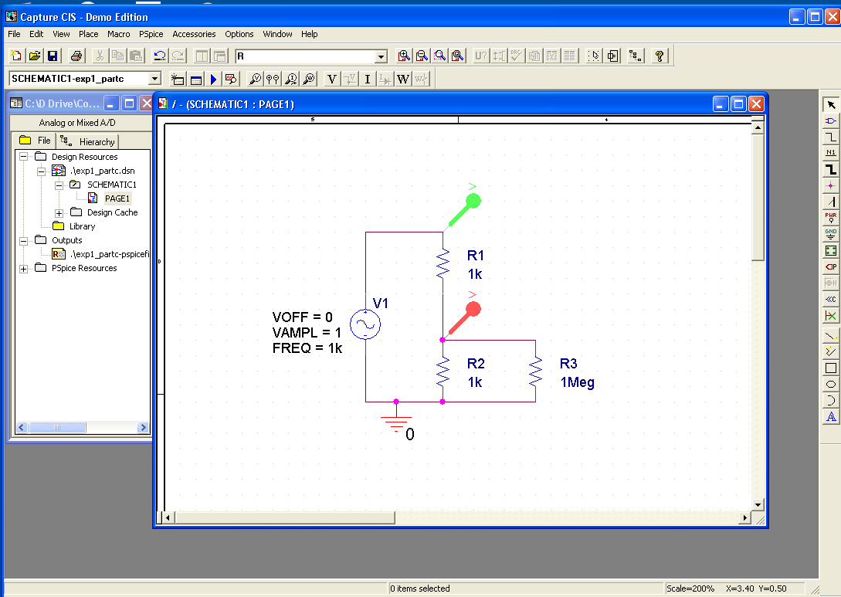
Figure C-4.

In the circuit shown in Figure C-4, we have some resistors, an AC voltage source, a ground and some wires. To create this diagram, we will use the command buttons. For the resistors and the voltage source, we will click on the second button from the top that has the device with the three little wires sticking out of it . You can also do this by using the Place menu or by hitting shift-P. You should bring up a screen similar to the one pictured in Figure C-5.

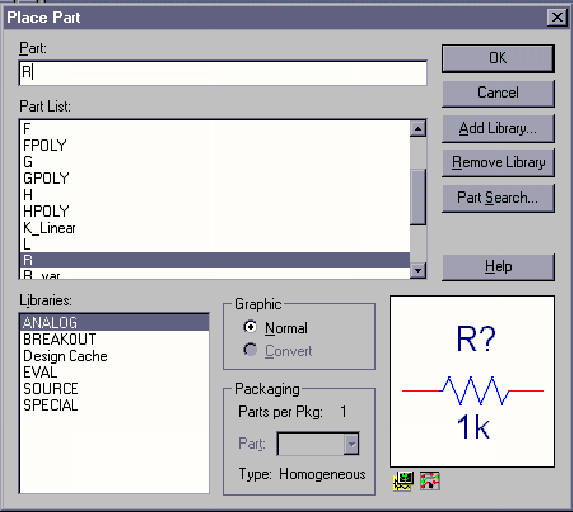
Figure C-5.

- The components and their PSpice names are:

Components Resistor Sinusoidal Voltage Source
Name R VSIN

- If you do not see any words in the Libraries list, there are no libraries loaded. You can use the Add Library button and browse to add the SOURCE and ANALOG libraries, if they are not already there.

- To get a resistor, click on the Place Part button and then type an R in the space at the upper left marked Part. Then click on OK and you will be back to the main window.

- You can place the resistors where you want them by moving the mouse around and clicking at the appropriate location. You will notice that there is a default condition for each component. For the resistor, the value will be 1k ohm and it will be horizontal. Since our circuit involves both horizontal and vertical resistors, you will need to rotate the symbol before placing it. To rotate the symbol, you need to use the keyboard command R for rotate or the right click menu. Once you have the resistor in the proper orientation, you can place in your selected position. Just place all the resistors first. We will change their values later.

- When you have finished placing resistors, hit the Esc key or just click on the Parts button again. Then, to get the voltage source, click on the Place Parts button and type VSIN in the parts box and place the voltage source where you want it.

- Finally, all circuits need a ground reference so we know where the voltage is equal to zero. Click on the Place Ground button, that is about half way down on the right . You want to choose the 0/SOURCE ground from the Place Ground window shown in Figure C-6, since it is the only one that works with PSpice. If the 0 ground is not listed, you should use Add Library to load the PSpice/SOURCE library.

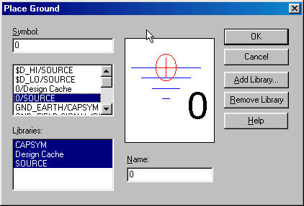
Figure C-6.

- We now have all the components and must connect them with wires. For the wires we will click on the third button down on the right with the thin line that steps down on it: . The mouse symbol will become a little cross. You will note that each component comes with little connecting wires on it. To connect two components together, just click the little cross near the boxes at the end of the little connecting wires. Make sure you click near the boxes. You can draw a wire almost anywhere, but you can only connect to the device at the ends of its connecting wires; be careful not to draw the wire through the components. Note that whenever you connect more than one wire at some point, a dot will appear there indicating a connection. It is possible for wires to cross one another without connecting if you choose. Then the dot will not appear.

- We now have drawn the circuit and need to indicate on it where we want to determine the voltage. On a physical circuit, we would connect a multimeter or an oscilloscope at these points. In our simulation we will do the same thing using the Voltage Level Marker button, which should be obvious, since it shows something that looks like a little probe with a V on it . (This button is located in the bottom row at the top of the main window.) Click on that button and place the probe to display the voltage at the upper right corner of the circuit (across the 1MEG resistor). You may want to rotate it into a convenient position. When the circuit is analyzed, a plot will be produced that shows the voltage at this location.

- To complete the schematic, we have to change the component values. Each resistor was given a name in the order it was placed on the diagram. Thus, your resistors may not have the same names as shown above. However, for simplicity, they will be referred to by the name shown here. To change R3 to 1Meg ohms, double click on the value 1k and you should get the window shown in Figure C-7 with the name Display Properties. Change the 1k to 1MEG. If you find that the number is in a hard to read position on the circuit diagram, you can single click on it and then move it with the mouse. When you type the value in the Display Properties window, you must type 1MEG with no spaces. Note that you have to type MEG since PSpice uses M to mean 10⁻³ and MEG for 10⁶. It is not case sensitive. Note that in the schematic pictured, R1 and R2 are the resistors in your voltage divider and R3 represents the impedance of the scope. Since the scope impedance is 1M, we set R3 to 1MEG. R1 and R2 are 1k ohms, you don’t need to set them since they are already 1K by default.

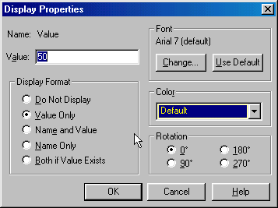
Figure C-7.

- After you have changed all the resistor values and moved them to readable positions, you must set up the voltage source. You can set the values of each of the voltage parameters next to the source by double clicking on them. Set the value of VAMPL (voltage amplitude) to 100m. Set the value of VOFF (voltage offset) to 0. Set the value of FREQ (frequency) to 1k. Note again that there is no space between the number and the m or k. Now the schematic is complete and each symbol stands for the correct part.

Setting Up the Analysis
After we have defined all the components, wired them up and changed their values appropriately, we are ready to do some analysis.

- Find the New Simulation Profile button in the top toolbar menu and click on it . You will get the window shown in Figure C-8, in which you must give a name to the file where the specifications for the analysis will be stored. Click on the Create button when you have chosen the name for your profile.

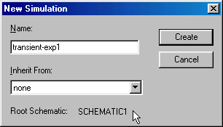
Figure C-8.

- Now we can set up the simulation. We will be doing Transient Analysis since that will produce a plot that is similar to what we see on the scope. The analysis options are found in the pull-down menu at the upper left of the Simulation Settings window shown in Figure C-9.

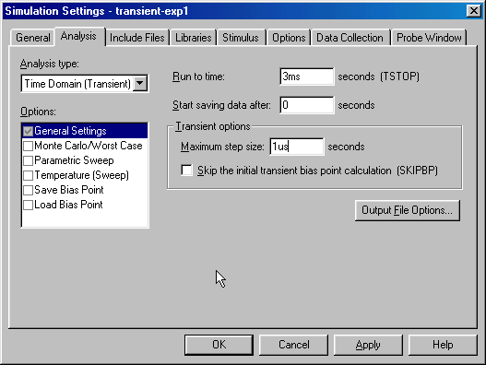
Figure C-9.

There are three boxes in which times need to be indicated. Usually two of the three values in the text boxes need to be set. The final time (Run to time:) has been set at 3ms because the period of a 1kHz sine wave is 1msec. This allows us to see three periods. The Maximum Step Size needs to be set so that you get a reasonable representation of the output. A step size that is too big will take a long time to run, a step size that is too small will give you an under-sampled representation of the output. A step size between 1/100 to 1/1000 of the run time is reasonable. The analysis will begin saving data at 0 seconds. Note again that there should never be any spaces between the number and its units. Click on the OK button when you are finished putting in the numbers.

- When you have finished, you should notice that the button that looks like an arrow in the second row at the top of the main window , now has become active. This is the Run button that we will use to run our simulation. All the buttons in this row should now be active.

Transient Analysis
You are now ready to do the simulation.

- Click on the Run button. It is possible to set up many kinds of analyses using the Simulation Settings window. Since you have already told PSpice where you want to know the voltage, it will produce a plot with the signal you have asked for. If you do not get something that looks like Figure C-10, ask for help.

- You should now go back and add another voltage level arrow at the location that represents the output of the function generator. Be sure you have the correct location. A very nice feature that Capture gives us is that the voltage plots and the voltage probe markers will be the same color, so it will be easy to determine which is which.

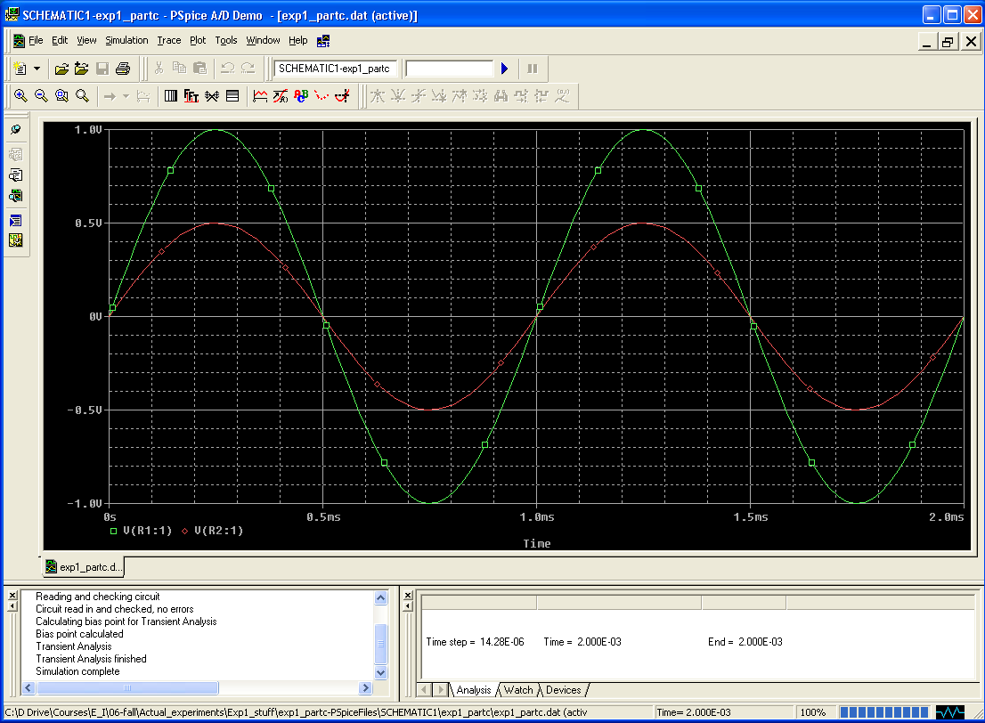
Figure C-10.

- You should get something like (but not identical to) the window shown above.
- You can print this plot directly. However, it is also useful to know how to copy plots and paste them into word. Under the Window menu in PSpice, click on “copy to clipboard”. This will bring up a window. Choose “change all colors to black” or “change white to black” and click OK. Now there is a bitmap in the clipboard that you can paste into any application. Open word and paste the bitmap in. Save this file or print the output plot for the 1K voltage divider directly.

- Change the values of the resistors in the voltage divider to 1MEG and rerun the simulation. Save or print this plot as well. Both plots should have two traces: the source voltage, and the voltage across the resistor closest to ground. Do the plots agree with your results from part B? What happens if you set the resistor values to the exact measured values of your resistors in part B? Are the results closer? Try varying the frequency, amplitude and offset of the VSIN source one at a time and rerun the analysis. What happens to your signal? Does it make sense based on your knowledge of sine waves and voltage dividers?

Summary

The combination of Capture and PSpice is a very powerful simulation tool meant to address the circuit simulation needs of all engineers who must do circuit design and analysis. Thus, there are many, many opportunities to make what seem like silly mistakes that prevent the analysis from working properly. In your first attempt at using these tools, it is likely that you have already made some of these mistakes. You should also have heard about some of them in class. What mistakes did you make?

Part D – Comparing Sine Waves
This part is for those who have spare time. It won’t be graded and it isn’t required.

In this part of the experiment we will use the oscilloscope to compare two sine waves. First we will use Lissajous figures to compare sine waves with similar amplitudes and proportional frequencies. Then we will use subtraction to create two identical signals.

Background

The cathode-ray tube: This is one of the most versatile pieces of laboratory test equipment that you will use. It is really a type of analog voltmeter with an arbitrary zero. It can read DC voltages as an offset voltage and AC voltages by displaying the true wave form. Most modern oscilloscopes are capable of measuring AC signals over a wide range of frequencies. The range of frequencies that our scopes can handle (also called bandwidth) is 10Hz to 100MegHz. The heart of any oscilloscope is the cathode-ray tube (CRT) shown in Figure D-1.

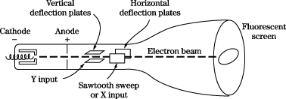
Figure D-1.

Electrons are released from the hot cathode and accelerated toward the screen by the use of a positively charged anode. An appropriate grid arrangement then governs the focus of the electron beam on the screen. The exact position of the spot on the screen is controlled by the use of the horizontal and vertical deflection plates. A voltage applied on one set of plates produces the x deflection, while a voltage on the other set produces the y deflection. Thus, with appropriate voltages on the two sets of plates, the electron beam may be made to fall on any particular spot on the screen of the tube. The screen is coated with a phosphorescent material, that emits light when struck by the electron beam. If the deflection of the beam against a known voltage input is calibrated, the oscilloscope may serve as a voltmeter. Since voltages of the order of several hundred volts are usually required to produce beam deflections across the entire diameter of the screen, the cathode-ray tube is not directly applicable for many low-level voltage measurements, and amplification must be provided to bring the input signal up to the operating conditions for the CRT.

The cathode-ray oscilloscope: An oscilloscope is comprised of a CRT, a horizontal amplifier, a vertical amplifier, a sweep circuit, and a synchronization circuit, as illustrated in Figure D-2.

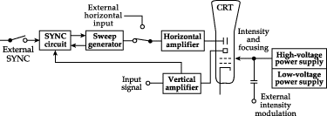
Figure D-2.

The gain of the vertical amplifier is controlled by the Volts/Div knob found above the two BNC input connectors on the HP54603B two channel scope. The sweep generator produces a sawtooth wave that may be used to provide a periodic horizontal deflection of the electron beam, in accordance with some desired frequency. This sweep then provides a time base for transient voltage measurements by means of the vertical deflection. Oscilloscopes provide internal circuits to vary the horizontal sweep frequency over a rather wide range as well as external connections for introducing other sweep frequencies. The frequency of the sweep generator is controlled by the Time/Div knob found above the Power button. If you slow the sweep down (by increasing the time per sweep) you will be able to see the electron beam spot move across the CRT screen. Internal switching is also provided. It enables the operator of the scope to lock the sweep frequency onto the frequency impressed on the vertical input. (This is more generally called sync.) This is what the AUTO SCALE button does for you when you push it. If we use the function generator to provide the input to our device under test, we can connect the SYNC output it provides to the External Trigger input on the scope and then select External for the trigger source. This is generally the best way to connect things, if we have enough cables. It also avoids the problem of accidentally confusing the SYNC with the OUTPUT BNC on the function generator.

Two channel scopes: A dual-beam oscilloscope provides for amplification and display of two signals at the same time, thereby permitting direct comparison of the signals on the CRT screen. It is a very good idea to always use both inputs, so that you can display both the signal into and out of the device you are studying. It is common to put the input signal (coming directly from the source device) on one channel and the output signal (a signal you want to observe in your circuit) on the other channel. This way you can observe what your circuit does to the input by comparing the input signal to the signal generated by the circuit. When we compare two signals we generally look at two things. The first is the change in amplitude between the input and the output. You observed this when you built the voltage divider in part B. The output can also be shifted in phase relative to the input. This means that two sinusoids are not synchronized along the time axis. These two conditions are illustrated in Figure D-3.
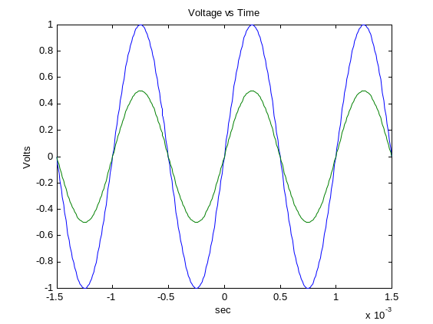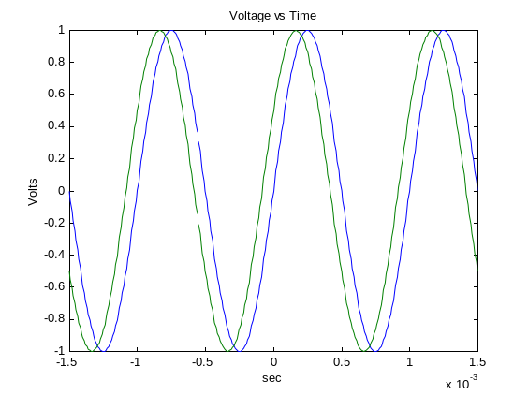
Different Amplitudes Different Phases
Figure D-3.

The phase difference can be found using the following equation:
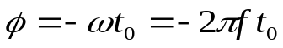
where ω is the angular frequency of the two sine waves and t₀ is the time between the start of the output wave and the start of the input wave. (Recall from the discussion of sine waves in part A that ω=2πf.)

Lissajous figures: The Mobile Studio scope offers a convenient means of comparing signal frequencies through the use of Lissajous diagrams. Two frequencies are impressed on the scope inputs, one on the horizontal input and one on the vertical input as shown in Figure D-4.
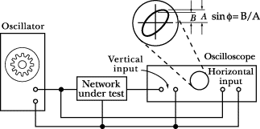
Figure D-4.

One of these frequencies may be a known frequency as obtained from a variable frequency oscillator or signal generator. If the two input frequencies are multiples of each other then the patterns that are displayed on the CRT screen are called Lissajous diagrams. The frequency ratio is related to number of vertical and horizontal maxima of the signals. The shape of the output depends on the phase difference between the two signals. Figure D-5 shows Lissajous figures for some simple frequencies ratios and phase differences.

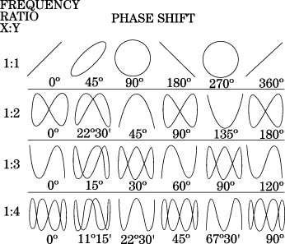

Figure D-5.

Lissajous figures may also be used to measure phase shift in an electronic circuit. An oscillator is connected to the input of the circuit under test. The phase-shift angle φ may be determined from the relation,
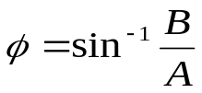
where B and A are measured as shown in Figure D-4. If both signals have the same input frequency, the shape of the figure varies depending upon the phase difference between the two signals. For zero phase shift, the ellipse will become a straight line with a slope of 45° to the right; for 90° phase shift it will become a circle; and for the 180° phase shift it will become a straight line with a slope of 45° to the left. The top row of Figure D-5 shows how the a Lissajous figure should look at different phase differences when the frequency ratio between the two signals is 1:1.

Experiment

Create a Lissajous Pattern
Under normal conditions, the scope displays voltage signals on the y axis against time on the x axis. It has a special function that allows one to plot one signal on the x axis and the other on the y axis.

- Select the Channel 1 function generator for one channel of your scope and Channel 2 function generator to the other channel of your scope (FUNC1 and FUNC2). Begin with both function generators set for 400mV peak-to-peak amplitude and a frequency of 1kHz. Use the scope to ensure that both function generators are producing the same signal.

- You should see two nearly identical sine waves once you hook up both function generators—one slightly out of phase with the other. Remember that the sine wave is defined by three parameters – amplitude, frequency and phase. Check to see that the voltage scale for both channels is the same. (Use the Volts/Div knob to adjust this if needed.) If the amplitudes are not the same, the sine waves will not be the same amplitude. If the phases are not the same, the sine waves will not line up horizontally. If the frequencies are not the same, the wave the oscilloscope is triggered on will be stationary, while the other wave will move (slowly we hope) to the left or right. Figure D-3 shows signals that vary in amplitude and frequency.

- We can now generate a Lissajous pattern by clicking on one of the scope buttons. Click on the MODE box in the Horizontal menu of the scope. Then select X-Y to combine the two signals into a single Lissajous pattern. Compare what you see to the examples of Lissajous figures. Use the picture key in the software to take a picture of the image and save it. Your TA or instructor can help you with this. Include this picture with your report. [Hint: Use the STOP button on the scope to freeze your figure at the point you wish to take a picture.]

- You should now play with the equipment and produce several other representative patterns. Create one pattern that you find particularly interesting. Take a picture of it with the Mobile Studio software.

Subtracting two Signals
Next, we will do a different kind of comparison of the two sine waves, one that will prove to be very important in the development of measurement techniques. In this measurement, we will compare two signals to see how close they are to one another by subtracting one from the other.

- Change back to the Y-T display by clicking so on the Horizontal controls section. This should bring back the two individual sine waves. Adjust them again so that they are as identical as possible. (Try to get them displayed on top of one another by using the Phase controls in the function generator window.)

- Click on the Enable Channel button again in the Math Channel section. Click on the Operation menu and select Ch1-Ch2, which will produce a third trace that is the difference between the two channels. If you have adjusted the two sine waves to be identical, their difference should be zero. How well did you do? Note that the amplitude, the frequency, and the phase must be identical to make the difference zero.

- Now make the two signals as identical as possible by adjusting the difference signal away. What did you have to do?

Summary

From this exercise, you should see the value of comparing one signal against some kind of reference. It is possible to tune a guitar, for example, by comparing the tone a string makes with an electronic tone. This permits a perfectly tuned instrument, even when the player has less than perfect pitch. You have also seen how we make what are called differential measurements. There are many advantages to making differential over absolute measurements. You have seen one of the key reasons since differential measurements allow you to focus on smaller quantities since you are working with the difference between two signals

Report and Conclusions

Reports for experiments should assume that the reader knows the details of the experiment. They must give all required results and answer the questions listed below. It is intended that these be quick to write.

The following should be included in your report. Everything should be labeled and easy to find. Partial credit will be deducted for poor labeling or unclear presentation.

Part A (14 points)

Answer the following questions:
- When only the scope is directly connected to the function generator, what does the display on the function generator read when the signal measured by the scope has a peak-to-peak amplitude of 400mV? (1 pt)
- Include the signed plot with the period marked, the frequency calculated, and the amplitude marked. Create a table comparing the FG settings, the Measurement window results and the results from the oscilloscope plot. (6 pt)
- What is the measured resistance of the speaker? (1 pt)
- When the speaker is also connected to the function generator, what does the scope measure for the peak-to-peak amplitude when the speaker is producing a comfortable level of sound? (2 pt)
- What is the period of the tone at the frequency that appears loudest when you scanned through the entire range of frequencies? Note: There is a range of acceptable answers to this question since it depends on the hearing of the person listening and the frequency response of the circuit. (2 pt)
- What frequencies make up the audio range? That is, what are the lowest and highest frequencies that humans can hear? If you do not know this, check the frequency response of a good speaker or do a search on the web for Audio Frequencies. Provide the reference you use. (2 pt)

Part B (48 points)

Include the following:
- B.1) A table of data for all four battery types. Remember that you only need to measure 2, and then collect data from other pairs to complete the table. The table must have a) battery type, b) unloaded battery voltage, c) loaded battery voltage, d) the total load resistance of the test, and e) the calculated value of Rbat. Show the formula you used to calculate the value of Rbat. (20 pt)
- B.1) Find one reference that states the expected internal resistance of one of the batteries used. In most cases we assume you will find one using a web search. Battery company web sites might be a place to look. Give the source and the value stated. Compare it to the measured value. (4 pt)
- B.2) Mobile Studio plot of input and output from the 1k voltage divider. (4 pt)
- B.2) Mobile Studio plot of input and output from the 1Meg voltage divider. (4 pt)
- Calculate the value of Radc2. (4 pt) Show your work. (4 pt)
- B.3) List the power out of the 9V battery and the power per resistor. Also state the power out of the AA battery pack. (4 pt)
- Plot the predicted power into the load vs. Rload for a 9V battery assuming the battery has an internal resistance of 30Ω. (4 pt)

Part C (14 points)

Include the following plots
- PSpice transient plot of voltage divider with 2 1K resistors (two traces). (4 pt)
- PSpice transient plot of voltage divider with 2 1MEG resistors (two traces). (4 pt)

Answer the following questions
- How does the signal you generated with PSpice using the 1K voltage divider compare to the one you generated with the scope? (3 pt)
- How does the signal you generated with PSpice using the 1Meg voltage divider compare to the one you generated with the scope? (3 pt)

Part D (no points, the following are listed incase we wish to require this part in the future. Don’t include them in your report)

Include the following plots:
- Mobile Studio plot of the Lissajous comparison of the signals from two function generators. Indicate on the plot the frequency you used for the X signal and the Y signal.
- Mobile Studio plot of one additional Lissajous pattern.

Answer the following questions:
- When you were displaying the two sine waves separately, the scope triggered on only one of the waves. Which way did the other wave move when its frequency was lower, right or left?
- Discuss which of the Lissajous patterns you were able to generate and what you had to do to create them.
- Qualitatively describe your efforts to make the difference between the two signals equal to zero using the channel math button to display channel 1 minus channel 2.
- If you wished to display three cycles of a sinusoidal voltage wave with a frequency of 10kHz, at what minimum value on the scope should you set the horizontal time division (Time/Div)? What is the minimum value would you need to display at least three cycles at 5kHz?

Responsibilities (4 points)

- List member responsibilities. (4 pt)

Total: 80 points for write up + 20 for attendance = 100 points.

Attendance: 3 classes (20 points), 2 classes (10 points), 1 class (0 points), out of 20 possible points
Minus 5 points for each late.
No attendance at all = No grade for experiment.

