True of False (5)

- For a forward propagating wave, the voltage and current are in phase.

- RG-58 coaxial cable has a characteristic impedance of 50Ω.

- The input impedance of the oscilloscope is 50Ω.

- During experiments, the voltage measured at the input of the transmission line is the forward propagating voltage.

- The author of the textbook is Fawwaz Ulaby.

Multiple Choices (20) – Circle ALL correct answers

The standing wave ratio may be:
- 0
- 1
- infinite
- complex

The characteristic impedance is dependent on:
- the inductance per unit length, l
- the capacitance per unit length, c
- the length of the line
- the frequency

For a lowloss line:
- no leakage current exists between the conductors
- perfect conductors are assumed in the line
- the characteristic imedance is approximately √(L/C)
- the propagation velocity is approximately √(1/LC)

The input impedance for a length of line with a resistive load can be:
- zero
- real
- equal to the load impedance
- equal to the characteristic impedance

When a standing wave maximum occurs at the load:
- the line is matched
- the load impedance is smaller than the characteristic impedance
- the load can be inductive
- the load can be capacitive

Lumped Parameters (6)

In the figure below, indicate what components are used for a lumped parameter model of a lossy transmission line. (4)

Describe the physical characteristics that cause and tow of these parameters. (2)

Load Matching (10)

When designing any system, it is very important to match the load impedance and line impedance. Unfortunately, when you are designing an antenna system, the load impedance will be dependent on the surrounding environment. You have designed an antenna with an impedance of 150+j45Ω. The line that delivers power to your antenna has a characteristic impedance of 150Ω. Add any electric component such that the load and line are matched at your broadcast frequency of 890kHz.

Z_{o} = 50Ω Z_{l} = 150+j45Ω

Draw the new circuit with the added component. (4)

Indicate any pertinent values for the component you added. (4)

Why is the performance improved with this design? (2)

Wave Propagation (28)

A standing wave pattern is shown in the figure. The transmission line is semi-infinite (it continues in the –z direction). The velocity of the line is 0.5c and the characteristic impedance is 50Ω. Note: the z-axis origin is defined at the load.

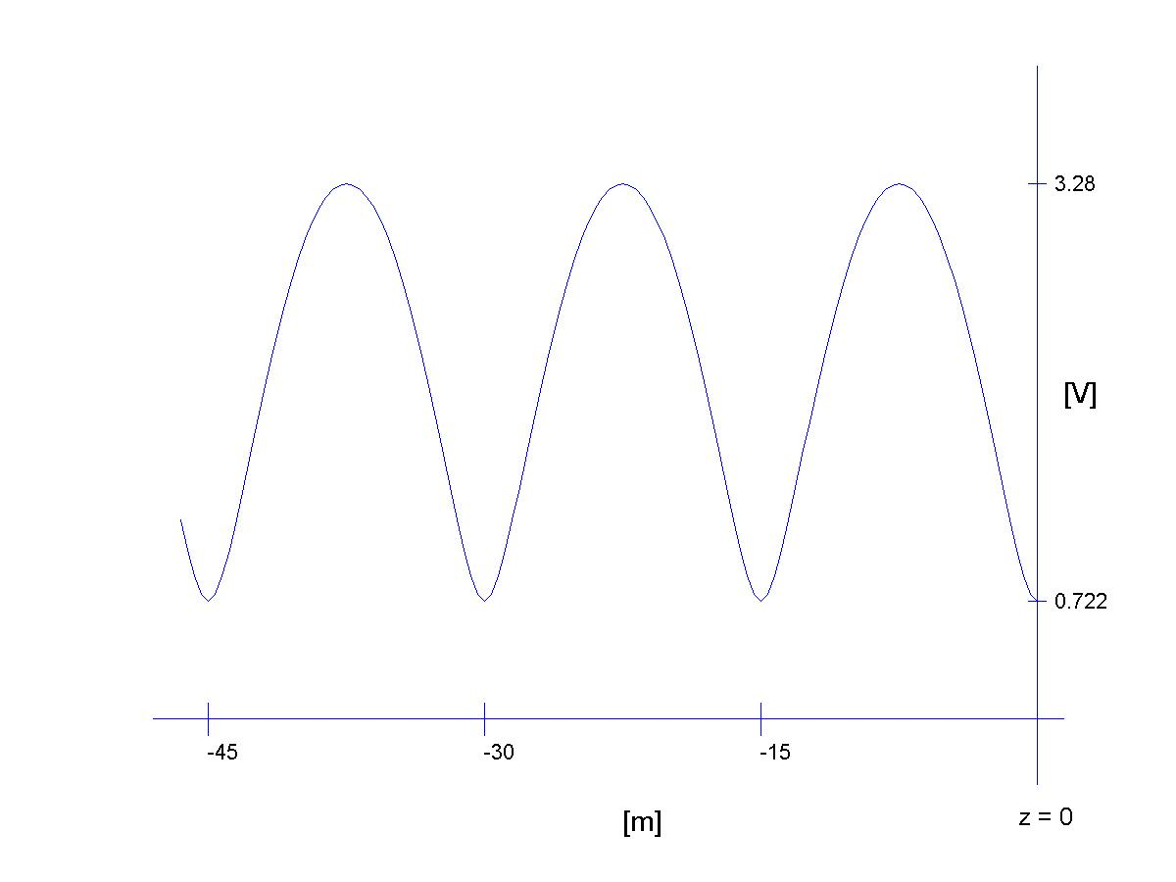

What is the standing wave ratio, SWR? (3)

What is the wavelength, λ? (3)

What is the frequency, f? (3)

What is the reflection coefficient, Γ? (3)

What is the total voltage on the transmission line in phasor form? (4)

What is the total current on the transmission line in phasor form? (4)

What is the total voltage on the transmission line in time domain form? (4)

What is the total voltage on the transmission line in time domain form? (4)

Extra Credit: Assume the standing wave pattern was shifted 4 meters to the left. What is the new reflection coefficient (4).

Snicker’s Question (0 points)

By attempting this problem, you wager one Snicker’s bar. You must get the solution correct to win. If you do not, you owe me a Snicker’s bar. If you do, then you win a Snicker’s or other candy bar.

Alternative candy bar choice:

Your dormitory has a single connection to the cable service and each dorm room is connected on a transmission line as shown in the figure. A length of line connects your cable box to the main transmission line and the distance between the rooms is fairly constant. All the cable boxes are the same, Z_{l}=50Ω and all the transmission lines are identical with Z_{o}=100Ω and a propagation velocity of 0.66c. The distance between the rooms and from the box to the main line (l₁) is 4.125 meters. Now, your university believes in wholesome entertainment so the only cable channel you receive airs episodes of The Love Boat on a frequency of 400MHz. The network continues to the left in the figure, repeating for all the rooms. If the voltage delivered to the dormitory has an amplitude of 10V, what is the power delivered to the dormitory?
