PREPARATION ASSIGNMENTS-6

Due Monday, April 5

- The x-y plane separates two magnetic media with magnetic permeabilities μ₁₌ μ₀ and μ₂₌ 4μ₀, as shown in the figure. If there is no surface current at the interface and the magnetic field in medium 1 is [A/m], find, θ₁, θ₂.

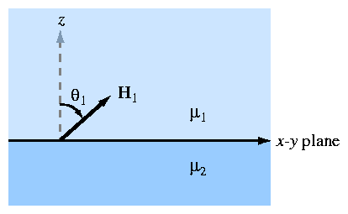

Due Wednesday, April 7

1. A loop wire carries 5 [A] of current, which generates total magnetic flux of 0.0001 [Tm²] through the loop. Compute the magnetic energy stored in the system.

